AURA-WEAR: AI-Integrated Custom Clothing Website


Developed By:
Muhammad Umer Javed (B.S CS Aut-21-Eve-0170)
Abdul Baqi (B.S CS Aut-2022-E-B-0260)

BS (Computer Science)

Supervised by:
Dr. Zaheen Khan

Department of Computer Science
Federal Urdu University of Arts, Science and Technology
Islamabad

Session [2022-2026]

AURA-WEAR: AI-Integrated Custom Clothing Website

A project submitted to the Department of Computer Science as partial fulfillment of the requirement for the award of Degree of Bachelor of Science in Computer Science.

Name | Registration Number
Muhammad Umer Javed | (Aut-21-Eve-0170)
Abdul Baqi | (Aut-2022-E-B-0260)

Supervisor
Dr. Zaheen Khan
Assistant Professor
Department of Computer Science
Federal Urdu University of Arts, Science and Technology
Islamabad

Final Approval

It is certified that I have read the project report submitted by Muhammad Umer Javed (B.S CS Aut-21-Eve-0170) and Abdul Baqi (B.S CS Aut-2022-E-B-0260) and it is our judgment that this project is of sufficient standard to warrant its acceptance by the FUUAST university, Islamabad for the Degree of Bachelor of Science in Computer Science.

Committee:

External Examiner | _______________________________

Internal Examiner | _______________________________  Mr. Nadeem Akhtar  Lecturer  Department of Computer Science  Federal Urdu University of Arts, Science and Technology  Islamabad

Supervisor | _______________________________  Dr. Zaheen Khan  Assistant Professor  Department of Computer Science  Federal Urdu University of Arts, Science and Technology  Islamabad

Declaration

We hereby declare that this software, neither as a whole nor as a part has been copied out from any source. It is further declared that we have developed this software and the accompanied report entirely on the basis of our personal efforts. If any part of this project is proved to be copied out from any source or found to be reproduction of some other, we will stand by the consequences. No portion of the work presented has been submitted in support of any application for any other degree or qualification of this or any other university or institute of learning.

Muhammad Umer Javed
Abdul Baqi

Dedicated to our beloved parents,
Teachers
And
The fellows

Acknowledgement

Thanks to Almighty Allah for giving us knowledge, power and strength to accomplish this task. We learned a great deal while developing this project and the experience will certainly benefit us in our professional careers. Many of our teachers guided us during this project but we are especially grateful to our supervisor Dr. Zaheen Khan for her invaluable guidance and continuous support throughout all phases of this work. Her encouragement motivated us during difficult times. We would also like to express our heartfelt gratitude to all our friends and family for their support and encouragement throughout this journey.

Muhammad Umer Javed
Abdul Baqi

Project in Brief

Project Title | AURA-WEAR: AI-Integrated Custom Clothing Website
Organization | Federal Urdu University of Arts, Science and Technology
Objectives | 1. To develop an AI-powered web platform for custom streetwear and sportswear design and ordering.  2. To implement a real-time 2D Canvas-based customization engine with dynamic pricing.  3. To integrate a RAG-based AI chatbot (n8n + OpenAI GPT-4o-mini) for personalized recommendations.  4. To provide a comprehensive admin panel with analytics, order management, and reporting.
Undertaken By | Muhammad Umer Javed  Abdul Baqi
Supervised By | Dr. Zaheen Khan
Date Started | Feb 16, 2026
Date Completed | Jun 26, 2026
Technologies Used | Frontend: HTML5, CSS3, Vanilla JavaScript  Backend: FastAPI (Python 3.11+)  Database: SQLite (development) / PostgreSQL (production)  AI/Chatbot: n8n Workflow + OpenAI GPT-4o-mini (RAG)  Deployment: Railway.app  Authentication: JWT + bcrypt  Image Storage: Cloudinary
System Used | 8th Gen Core i5 Processor @ 2.40 GHz, 16 GB RAM, 512 GB SSD

ABSTRACT

AURA-WEAR: AI-Integrated Custom Clothing Website

The fashion e-commerce industry in Pakistan faces a significant gap: existing platforms rarely offer personalized clothing customization with real-time design preview capabilities and AI-based recommendations. AURA-WEAR is an AI-integrated web platform designed to bridge this gap by enabling customers to design and order custom streetwear and sportswear through an intelligent, interactive interface.
The platform is built on a 4-tier layered architecture comprising a Vanilla JavaScript frontend, a FastAPI (Python) backend, an n8n-powered AI processing layer, and a relational database. Customers can use the real-time 2D Canvas-based customization engine to select fabric type, garment color, stitching style, print method, wash effect, and upload custom logos, with dynamic pricing computed instantly as selections are made. An AI chatbot powered by Retrieval-Augmented Generation (RAG) via n8n workflows and OpenAI GPT-4o-mini provides personalized product recommendations and FAQ assistance.
The system supports two roles: Customer and Admin. Customers can register, customize products, place orders, track order status through a five-stage lifecycle, make payments (Cash on Delivery and PayFast), and download invoices. Admin users have access to a comprehensive dashboard with real-time analytics, full CRUD operations on products, order and customer management, inventory alerts, sales reporting, coupon/promo code management, and CSV data export.
AURA-WEAR implements industry-standard security practices including bcrypt password hashing, JWT-based authentication with role-based access control, OTP-based password reset via email, and HTTPS/TLS communication. The platform was tested against 56 functional test cases, all of which passed successfully, demonstrating a reliable, scalable, and user-friendly solution for the custom clothing industry in Pakistan.

Contents
Chapter-1
Proposal……………..……………………………….……………………………………………..1
Revision History 2
1.1 Introduction 2
1.2 Problem Statement 2
1.3 Proposed System 3
1.4 Benefits of the Proposed System 3
1.5 Scope 4
1.6 Survey Analysis 4
1.6.1 Survey Analysis Table 4
1.7 Modules & Submodules 5
1.7.1 Security Management 5
1.7.2 User Profile Management 5
1.7.3 Product Catalog Management 5
1.7.4 Product Customization 5
1.7.5 AI Chatbot Management 5
1.7.6 Order Management 5
1.7.7 Payment Management 5
1.7.8 Admin Dashboard Management 6
1.8 Primary Actor 6
1.9 Tools & Technologies 6
1.9.1 Front-End Tools 6
1.9.2 Back-End Tools 6
1.9.3 AI / Automation Tools 6
1.9.4 Database 6
1.9.5 Deployment 7
1.10 System Design Approach 7
1.11 Process Model Used 9
1.12 Modelling Techniques / Tools Used 10
1.13 Limitation / Constraint 10
1.14 References 11
Chapter-2
Analysis……………………………………………………….…………………………………12
2.1 Introductio 13
2.1.1 Purpose 13
2.1.2 Scope 13
2.1.3 Definitions, Acronyms, and Abbreviations 13
2.1.4 Overview 14
2.2 Functional Requirements 14
2.2.1 Security Management 14
2.2.1.1 Process SignUp 14
2.2.1.2 Process SignIn 14
2.2.1.3 Forgot Password 15
2.2.1.4 Change Account Password 15
2.2.1.5 JWT Authentication 15
2.2.1.6 OTP Verification 15
2.2.1.7 Role-Based Access Control 15
2.2.1.8 Session Management 15
2.2.2 User Profile Management 15
2.2.2.1 Add Customer Profile 15
2.2.2.2 Update Customer Profile 15
2.2.2.3 View Customer Profile 16
2.2.2.4 Manage Customer Account Status 16
2.2.3 Product Catalog Management 16
2.2.3.1 Add New Product 16
2.2.3.2 Update Product Details 16
2.2.3.3 Enable or Disable Product 16
2.2.3.4 Search Product 16
2.2.3.5 View All Products 16
2.2.3.6 Filter Products by Category 16
2.2.4 Product Customization 17
2.2.4.1 Select Fabric Type 17
2.2.4.2 Select Color 17
2.2.4.3 Upload Custom Logo 17
2.2.4.4 Select Stitching Style 17
2.2.4.5 Select Print Method 17
2.2.4.6 Select Wash Effect 17
2.2.4.7 View Real-Time 2D Design Preview 17
2.2.4.8 Calculate Dynamic Price 17
2.2.5 AI Chatbot Management 18
2.2.5.1 Send Query to Chatbot 18
2.2.5.2 Get AI Design Recommendation (RAG) 18
2.2.5.3 View FAQ via Chatbot 18
2.2.5.4 View Chat History 18
2.2.5.5 Admin Manage FAQ Entries 18
2.2.6 Order Management 18
2.2.6.1 Create New Order 18
2.2.6.2 Search Order History 18
2.2.6.3 View Order History 18
2.2.6.4 Cancel Order 19
2.2.6.5 Track Order Status 19
2.2.6.6 Reorder Previous Order 19
2.2.7 Payment Management 19
2.2.7.1 Record Online Payment 19
2.2.7.2 Record Cash on Delivery 19
2.2.7.3 Generate Digital Receipt 19
2.2.7.4 View All Payments and Transactions 19
2.2.7.5 Download Invoice 19
2.2.8 Admin Dashboard Management 20
2.2.8.1 Manage Products (Admin) 20
2.2.8.2 Manage Customer Accounts (Admin) 20
2.2.8.3 View and Update Order Management (Admin) 20
2.2.8.4 View Inventory and Stock Alerts (Admin) 20
2.2.8.5 Generate Sales Report 20
2.2.8.6 Generate Order Report 20
2.2.8.7 View Analytics Dashboard 20
2.2.8.8 Send Notification to Customers 20
2.2.8.9 Manage Content (Terms, Privacy, FAQ) 20
2.2.8.10 Manage Coupon/Promo Codes 21
2.2.8.11 Export Data as CSV 21
2.3 Non-Functional Requirements 21
2.3.1 Performance Requirements 21
2.3.2 Usability Requirements 21
2.3.3 Security Requirements 21
2.3.4 Reliability Requirements 21
2.3.5 Scalability Requirements 21
2.3.6 Maintainability & Support Requirements 22
2.3.7 Compatibility Requirements 22
2.3.8 Support Requirements 22
2.4 External Interface Requirements 22
2.4.1 User Interfaces 22
2.4.2 Hardware Interfaces 22
2.4.3 Software Interfaces 22
2.4.4 Communication Interfaces 23
Chapter-3
Design…………….………………………………….……………………………………24
3.1 Use Case Diagram 25
3.2 Fully Dressed Use Cases 26
UC-01: Process SignUp 26
UC-02: Process SignIn 26
UC-03: Forgot Password 27
UC-04: Change Account Password 28
UC-05: JWT Authentication 29
UC-06: OTP Verification 29
UC-07: Role-Based Access Control 30
UC-08: Session Management 31
UC-09: Add Customer Profile 31
UC-10: Update Customer Profile 32
UC-11: View Customer Profile 33
UC-12: Manage Customer Account Status 34
UC-13: Add New Product 34
UC-14: Update Product Details 35
UC-15: Enable or Disable Product 36
UC-16: Search Product 37
UC-17: View All Products 37
UC-18: Filter Products by Category 38
UC-19: Select Fabric Type 39
UC-20: Select Color 39
UC-21: Upload Custom Logo 40
UC-22: Select Stitching Style 41
UC-23: Select Print Method 41
UC-24: Select Wash Effect 42
UC-25: View Real-Time 2D Design Preview 43
UC-26: Calculate Dynamic Price 44
UC-27: Send Query to Chatbot 44
UC-28: Get AI Design Recommendation (RAG) 45
UC-29: View FAQ via Chatbot 46
UC-30: View Chat History 47
UC-31: Admin Manage FAQ Entries 47
UC-32: Create New Order 48
UC-33: Search Order History 49
UC-34: View Order History 50
UC-35: Cancel Order 50
UC-36: Track Order Status 51
UC-37: Reorder Previous Order 52
UC-38: Record Online Payment 52
UC-39: Record Cash on Delivery 53
UC-40: Generate Digital Receipt 54
UC-41: View All Payments and Transactions 54
UC-42: Download Invoice 55
UC-43: Manage Products - Admin 56
UC-44: Manage Customer Accounts - Admin 57
UC-45: View and Update Order Management - Admin 57
UC-46: View Inventory and Stock Alerts - Admin 58
UC-47: Generate Sales Report 59
UC-48: Generate Order Report 59
UC-49: View Analytics Dashboard 60
UC-50: Send Notification to Customers 61
UC-51: Manage Content - Terms, Privacy, FAQ 61
UC-52: Manage Coupon/Promo Codes 62
UC-53: Export Data as CSV 63
UC-54: Manage Admin Users 63
UC-55: View Customer Reviews 64
UC-56: Generate Provider Performance Report 65
3.3 Domain Model 66
3.4 System Sequence Diagrams 67
SSD:1 Process SignUp 69
SSD:2 Process SignIn 69
SSD:3 Forgot Password 70
SSD:4 Reset Password 70
SSD:5 Update Profile 71
SSD:6 Upload Profile Picture 71
SSD:7 View Products 72
SSD:8 Search Products 72
SSD:9 Customize Product 72
SSD:10 Upload Logo 73
SSD:11 Generate AI Design Suggestion 73
SSD:12 View 2D Real-Time Preview 74
SSD:13 Save Customization to Cart 74
SSD:14 View Cart 75
SSD:15 Update Cart 75
SSD:16 Apply Coupon Code 76
SSD:17 Interact with AI Chatbot 76
SSD:18 Get Product Recommendation 77
SSD:19 Get Customization Assistance 77
SSD:20 Get Pricing Information 78
SSD:21 Submit Review 78
SSD:22 View Reviews 79
SSD:23 Manage Wishlist 79
SSD:24 Add Shipping Address 80
SSD:25 Select Shipping Address at Checkout 80
SSD:26 Receive Order Confirmation Email 80
SSD:27 Subscribe to Newsletter 81
SSD:28 Contact Support 81
SSD:29 View FAQ via Chatbot 82
SSD:30 View Chat History 82
SSD:31 Admin Manage FAQ Entries 83
SSD:32 Create New Order 83
SSD:33 Search Order History 84
SSD:34 View Order History 84
SSD:35 Cancel Order 85
SSD:36 Track Order Status 85
SSD:37 Reorder Previous Order 86
SSD:38 Record Online Payment 86
SSD:39 Record Cash on Delivery 87
SSD:40 Generate Digital Receipt 87
SSD:41 View All Payments and Transactions 88
SSD:42 Download Invoice 88
SSD:43 Manage Products - Admin 89
SSD:44 Manage Customer Accounts - Admin 89
SSD:45 View and Update Order Management - Admin 90
SSD:46 View Inventory and Stock Alerts - Admin 90
SSD:47 Generate Sales Report 91
SSD:48 Generate Order Report 91
SSD:49 View Analytics Dashboard 92
SSD:50 Send Notification to Customers 92
SSD:51 Manage Content - Terms, Privacy, FAQ 93
SSD:52 Manage Coupon/Promo Codes 93
SSD:53 Export Data as CSV 94
SSD:54 Manage Admin Users 94
SSD:55 View Customer Reviews 95
SSD:56 Generate Performance Report 95
3.5 Schema Diagram 96
users 96
products 97
orders 97
order_items 98
payments 99
chat_logs 99
inventory 99
coupons 100
faq 100
Chapter-4
Construction…………………………………………….……………………………….102
4.1 Class Diagram 103
4.2 Project Code (Business Logic) 104
4.2.1 Backend: FastAPI Routes 104
4.2.2 Frontend: JavaScript Logic 106
4.3 Sample Queries 107
Chapter-5 Testing…………....................………………………………….………………………………109
5.1 Test Cases 110
TC-01 Process SignUp 110
TC-02 Process SignIn 110
TC-03 Forgot Password 111
TC-04 Change Account Password 112
TC-05 JWT Authentication 112
TC-06 OTP Verification 113
TC-07 Role-Based Access Control 113
TC-08 Session Management 114
TC-09 Add Customer Profile 114
TC-10 Update Customer Profile 115
TC-11 View Customer Profile 116
TC-12 Manage Customer Account Status 116
TC-13 Add New Product 117
TC-14 Update Product Details 117
TC-15 Enable or Disable Product 118
TC-16 Search Product 118
TC-17 View All Products 119
TC-18 Filter Products by Category 120
TC-19 Select Fabric Type 120
TC-20 Select Color 121
TC-21 Upload Custom Logo 121
TC-22 Select Stitching Style 122
TC-23 Select Print Method 122
TC-24 Select Wash Effect 123
TC-25 View Real-Time 2D Design Preview 124
TC-26 Calculate Dynamic Price 124
TC-27 Send Query to Chatbot 125
TC-28 Get AI Design Recommendation (RAG) 126
TC-29 View FAQ via Chatbot 126
TC-30 View Chat History 127
TC-31 Admin Manage FAQ Entries 127
TC-32 Create New Order 128
TC-33 Search Order History 129
TC-34 View Order History 129
TC-35 Cancel Order 130
TC-36 Track Order Status 130
TC-37 Reorder Previous Order 131
TC-38 Record Online Payment 131
TC-39 Record Cash on Delivery 132
TC-40 Generate Digital Receipt 132
TC-41 View All Payments and Transactions 133
TC-42 Download Invoice 134
TC-43 Manage Products - Admin 134
TC-44 Manage Customer Accounts - Admin 135
TC-45 View and Update Order Management - Admin 135
TC-46 View Inventory and Stock Alerts - Admin 136
TC-47 Generate Sales Report 137
TC-48 Generate Order Report 137
TC-49 View Analytics Dashboard 138
TC-50 Send Notification to Customers 138
TC-51 Manage Content 139
TC-52 Manage Coupon/Promo Codes 139
TC-53 Export Data as CSV 140
TC-54 Manage Admin Users 141
TC-55 View Customer Reviews 141
TC-56 Generate Performance Report 142
Chapter-6
User Manual………………………………….……………………………………………143
User Roles in this Application 144
6.1 Screenshots 144
6.1.1 Landing / Home Page 144
6.1.2 Registration Screen 144
6.1.3 Sign In Screen 145
6.1.4 Forgot Password Screen 145
6.1.5 OTP Verification Screen 145
6.1.6 Change Password Screen 145
6.1.7 Product Catalog Screen 146
6.1.8 Product Detail Screen 146
6.1.9 Product Customization Screen (Designer) 146
6.1.10 Real-Time 2D Preview Panel 146
6.1.11 Logo Upload Section 147
6.1.12 AI Chatbot Widget 147
6.1.13 Shopping Cart Screen 147
6.1.14 Checkout Screen 147
6.1.15 Order Confirmation Screen 148
6.1.16 Order History Screen 148
6.1.17 Order Detail Screen 148
6.1.18 Order Tracking Screen 148
6.1.19 Payment History Screen 149
6.1.20 Customer Profile Screen 149
6.1.21 Admin Login Screen 149
6.1.22 Admin Dashboard 149
6.1.23 Customer Management Screen 150
6.1.24 Product Management Screen 150
6.1.25 Order Management Screen (Admin) 150
6.1.26 Payment Management Screen 150
6.1.27 Inventory Management Screen 151
6.1.28 Reports Screen 151
6.1.29 Coupon Management Screen 151
6.1.30 Content Management Screen 151

CHAPTER # 1:
PROPOSAL

Revision History
Table 1: Revision History
Version | Date | Description | Author
v1.0 | Nov 2025 | Initial SRS document: core requirements, basic use cases, project scope, and initial technology selection. | Muhammad Umer Javed
v2.0 | Jan 2026 | Added use case diagrams, ER diagram, system architecture, and expanded functional requirements. | Abdul Baqi
v3.0 | Mar 2026 | Tech stack upgraded to FastAPI + Python, JWT authentication added, AI chatbot design finalized. | Muhammad Umer Javed
v4.0 | Jun 2026 | Final version: all 56 functional requirements implemented, complete test cases, user manual added. | Both Authors

1.1 Introduction
The fashion industry is rapidly shifting toward personalized and custom-made clothing, driven by rising consumer expectations for uniqueness and individual expression. In Pakistan, this shift presents a significant untapped market opportunity, as most existing e-commerce platforms offer only standardized, off-the-shelf garments without meaningful customization capabilities.
AURA-WEAR is an AI-integrated, web-based custom clothing platform designed to address this gap. The system enables customers to design their own streetwear and sportswear through a real-time 2D Canvas-based design engine, supported by an AI chatbot that provides intelligent fabric, style, and design recommendations. The platform is built on a modern, scalable 4-tier architecture using FastAPI (Python) as the backend, Vanilla JavaScript for the frontend, n8n with OpenAI GPT-4o-mini for the AI layer, and SQLite/PostgreSQL for data persistence.

1.2 Problem Statement
In Pakistan, there is a significant gap in online platforms offering custom clothing with real-time design preview capabilities and AI-based recommendations. Existing platforms either provide basic template customization without live previews, or offer design tools without intelligent assistance. Customers who wish to order uniquely designed garments face challenges in visualizing their final product before committing to a purchase, leading to dissatisfaction and high return rates. Additionally, clothing businesses lack automated systems to manage custom orders, track production, and provide customers with transparent order status updates. AURA-WEAR is designed to solve these problems comprehensively.

1.3 Proposed System
AURA-WEAR proposes a comprehensive web-based solution for custom clothing design and ordering. The system is organized into three primary portals:
1. Customer Portal: Allows customers to browse the product catalog, use the AI-powered 2D customization engine, interact with the AI chatbot, place orders, track order status, manage payments, and view order history.
2. Admin Panel: Provides administrators with full CRUD capabilities for product management, customer account management, order processing, inventory monitoring, sales reporting, coupon management, and analytics visualization.
3. AI Processing Layer: An n8n workflow automation platform integrates with OpenAI GPT-4o-mini to implement a Retrieval-Augmented Generation (RAG) pipeline that answers product queries and provides personalized design recommendations.

1.4 Benefits of the Proposed System
- Real-Time 2D Design Preview: Customers can visualize their custom garment configurations instantly before placing an order, reducing uncertainty and return rates.
- AI-Powered Recommendations: The RAG-based chatbot provides intelligent fabric, style, and design suggestions tailored to each customer's preferences and queries.
- Transparent Dynamic Pricing: Pricing is calculated in real time as customers add customization options, building trust and eliminating hidden costs.
- Streamlined Ordering Process: A complete e-commerce workflow — from design to checkout to order tracking — ensures a smooth customer journey.
- Admin Analytics Dashboard: Administrators gain insights into sales trends, inventory levels, and customer behavior through a built-in analytics panel.
- Scalable Architecture: The 4-tier layered architecture ensures the system can scale to handle growing user demand without architectural overhaul.
- Secure Platform: JWT authentication, bcrypt password hashing, and OTP verification ensure data security and user account protection.

1.5 Scope
AURA-WEAR is scoped as a web-based platform accessible via modern browsers on desktop and mobile devices. The system covers custom design and ordering for four garment categories: T-Shirts, Hoodies, Jackets, and Sports Uniforms. The customization options include fabric type selection, color selection, logo upload, stitching style, print method, and wash effect.
The system supports two user roles (Customer and Admin) with distinct access controls. Payment methods include Cash on Delivery (COD) and PayFast gateway integration. Order tracking covers a five-stage lifecycle: Pending, In Production, Quality Check, Shipped, and Delivered.
Out of scope for this version: a native mobile application (iOS/Android), integration with a physical store inventory system, Stripe payment gateway (deferred due to regional API restrictions), and support for languages other than English.

1.6 Survey Analysis
A comparative analysis was conducted of five existing e-commerce and custom clothing platforms to identify gaps that AURA-WEAR addresses. The systems evaluated were Amazon Custom, Printful, Custom Ink, Spreadshirt, and AURA-WEAR.

1.6.1 Survey Analysis Table
Table 2: Comparative Survey of Custom Clothing Platforms
System Name | AI Chatbot | 2D Preview | Custom Fabric | Real-Time Pricing | Order Tracking
Amazon Custom | No | No | Limited | No | Yes
Printful | No | Basic | Yes | Yes | Yes
Custom Ink | No | 2D Basic | Limited | Yes | Yes
Spreadshirt | No | Basic | Limited | Yes | Yes
AURA-WEAR | Yes (RAG) | Yes (Canvas) | Yes (Full) | Yes (Dynamic) | Yes

The survey confirms that AURA-WEAR is the only platform among those evaluated to offer all five features simultaneously, making it a uniquely comprehensive solution for the Pakistani custom clothing market.

1.7 Modules & Submodules
AURA-WEAR is divided into eight functional modules, each responsible for a distinct area of the system's functionality:

1.7.1 Security Management
Handles user authentication and authorization including registration, login, logout, JWT token management, and bcrypt password hashing. Ensures secure access to all protected endpoints via role-based access control.

1.7.2 User Profile Management
Allows customers to create, view, and update their profile information including personal details, shipping addresses, and profile pictures stored on Cloudinary. Admins can view and manage customer account statuses.

1.7.3 Product Catalog Management
Manages the product listings for streetwear and sportswear categories. Admins can add, update, delete, and toggle product availability. Customers can browse, search, and filter products.

1.7.4 Product Customization
The core module of AURA-WEAR. Provides the 2D Canvas-based design interface where customers select garment type, color, fabric, size, add custom text and logo, choose stitching style, print method, and wash effect with real-time dynamic pricing.

1.7.5 AI Chatbot Management
Integrates the RAG-based AI chatbot powered by n8n workflows and OpenAI GPT-4o-mini. Provides product-related answers, design recommendations, and FAQ responses. Chat history is persisted for authenticated users.

1.7.6 Order Management
Handles the complete order lifecycle: cart management, order placement, status updates (Pending, In Production, Quality Check, Shipped, Delivered), order cancellation, and reorder functionality.

1.7.7 Payment Management
Manages payment processing supporting Cash on Delivery (COD) and PayFast gateway. Records payment status, generates digital receipts, provides payment history, and enables PDF invoice download.

1.7.8 Admin Dashboard Management
Provides administrators with a centralized analytics dashboard showing key metrics: total orders, revenue, active customers, inventory levels, and recent activity. Supports CSV export, coupon management, and bulk customer notifications.

1.8 Primary Actor
AURA-WEAR has two primary actors who interact with the system:
Customer: The end-user of the platform. A Customer can register an account, log in, browse the product catalog, use the 2D customization engine to design custom garments, interact with the AI chatbot, add items to the cart, place orders, track order status, manage payments, and view their profile and order history.
Admin: The system administrator. An Admin can log in to the admin panel, manage product listings, manage customer accounts, process and update orders, monitor inventory, generate sales and performance reports, manage coupon codes, send notifications, manage content (Terms, Privacy, FAQ), and export data as CSV.

1.9 Tools & Technologies

1.9.1 Front-End Tools
HTML5, CSS3, Vanilla JavaScript (ES6+), HTML5 Canvas API for 2D customization preview, Fetch API for REST communication.

1.9.2 Back-End Tools
FastAPI (Python 3.11+): High-performance asynchronous REST API framework. SQLAlchemy ORM for database interaction. Passlib/bcrypt for password hashing. python-jose for JWT token generation and validation. Gmail SMTP via smtplib for OTP email delivery.

1.9.3 AI / Automation Tools
n8n (v1.x): Open-source workflow automation platform used to build the RAG pipeline. OpenAI GPT-4o-mini: Large language model providing natural language understanding and generation. ChromaDB: Vector store for semantic similarity search in RAG pipeline.

1.9.4 Database
SQLite: Lightweight relational database used during development. PostgreSQL: Production-grade relational database for the deployed application.

1.9.5 Deployment
Railway.app: Cloud hosting platform for the FastAPI backend. Git and GitHub for version control. Cloudinary for cloud-based image storage and management.

1.10 System Design Approach
AURA-WEAR follows a 4-Tier Layered Architecture that separates concerns across distinct layers:
Tier 1 — Presentation Layer (Browser): HTML5/CSS3/Vanilla JS frontend. Handles all user interactions, renders the 2D Canvas customization preview, and communicates with the backend via REST API calls.
Tier 2 — Application Layer (FastAPI Backend): Core business logic layer. Receives HTTP requests, authenticates users via JWT, processes data through SQLAlchemy ORM, and coordinates with external services.
Tier 3 — AI Processing Layer (n8n + OpenAI): Intelligent service layer. Processes chatbot queries through the RAG pipeline — retrieving relevant product documents from ChromaDB and generating contextualized responses via GPT-4o-mini.
Tier 4 — Data Layer (SQLite / PostgreSQL): Persistence layer. Stores all structured data including users, products, orders, payments, customizations, chat logs, inventory, coupons, and FAQs.
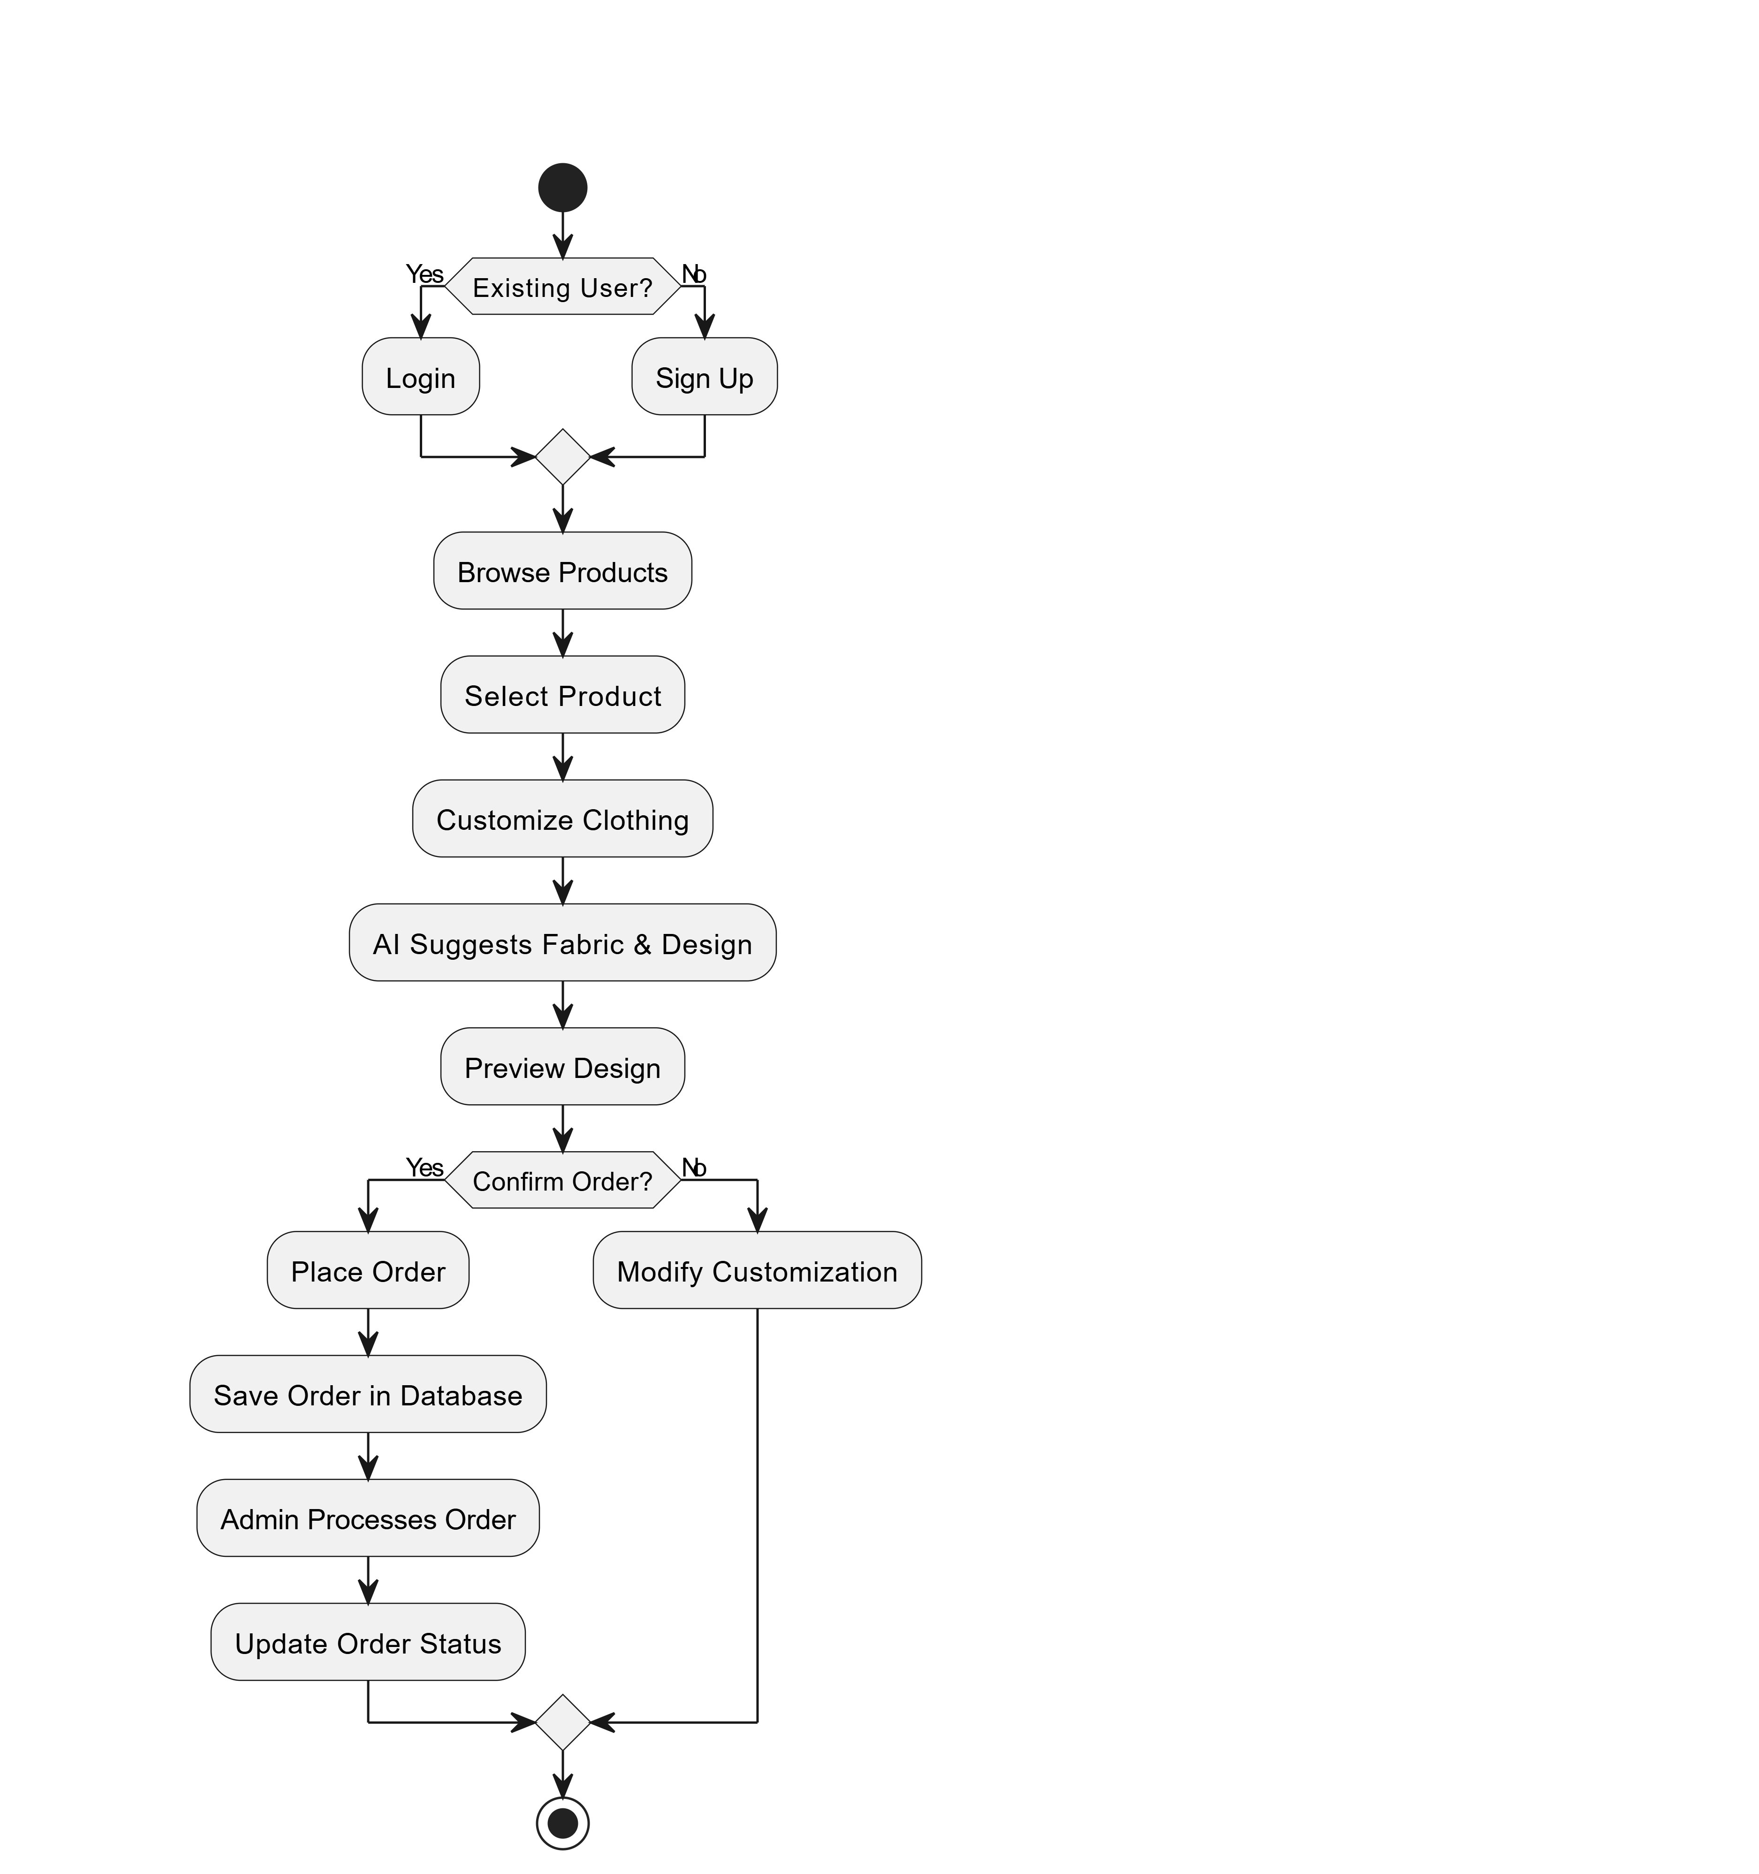
Figure 1: Activity Diagram — Customer Order Flow

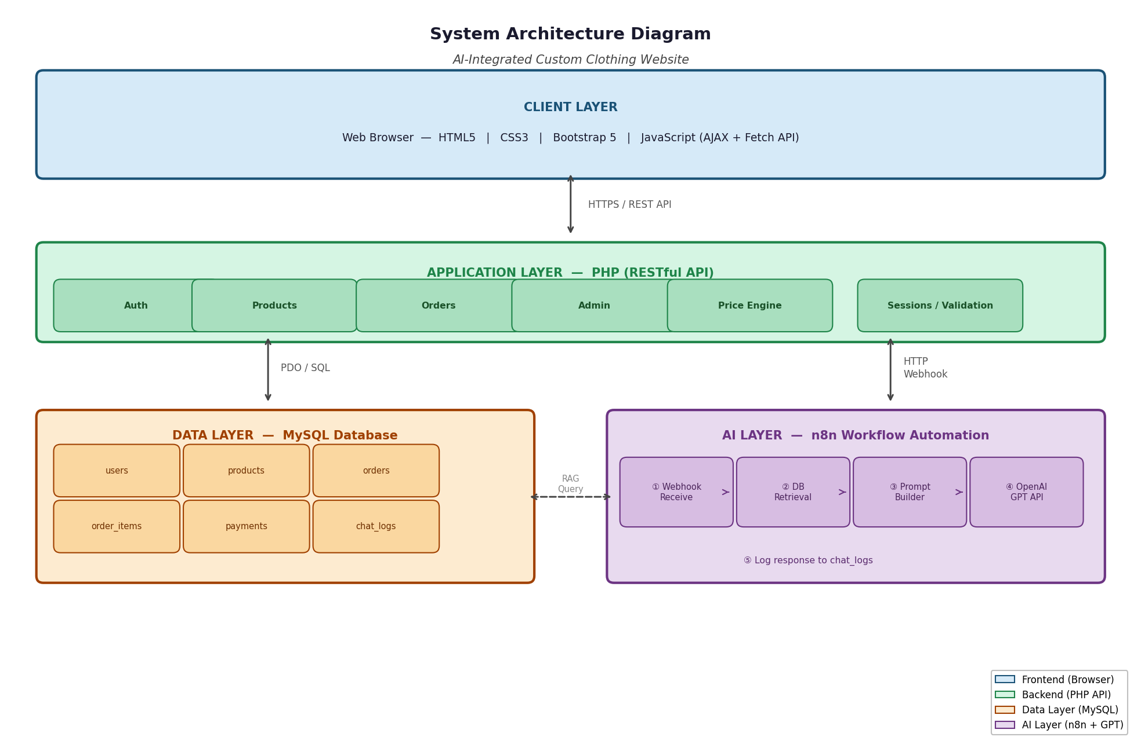
Figure 2: System Architecture Diagram — 4-Tier Layered Architecture

1.11 Process Model Used
AURA-WEAR was developed using the Agile Incremental process model. This approach allowed the team to deliver working software in short, iterative sprints while continuously incorporating feedback and refining requirements.
Sprint 1 (Weeks 1–3) — Foundation: Project setup, technology stack finalization, database schema design, FastAPI project structure, basic authentication (register/login/JWT), and initial product catalog API.
Sprint 2 (Weeks 4–6) — Core Features: 2D Canvas customization engine, dynamic pricing logic, product catalog frontend, shopping cart implementation, and order placement workflow.
Sprint 3 (Weeks 7–9) — AI & Admin: n8n RAG pipeline integration, AI chatbot frontend, admin panel (product/order/customer management), analytics dashboard, and payment integration (COD + PayFast).
Sprint 4 (Weeks 10–12) — Testing & Deployment: Comprehensive testing (56 test cases), bug fixing, performance optimization, Railway.app deployment, documentation, and user manual preparation.

1.12 Modelling Techniques / Tools Used
- Use Case Diagrams: To capture functional requirements and actor interactions for all 8 modules.
- Fully Dressed Use Cases: Detailed specifications with main success scenarios and alternative/exception flows.
- Domain Model: To identify key entities and their relationships in the problem domain.
- System Sequence Diagrams (SSDs): To illustrate interactions between actors and the system for each use case.
- Class Diagrams: To represent the software architecture including classes, attributes, methods, and associations.
- Entity-Relationship (ER) Diagram: To design the relational database schema.

Modelling and development tools used:
- draw.io: UML diagrams (use case, class, ER, SSDs, domain model).
- Visual Studio Code: Primary code editor for Python and JavaScript development.
- Postman: REST API testing and documentation.
- GitHub: Version control and remote repository hosting.
- Railway.app Dashboard: Deployment monitoring and environment variable management.
- n8n Canvas: Visual workflow builder for the RAG AI pipeline.

1.13 Limitation / Constraint
- Web Browser Only: AURA-WEAR is a web application and does not have a dedicated native mobile application for iOS or Android.
- Payment Methods: Only Cash on Delivery (COD) and PayFast are supported. Stripe integration was deferred due to regional API restrictions.
- AI Chatbot Requires Internet: The chatbot depends on the n8n server and OpenAI API; offline operation is not supported.
- No Physical Store Integration: AURA-WEAR operates as an independent web platform with no integration with any physical retail system.
- Single Language: The platform is currently available in English only. Urdu and other regional language support is not included.
- No Real-Time Notifications: Push notifications are not implemented in this version; users must check order status manually.

1.14 References
[1] P. Loureiro, J. Bettencourt-Silva, and A. Trindade, "Artificial Intelligence in E-Commerce: A Systematic Literature Review," IEEE Access, vol. 10, pp. 12345–12360, 2022.
[2] T. Brown et al., "Language Models are Few-Shot Learners," in Proc. NeurIPS, 2020.
[3] Y. Gao et al., "Retrieval-Augmented Generation for Large Language Models: A Survey," arXiv preprint arXiv:2312.10997, 2023.
[4] S. Kim, J. Lee, and H. Park, "Personalized Fashion Recommendation Using Deep Learning and Visual Similarity," Journal of Fashion Technology & Textile Engineering, vol. 9, no. 3, 2021.
[5] FastAPI Documentation, Sebastián Ramírez, 2024. [Online]. Available: https://fastapi.tiangolo.com/
[6] n8n Documentation, n8n GmbH, 2024. [Online]. Available: https://docs.n8n.io/
[7] OpenAI API Reference, OpenAI, 2024. [Online]. Available: https://platform.openai.com/docs/

CHAPTER # 2:
ANALYSIS

2.1 Introduction

2.1.1 Purpose
This document defines the functional and non-functional requirements for the AURA-WEAR AI-Integrated Custom Clothing Website system. It serves as a formal contract between the development team and project stakeholders, providing a clear and unambiguous specification of all system features, constraints, and quality attributes.

2.1.2 Scope
The AURA-WEAR system encompasses three primary components: a customer-facing web portal, an administrative management panel, and an AI-powered chatbot assistant. The scope covers all 56 functional requirements organized into eight management modules. Explicitly out of scope: native mobile applications, physical store integration, and third-party marketplace API connections.

2.1.3 Definitions, Acronyms, and Abbreviations
Table 3: Glossary of Terms and Abbreviations
Term | Definition
RAG | Retrieval-Augmented Generation: AI technique combining information retrieval with language generation.
JWT | JSON Web Token: compact, URL-safe means of representing claims between parties.
OTP | One-Time Password: 6-digit numeric code sent to a user's registered email for verification.
2D Preview | Real-time Canvas-based visualization of the garment with applied customizations.
COD | Cash on Delivery: payment method where the customer pays upon receiving the product.
CRUD | Create, Read, Update, Delete: basic data operations.
API | Application Programming Interface: set of protocols for building software applications.
SRS | Software Requirements Specification: document describing system requirements.
ORM | Object-Relational Mapper: tool that maps database tables to Python classes.
UML | Unified Modeling Language: standardized modeling language for software design.
DTG | Direct to Garment: printing technique that applies ink directly to fabric.
HTTPS | Hypertext Transfer Protocol Secure: encrypted version of HTTP using TLS.
TLS | Transport Layer Security: cryptographic protocol for secure internet communications.

2.1.4 Overview
This chapter presents the complete set of Functional Requirements (Section 2.2) organized into eight management modules, followed by Non-Functional Requirements (Section 2.3) covering performance, security, reliability, and other quality attributes, and External Interface Requirements (Section 2.4) covering user, hardware, software, and communication interfaces.

2.2 Functional Requirements
This section enumerates all functional requirements for the AURA-WEAR system. Requirements are grouped into eight modules corresponding to major system features.

2.2.1 Security Management

2.2.1.1 Process SignUp
The system shall allow new users to register by providing their full name, email address, and password. The system validates the email format using a standard regex pattern and enforces a minimum password strength requirement of 8 characters including at least one numeric digit. The email is checked for uniqueness before the bcrypt-hashed password and user record are saved to the database. A success message is displayed and the user is redirected to the login page.

2.2.1.2 Process SignIn
Registered users shall authenticate using their email and password. The system retrieves the stored bcrypt hash, verifies the entered password, and generates a JWT token with 30-minute expiry (7 days if "Remember Me" is checked). The token is stored in browser localStorage and the user is redirected to the appropriate dashboard.

2.2.1.3 Forgot Password
Users can initiate a password reset by entering their registered email. The system generates a cryptographically random 6-digit OTP with a 10-minute expiry and sends it via Gmail SMTP. The system confirms OTP dispatch without revealing whether the email is registered.

2.2.1.4 Change Account Password
Authenticated users can change their password from profile settings. The system verifies the current password, validates the new password strength, hashes the new password with bcrypt, updates the database, and invalidates all other active sessions.

2.2.1.5 JWT Authentication
All protected API endpoints require a valid Bearer JWT token in the HTTP Authorization header. The system validates the token signature, checks expiry, and extracts the user ID and role from the payload. Requests without a valid token receive HTTP 401 Unauthorized.

2.2.1.6 OTP Verification
The system generates and validates 6-digit numeric OTPs for password reset and account verification workflows. Each OTP has a 10-minute expiry and is invalidated after first use. After three failed attempts, the OTP is automatically invalidated.

2.2.1.7 Role-Based Access Control
The system implements two roles: Customer and Admin. Customers access the public portal; Admins access the management panel. Unauthorized role access returns HTTP 403 Forbidden.

2.2.1.8 Session Management
JWT tokens are persisted in browser localStorage. Every API call validates the token; upon expiry or inactivity (30 minutes), the system clears localStorage and redirects to the login page.

2.2.2 User Profile Management

2.2.2.1 Add Customer Profile
After registration, customers can add supplementary profile information: phone number, full delivery address, city, and profile picture. Profile pictures are uploaded to Cloudinary.

2.2.2.2 Update Customer Profile
Authenticated customers can modify profile information including display name, phone number, delivery address, city, and profile picture through the Profile Settings page.

2.2.2.3 View Customer Profile
Customers can view their consolidated profile including personal details, profile picture, total order count, and registration date.

2.2.2.4 Manage Customer Account Status
Admins can activate or deactivate customer accounts from the admin panel. Deactivated accounts have all active JWT tokens invalidated.

2.2.3 Product Catalog Management

2.2.3.1 Add New Product
Admins can add products by specifying name, category (T-Shirt, Hoodie, Jacket, Sports Uniform), description, base price, size options, available colors, and product images (uploaded to Cloudinary).

2.2.3.2 Update Product Details
Admins can edit any product attribute including name, description, category, base price, size options, and images.

2.2.3.3 Enable or Disable Product
Admins can toggle product availability. Disabled products are excluded from all customer-facing catalog pages.

2.2.3.4 Search Product
Both customers and admins can search products using keyword matching against product names and categories using a LIKE query pattern.

2.2.3.5 View All Products
Customers can browse the complete product catalog organized by category sections. Each product card shows name, primary image, base price, and available sizes.

2.2.3.6 Filter Products by Category
The catalog provides category filter controls allowing customers to restrict displayed products to T-Shirts, Hoodies, Jackets, or Sports Uniforms.

2.2.4 Product Customization

2.2.4.1 Select Fabric Type
Customers can select from Cotton, Polyester, Blended, and Fleece fabrics. Each selection updates the dynamic price in real time.

2.2.4.2 Select Color
Customers can choose the base garment color using an integrated color picker supporting predefined palette and direct hex code entry. The 2D Canvas preview updates instantly.

2.2.4.3 Upload Custom Logo
Customers can upload a PNG or JPG logo (max 5MB) and specify placement (chest, back, sleeve). The logo appears on the 2D Canvas preview.

2.2.4.4 Select Stitching Style
Customers select from Flatlock, Overlock, and Chain Stitch options. Each adds a defined price premium.

2.2.4.5 Select Print Method
Customers choose from Screen Print, Direct to Garment (DTG), Embroidery, and Heat Transfer. Each option has a different pricing tier.

2.2.4.6 Select Wash Effect
Customers select from Standard, Stone Wash, Acid Wash, and Enzyme Wash finishing treatments.

2.2.4.7 View Real-Time 2D Design Preview
The Canvas-based preview renders the garment silhouette, applies the selected color, positions the uploaded logo, and updates with every customization change.

2.2.4.8 Calculate Dynamic Price
The system automatically computes and displays the total price in real time by summing the base price with add-on costs for fabric, stitching, print method, and wash effect.

2.2.5 AI Chatbot Management

2.2.5.1 Send Query to Chatbot
Customers access the AI chatbot through a floating widget available on all pages. Queries are sent to the n8n RAG pipeline for processing.

2.2.5.2 Get AI Design Recommendation (RAG)
The chatbot uses a RAG pipeline that retrieves relevant product documents from ChromaDB and passes them as context to GPT-4o-mini for generating personalized design recommendations.

2.2.5.3 View FAQ via Chatbot
The chatbot answers frequently asked questions about delivery, returns, care instructions, and bulk pricing using the FAQ knowledge base.

2.2.5.4 View Chat History
All chatbot conversations are persisted with user ID, message content, sender role, and timestamp. Authenticated customers can review past conversations.

2.2.5.5 Admin Manage FAQ Entries
Admins can create, update, and delete FAQ entries through the admin panel. Changes are reflected immediately in chatbot responses.

2.2.6 Order Management

2.2.6.1 Create New Order
Customers place orders by adding customized items to cart and proceeding to checkout. All customization specifications are captured in the order record.

2.2.6.2 Search Order History
Customers can search their order history by Order ID, product name, or date range. Admins have access to a global order search across all customers.

2.2.6.3 View Order History
Customers view a paginated list of all orders showing Order ID, product name, order date, status, and total amount.

2.2.6.4 Cancel Order
Customers can cancel orders still in Pending status. The system updates order status to Cancelled and logs the cancellation timestamp.

2.2.6.5 Track Order Status
Each order progresses through five stages: Pending → In Production → Quality Check → Shipped → Delivered. Customers view the current status on the Order Detail page.

2.2.6.6 Reorder Previous Order
Customers can reorder any completed order. The system pre-populates the customization form with all specifications from the original order.

2.2.7 Payment Management

2.2.7.1 Record Online Payment
The system integrates with PayFast to process online payments. Upon successful authorization, a transaction record is created and the order status updated.

2.2.7.2 Record Cash on Delivery
COD orders are marked as COD-Pending at checkout. Upon delivery confirmation by admin, the payment status is updated to Completed.

2.2.7.3 Generate Digital Receipt
Upon order placement, the system auto-generates and displays a digital receipt including order ID, itemized list, subtotal, and total amount.

2.2.7.4 View All Payments and Transactions
Customers view their payment history with dates, amounts, order IDs, and payment methods. Admins access a global transaction ledger.

2.2.7.5 Download Invoice
Customers can download a PDF invoice for any completed order including AURA-WEAR business details, customer information, and itemized order summary.

2.2.8 Admin Dashboard Management

2.2.8.1 Manage Products (Admin)
Admin performs full CRUD operations on product records including bulk CSV import and export.

2.2.8.2 Manage Customer Accounts (Admin)
Admin views a searchable, paginated customer list and can activate/deactivate accounts.

2.2.8.3 View and Update Order Management (Admin)
Admin accesses all orders, views details, and updates order status through the production pipeline.

2.2.8.4 View Inventory and Stock Alerts (Admin)
The dashboard monitors material stock quantities and alerts admins when items fall below defined thresholds.

2.2.8.5 Generate Sales Report
Admin generates monthly or annual sales reports showing revenue, order counts, and category breakdowns, exportable as PDF or CSV.

2.2.8.6 Generate Order Report
Admin generates order reports filtered by date range, status, or category showing summary breakdowns and trend analysis.

2.2.8.7 View Analytics Dashboard
The main admin dashboard displays real-time charts for daily orders, weekly revenue, product category distribution, and customer acquisition trends.

2.2.8.8 Send Notification to Customers
Admin composes and sends email notifications to all customers (bulk) or specific customers by ID or category.

2.2.8.9 Manage Content (Terms, Privacy, FAQ)
Admin updates Terms & Conditions, Privacy Policy, and FAQ sections through a rich-text editor. Changes are immediately visible to customers.

2.2.8.10 Manage Coupon/Promo Codes
Admin creates promotional codes specifying discount type (percentage or fixed), value, usage limits, and validity dates.

2.2.8.11 Export Data as CSV
Admin exports customer lists, order records, payment transactions, and inventory data as CSV files for external analysis.

2.3 Non-Functional Requirements

2.3.1 Performance Requirements
The web portal shall load any page within 3 seconds on a standard broadband connection (minimum 10 Mbps). The 2D customization preview shall reflect changes within 100ms. The FastAPI backend shall handle a minimum of 50 concurrent user sessions without degradation. AI chatbot responses shall be delivered within 3 seconds for typical queries.

2.3.2 Usability Requirements
The interface shall be fully responsive across screen widths from 320px (mobile) to 1920px (widescreen). All primary user flows shall be completable within 5 user interactions. Error messages shall be clear, specific, and actionable.

2.3.3 Security Requirements
All passwords shall be hashed using bcrypt (cost factor ≥ 10). All database queries shall use parameterized statements to prevent SQL injection. All API endpoints shall implement input validation. User data shall never be transmitted in plaintext.

2.3.4 Reliability Requirements
The system shall target 99% uptime monthly (≤7.3 hours unplanned downtime). All database write operations shall be wrapped in transactions with rollback capability. The system shall implement comprehensive error logging.

2.3.5 Scalability Requirements
The FastAPI backend shall be stateless to support horizontal scaling. The database schema shall support up to 100,000 user records and 500,000 order records without schema changes.

2.3.6 Maintainability & Support Requirements
The codebase shall follow MVC architectural pattern with clear separation of concerns. All FastAPI endpoints shall be documented using auto-generated OpenAPI/Swagger. Database migrations shall use Alembic version control.

2.3.7 Compatibility Requirements
The web application shall be compatible with the two most recent major versions of Chrome, Firefox, Safari, and Edge browsers. The application shall function correctly on devices with a minimum screen width of 320 pixels.

2.3.8 Support Requirements
The admin panel shall empower the admin to perform all routine operations without developer intervention. The system shall include a comprehensive user manual covering all screen interactions and workflows.

2.4 External Interface Requirements

2.4.1 User Interfaces
The AURA-WEAR system provides a responsive web interface built with HTML5, CSS3, and Vanilla JavaScript. The design adopts a clean, minimalist aesthetic emphasizing product imagery. The 2D Canvas customization panel occupies the right side of the customizer screen. The AI chatbot appears as a floating widget on all pages.

2.4.2 Hardware Interfaces
The system requires no specialized hardware beyond a standard device capable of running a supported web browser. Image uploads require a device with file access capabilities. No proprietary hardware dependencies exist.

2.4.3 Software Interfaces
FastAPI REST API: Primary interface between frontend and backend (JSON over HTTP). OpenAI GPT-4o-mini API: AI response generation via n8n workflows. PayFast Payment Gateway API: Payment processing for online transactions. Gmail SMTP: OTP delivery via email. Cloudinary API: Image upload and storage. ChromaDB: Vector database for RAG semantic search.

2.4.4 Communication Interfaces
All client-server communication uses HTTPS with TLS 1.3. REST API calls use JSON payloads with proper Content-Type headers. The n8n webhook integration uses HTTPS POST requests. Email notifications use SMTP over port 587 with STARTTLS.

CHAPTER # 3:
DESIGN

3.1 Use Case Diagram
The Use Case Diagram for AURA-WEAR illustrates the interactions between the system actors (Customer and Admin) and the system's eight functional modules. The diagram captures all 56 use cases distributed across Security Management, User Profile Management, Product Catalog Management, Product Customization, AI Chatbot Management, Order Management, Payment Management, and Admin Dashboard Management.
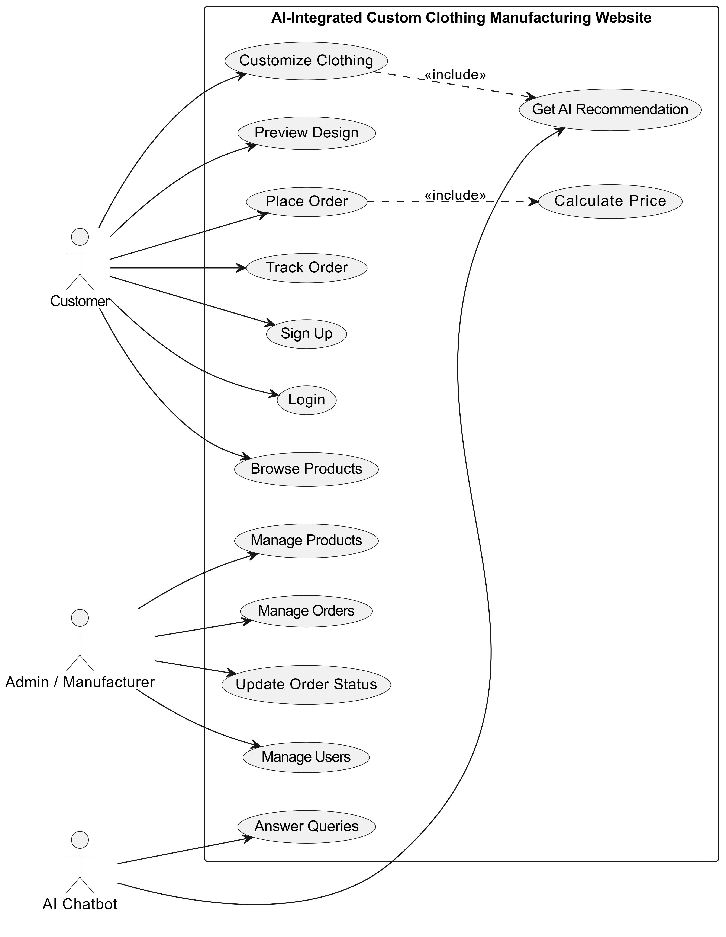
Figure 3: Use Case Diagram — AURA-WEAR AI-Integrated Custom Clothing Website

3.2 Fully Dressed Use Cases
The following fully dressed use cases describe the detailed interaction specifications for all 56 functional requirements of the AURA-WEAR system. Each use case includes the use case ID, name, actor(s), pre-conditions, post-conditions, main flow, alternative flow, and exception flow.

UC-01: Process SignUp
Table UC-01: Use Case — Process SignUp
Use Case ID | UC-01
Use Case Name | Process SignUp
Actor(s) | Customer
Pre-Conditions | User not registered; internet connection available
Post-Conditions | New account created; user redirected to login page
Main Flow | 1. User navigates to the registration page.  2. User enters full name, email address, and password.  3. User clicks the Register button.  4. System validates email format and password strength (min 8 chars, at least one number).  5. System checks if email is already registered.  6. System hashes the password using bcrypt and saves the user record to the database.  7. System displays a success message and redirects to the login page.
Alternative Flow | If email already exists, system displays "Email already registered" error without saving.
Exception Flow | If database error occurs, system displays "Registration failed. Please try again." and logs the error.

UC-02: Process SignIn
Table UC-02: Use Case — Process SignIn
Use Case ID | UC-02
Use Case Name | Process SignIn
Actor(s) | Customer / Admin
Pre-Conditions | User has a registered account; credentials are correct
Post-Conditions | User is authenticated; JWT token issued; user redirected to dashboard
Main Flow | 1. User navigates to the sign-in page.  2. User enters registered email and password.  3. User clicks the Sign In button.  4. System validates input fields are not empty.  5. System queries the database for the email.  6. System verifies the bcrypt password hash.  7. System generates a JWT token with 30-minute expiry.  8. System stores the token in localStorage and redirects to the appropriate dashboard.
Alternative Flow | If remember me is checked, token expiry is extended to 7 days.
Exception Flow | If credentials are invalid, display "Invalid email or password" without revealing which field is wrong.

UC-03: Forgot Password
Table UC-03: Use Case — Forgot Password
Use Case ID | UC-03
Use Case Name | Forgot Password
Actor(s) | Customer
Pre-Conditions | User has a registered account; email address is valid
Post-Conditions | OTP sent to user's email; password reset initiated
Main Flow | 1. User clicks "Forgot Password" on the login page.  2. System displays the Forgot Password form.  3. User enters their registered email address.  4. User clicks Submit.  5. System verifies the email exists in the database.  6. System generates a random 6-digit OTP with 10-minute expiry.  7. System sends the OTP to the user's email via Gmail SMTP.  8. System displays "OTP sent to your email address."
Alternative Flow | If email not found, display "No account associated with this email."
Exception Flow | If email service fails, display "Unable to send OTP. Please try again later."

UC-04: Change Account Password
Table UC-04: Use Case — Change Account Password
Use Case ID | UC-04
Use Case Name | Change Account Password
Actor(s) | Customer
Pre-Conditions | User is authenticated; current password is known
Post-Conditions | Password updated successfully in the database
Main Flow | 1. Authenticated user navigates to Profile Settings.  2. User clicks "Change Password."  3. System displays the Change Password form.  4. User enters current password, new password, and confirmation.  5. System verifies the current password hash.  6. System validates new password meets strength requirements.  7. System hashes the new password and updates the database.  8. System displays "Password changed successfully" and logs out all other sessions.
Alternative Flow | If confirmation does not match, display "Passwords do not match."
Exception Flow | If current password is incorrect, display "Current password is wrong."

UC-05: JWT Authentication
Table UC-05: Use Case — JWT Authentication
Use Case ID | UC-05
Use Case Name | JWT Authentication
Actor(s) | System (automatic)
Pre-Conditions | User is making a request to a protected endpoint
Post-Conditions | Request is allowed or rejected based on token validity
Main Flow | 1. Client sends HTTP request with Bearer JWT in Authorization header.  2. FastAPI middleware intercepts the request.  3. System extracts and decodes the JWT token.  4. System validates token signature using the secret key.  5. System checks token expiry timestamp.  6. If valid, system extracts user ID and role from token payload.  7. System attaches user context to the request and proceeds to the endpoint handler.
Alternative Flow | If token is missing, return HTTP 401 Unauthorized.
Exception Flow | If token is expired, return HTTP 401 with message "Session expired. Please sign in again."

UC-06: OTP Verification
Table UC-06: Use Case — OTP Verification
Use Case ID | UC-06
Use Case Name | OTP Verification
Actor(s) | Customer
Pre-Conditions | OTP has been sent to user's email; OTP has not expired
Post-Conditions | OTP validated; user proceeds to reset password form
Main Flow | 1. User receives OTP in email.  2. User navigates to the OTP verification screen.  3. User enters the 6-digit OTP.  4. User clicks Verify.  5. System retrieves stored OTP and expiry from database.  6. System compares entered OTP with stored value.  7. System checks OTP has not expired (within 10 minutes).  8. If valid, system marks OTP as used and redirects user to Reset Password form.
Alternative Flow | If OTP is incorrect, display "Invalid OTP. Please try again." (max 3 attempts).
Exception Flow | If OTP expired, display "OTP has expired. Please request a new one."

UC-07: Role-Based Access Control
Table UC-07: Use Case — Role-Based Access Control
Use Case ID | UC-07
Use Case Name | Role-Based Access Control
Actor(s) | System (automatic)
Pre-Conditions | User is authenticated with a JWT token
Post-Conditions | Access granted or denied based on user role
Main Flow | 1. System receives request from authenticated user.  2. System extracts role from JWT payload (Customer or Admin).  3. System checks the requested endpoint's required role.  4. If user role matches required role, access is granted.  5. Request proceeds to the handler function.  6. Response is returned to the user.
Alternative Flow | If Customer tries to access Admin endpoint, system returns HTTP 403 Forbidden.
Exception Flow | If role field is missing from JWT, treat as unauthorized and return HTTP 401.

UC-08: Session Management
Table UC-08: Use Case — Session Management
Use Case ID | UC-08
Use Case Name | Session Management
Actor(s) | Customer / Admin
Pre-Conditions | User is signed in; JWT token stored in localStorage
Post-Conditions | Session maintained or expired; user redirected to login if expired
Main Flow | 1. User performs any action on the website.  2. Browser sends JWT token with every API request.  3. System validates token on each request.  4. If token is valid and not expired, session continues.  5. System tracks last activity timestamp.  6. If 30 minutes of inactivity, token is invalidated.  7. Next request returns HTTP 401; frontend detects this.  8. Frontend clears localStorage and redirects to login page with notification.
Alternative Flow | If user clicks Logout manually, token is cleared from localStorage immediately.
Exception Flow | If localStorage is unavailable, session defaults to in-memory with tab-close expiry.

UC-09: Add Customer Profile
Table UC-09: Use Case — Add Customer Profile
Use Case ID | UC-09
Use Case Name | Add Customer Profile
Actor(s) | Customer
Pre-Conditions | Customer is registered and signed in; profile not yet completed
Post-Conditions | Profile information saved to database; profile marked as complete
Main Flow | 1. Customer navigates to their Profile page after first login.  2. System displays the Complete Profile form.  3. Customer enters phone number, delivery address, city, and optionally uploads a profile picture.  4. Customer clicks Save Profile.  5. System validates phone number format.  6. If profile picture uploaded, system stores it in Cloudinary.  7. System saves all profile data linked to user ID.  8. System displays "Profile saved successfully."
Alternative Flow | Customer can skip profile completion and complete it later.
Exception Flow | If image upload fails, profile saved without picture with a warning message.

UC-10: Update Customer Profile
Table UC-10: Use Case — Update Customer Profile
Use Case ID | UC-10
Use Case Name | Update Customer Profile
Actor(s) | Customer
Pre-Conditions | Customer is signed in; profile exists
Post-Conditions | Updated profile saved to database
Main Flow | 1. Customer navigates to Profile Settings.  2. System displays current profile information in editable form.  3. Customer modifies desired fields (name, phone, address, city, picture).  4. Customer clicks Update.  5. System validates modified fields.  6. If new profile picture selected, old image deleted from Cloudinary, new one uploaded.  7. System updates the user record in database.  8. System displays "Profile updated successfully."
Alternative Flow | If no changes made, display "No changes detected."
Exception Flow | If validation fails on any field, display field-specific error messages.

UC-11: View Customer Profile
Table UC-11: Use Case — View Customer Profile
Use Case ID | UC-11
Use Case Name | View Customer Profile
Actor(s) | Customer
Pre-Conditions | Customer is signed in
Post-Conditions | Profile information displayed to the customer
Main Flow | 1. Customer clicks on their profile icon or navigates to Profile page.  2. System fetches user data from the database using JWT-extracted user ID.  3. System retrieves profile picture URL from Cloudinary.  4. System fetches order count from orders table.  5. System displays profile page with personal details, profile picture, order count, and registration date.  6. Edit Profile and Change Password buttons are displayed.
Alternative Flow | If profile is incomplete, display a prompt to complete the profile.
Exception Flow | If data fetch fails, display cached profile data with a reload option.

UC-12: Manage Customer Account Status
Table UC-12: Use Case — Manage Customer Account Status
Use Case ID | UC-12
Use Case Name | Manage Customer Account Status
Actor(s) | Admin
Pre-Conditions | Admin is signed in; customer accounts exist in the system
Post-Conditions | Account status updated; customer notified if deactivated
Main Flow | 1. Admin navigates to Customer Management in admin panel.  2. System displays list of all customers with status indicators.  3. Admin searches for or selects a customer.  4. Admin clicks Activate or Deactivate.  5. System prompts for confirmation.  6. Admin confirms the action.  7. System updates account status in the database.  8. If deactivated, system invalidates all active JWT tokens for that user.  9. System logs the admin action.
Alternative Flow | Admin can filter customers by active/inactive status.
Exception Flow | Admin cannot deactivate another admin account.

UC-13: Add New Product
Table UC-13: Use Case — Add New Product
Use Case ID | UC-13
Use Case Name | Add New Product
Actor(s) | Admin
Pre-Conditions | Admin is signed in; product details are ready
Post-Conditions | New product saved to database; visible in catalog
Main Flow | 1. Admin navigates to Product Management > Add Product.  2. Admin enters product name, category, description, and base price.  3. Admin selects available sizes (XS to XXL).  4. Admin uploads one or more product images.  5. Admin sets fabric options and available customization options.  6. Admin clicks Save Product.  7. System validates all required fields.  8. System uploads images to Cloudinary.  9. System saves product record to database with Active status.
Alternative Flow | Admin can save as Draft to publish later.
Exception Flow | If image upload fails, prompt admin to retry without saving other fields.

UC-14: Update Product Details
Table UC-14: Use Case — Update Product Details
Use Case ID | UC-14
Use Case Name | Update Product Details
Actor(s) | Admin
Pre-Conditions | Admin is signed in; product exists in catalog
Post-Conditions | Product details updated in database; changes reflected in catalog
Main Flow | 1. Admin navigates to Product Management and selects a product.  2. System displays product edit form with current details.  3. Admin modifies desired fields (name, price, description, sizes, images).  4. Admin clicks Update Product.  5. System validates modified fields.  6. If new images added, they are uploaded to Cloudinary.  7. System updates the product record in the database.  8. System displays "Product updated successfully."
Alternative Flow | Admin can cancel edit and return to product list without changes.
Exception Flow | If price set to zero or negative, display "Price must be greater than 0."

UC-15: Enable or Disable Product
Table UC-15: Use Case — Enable or Disable Product
Use Case ID | UC-15
Use Case Name | Enable or Disable Product
Actor(s) | Admin
Pre-Conditions | Admin is signed in; product exists
Post-Conditions | Product status toggled; catalog updated accordingly
Main Flow | 1. Admin navigates to Product Management.  2. Admin locates the product by searching or scrolling.  3. Admin clicks the Enable/Disable toggle next to the product.  4. System prompts for confirmation.  5. Admin confirms.  6. System updates product status in database.  7. Disabled products are hidden from the customer catalog.  8. Admin panel shows updated status indicator.
Alternative Flow | Admin can enable/disable multiple products using bulk action checkboxes.
Exception Flow | If product has active pending orders, system warns but allows disable.

UC-16: Search Product
Table UC-16: Use Case — Search Product
Use Case ID | UC-16
Use Case Name | Search Product
Actor(s) | Customer / Admin
Pre-Conditions | Product catalog has at least one active product
Post-Conditions | Search results displayed matching the query
Main Flow | 1. User enters a keyword in the search bar.  2. User presses Enter or clicks the Search icon.  3. System queries the database for products where name or description contains the keyword.  4. System returns matching results.  5. Results are displayed in a product grid.  6. If no results, display "No products found for your search."
Alternative Flow | Admin search includes disabled products in results (marked differently).
Exception Flow | If search query is empty, display all active products.

UC-17: View All Products
Table UC-17: Use Case — View All Products
Use Case ID | UC-17
Use Case Name | View All Products
Actor(s) | Customer
Pre-Conditions | Customer is on the product catalog page; at least one active product exists
Post-Conditions | Product catalog displayed with all active products
Main Flow | 1. Customer navigates to the Products page.  2. System queries database for all active products.  3. System retrieves product images from Cloudinary URLs.  4. System displays products in a responsive grid (3 columns on desktop, 1 on mobile).  5. Each product card shows name, image, base price, and available categories.  6. Customer can click any product to view its details.
Alternative Flow | If no products available, display "No products currently available."
Exception Flow | If image URLs fail to load, display a placeholder image.

UC-18: Filter Products by Category
Table UC-18: Use Case — Filter Products by Category
Use Case ID | UC-18
Use Case Name | Filter Products by Category
Actor(s) | Customer
Pre-Conditions | Product catalog page is loaded; multiple categories exist
Post-Conditions | Filtered products displayed matching the selected category
Main Flow | 1. Customer clicks on a category filter button (T-Shirts, Hoodies, Jackets, Sports Uniforms).  2. System highlights the selected category filter.  3. System filters the product grid to show only products in the selected category.  4. System updates the product count display.  5. Customer can clear filter to show all products.  6. Multiple categories can be selected simultaneously.
Alternative Flow | If selected category has no products, display "No products in this category."
Exception Flow | Filter state is preserved if user navigates back to catalog.

UC-19: Select Fabric Type
Table UC-19: Use Case — Select Fabric Type
Use Case ID | UC-19
Use Case Name | Select Fabric Type
Actor(s) | Customer
Pre-Conditions | Customer has selected a product for customization
Post-Conditions | Fabric type recorded; price updated dynamically
Main Flow | 1. Customer is on the product customization page.  2. System displays available fabric options for the product (Cotton, Polyester, Blended, Fleece).  3. Customer clicks on the desired fabric type.  4. Selected fabric is highlighted.  5. System calculates fabric price premium.  6. System updates the dynamic price display.  7. Fabric selection is stored in the customization state.
Alternative Flow | If only one fabric is available, it is pre-selected and not changeable.
Exception Flow | If fabric stock is unavailable, option is shown as greyed out.

UC-20: Select Color
Table UC-20: Use Case — Select Color
Use Case ID | UC-20
Use Case Name | Select Color
Actor(s) | Customer
Pre-Conditions | Customer is on the customization page; fabric type selected
Post-Conditions | Color choice recorded; 2D preview updated with new color
Main Flow | 1. Customer views the color selection panel.  2. System displays a color picker with preset color swatches.  3. Customer selects a preset color or enters a hex code.  4. System validates the hex code format.  5. System updates the 2D Canvas preview to show the garment in the selected color.  6. Color value is stored in the customization state.  7. No additional price change for color selection.
Alternative Flow | Customer can type a hex code directly into the input field.
Exception Flow | If invalid hex code entered, revert to the last valid color.

UC-21: Upload Custom Logo
Table UC-21: Use Case — Upload Custom Logo
Use Case ID | UC-21
Use Case Name | Upload Custom Logo
Actor(s) | Customer
Pre-Conditions | Customer is on the customization page
Post-Conditions | Logo uploaded; displayed on 2D preview at specified position
Main Flow | 1. Customer clicks "Upload Logo" in the customization panel.  2. System opens file picker (accepts PNG and JPG, max 5MB).  3. Customer selects their logo file.  4. System validates file type and size.  5. System uploads the file and generates a preview URL.  6. Customer selects logo placement (Left Chest, Center, Back).  7. System overlays the logo on the 2D Canvas preview at the chosen position.  8. Logo reference stored in customization state.
Alternative Flow | Customer can remove the logo by clicking the Remove Logo button.
Exception Flow | If file exceeds 5MB, display "File too large. Maximum size is 5MB."

UC-22: Select Stitching Style
Table UC-22: Use Case — Select Stitching Style
Use Case ID | UC-22
Use Case Name | Select Stitching Style
Actor(s) | Customer
Pre-Conditions | Customer is on the customization page
Post-Conditions | Stitching style recorded in customization state
Main Flow | 1. Customer views the Stitching Style section on the customization panel.  2. System displays available options: Flatlock, Overlock, Chain Stitch with brief descriptions.  3. Customer clicks on the desired stitching style.  4. Selected option is highlighted with a checkmark.  5. System updates the dynamic price based on the stitching premium.  6. Selection is stored in the customization state.
Alternative Flow | If no stitching preference, default to Flatlock.
Exception Flow | No exception: all stitching options are always available.

UC-23: Select Print Method
Table UC-23: Use Case — Select Print Method
Use Case ID | UC-23
Use Case Name | Select Print Method
Actor(s) | Customer
Pre-Conditions | Customer is on the customization page
Post-Conditions | Print method recorded; price updated
Main Flow | 1. Customer views the Print Method section.  2. System displays options: Screen Print, DTG (Direct to Garment), Embroidery, Heat Transfer.  3. Each option shows a price premium.  4. Customer selects a print method.  5. System records the selection.  6. System updates the dynamic price calculation to include the print method cost.  7. 2D preview may show a texture hint for embroidery selection.
Alternative Flow | Customer can hover over each option to see a description tooltip.
Exception Flow | No exception: all print methods are standard options.

UC-24: Select Wash Effect
Table UC-24: Use Case — Select Wash Effect
Use Case ID | UC-24
Use Case Name | Select Wash Effect
Actor(s) | Customer
Pre-Conditions | Customer is on the customization page; base garment color selected
Post-Conditions | Wash effect recorded; 2D preview updated to reflect effect
Main Flow | 1. Customer views the Wash Effect section.  2. System displays options: Standard, Stone Wash, Acid Wash, Enzyme Wash.  3. Customer clicks on the desired effect.  4. System applies a visual filter to the 2D Canvas preview to simulate the wash effect.  5. Selection is stored in the customization state.  6. Price update applied if premium wash selected.
Alternative Flow | Default is Standard (no wash effect) if customer skips this section.
Exception Flow | If Canvas rendering fails, selection is still saved without visual update.

UC-25: View Real-Time 2D Design Preview
Table UC-25: Use Case — View Real-Time 2D Design Preview
Use Case ID | UC-25
Use Case Name | View Real-Time 2D Design Preview
Actor(s) | Customer
Pre-Conditions | Customer is on the customization page
Post-Conditions | Real-time 2D preview reflects all current customization selections
Main Flow | 1. Customer opens the product customization page.  2. System initializes the HTML5 Canvas with the product base template.  3. System renders the current garment color on the canvas.  4. As customer makes each customization selection (color, logo, wash), system updates the canvas in real time.  5. Logo is rendered at the selected placement position.  6. Wash effect filter is applied.  7. Customer can zoom in on the preview.  8. Customer can toggle between front and back views.
Alternative Flow | If browser does not support Canvas, display a static placeholder image.
Exception Flow | If preview rendering lags, debounce updates to 300ms after last user input.

UC-26: Calculate Dynamic Price
Table UC-26: Use Case — Calculate Dynamic Price
Use Case ID | UC-26
Use Case Name | Calculate Dynamic Price
Actor(s) | Customer (automatic)
Pre-Conditions | Customer is on the customization page; at least one customization made
Post-Conditions | Updated total price displayed in real time
Main Flow | 1. Customer makes any customization selection.  2. System triggers the price calculation function.  3. System starts with the base product price.  4. System adds fabric type premium (Cotton: +0%, Polyester: +5%, Blended: +10%, Fleece: +15%).  5. System adds print method cost (Screen Print: +PKR 300, DTG: +PKR 500, Embroidery: +PKR 800, Heat Transfer: +PKR 400).  6. System adds stitching premium if applicable.  7. System applies any active coupon code discount.  8. System displays updated total price in PKR.
Alternative Flow | If coupon code applied, show discounted price with original crossed out.
Exception Flow | If price calculation results in negative (unlikely), cap at base price.

UC-27: Send Query to Chatbot
Table UC-27: Use Case — Send Query to Chatbot
Use Case ID | UC-27
Use Case Name | Send Query to Chatbot
Actor(s) | Customer
Pre-Conditions | Customer is on any page of the website; chatbot widget is loaded
Post-Conditions | Query sent to n8n RAG pipeline; response displayed in chat window
Main Flow | 1. Customer clicks the chatbot bubble icon (floating button).  2. Chatbot widget opens with greeting message.  3. Customer types their query in the input field.  4. Customer presses Enter or clicks Send.  5. System sends the query to the n8n webhook endpoint.  6. n8n workflow processes the query through the RAG pipeline.  7. Response is returned as JSON.  8. System displays the AI response in the chat window with a typing animation.
Alternative Flow | If customer is not logged in, chatbot works in anonymous mode without history saving.
Exception Flow | If n8n endpoint is unreachable, display "AI assistant is temporarily unavailable."

UC-28: Get AI Design Recommendation (RAG)
Table UC-28: Use Case — Get AI Design Recommendation (RAG)
Use Case ID | UC-28
Use Case Name | Get AI Design Recommendation (RAG)
Actor(s) | Customer (via chatbot)
Pre-Conditions | Customer has sent a fabric or design-related query; n8n is running
Post-Conditions | Context-aware AI recommendation returned and displayed
Main Flow | 1. Customer asks a design question (e.g., "What fabric is best for summer hoodies?").  2. n8n receives query via webhook.  3. n8n Node 1 queries SQLite database for relevant fabric/product records matching query keywords.  4. n8n Node 2 formats the retrieved database context.  5. n8n Node 3 constructs OpenAI GPT-4o-mini prompt with query + database context.  6. n8n Node 4 calls OpenAI API and receives recommendation.  7. n8n returns formatted response to the website.  8. System displays the recommendation with relevant product suggestions.
Alternative Flow | If no relevant database records found, GPT responds from its general knowledge.
Exception Flow | If OpenAI API quota exceeded, display "AI recommendations temporarily unavailable. Please try again later."

UC-29: View FAQ via Chatbot
Table UC-29: Use Case — View FAQ via Chatbot
Use Case ID | UC-29
Use Case Name | View FAQ via Chatbot
Actor(s) | Customer
Pre-Conditions | Chatbot widget is open
Post-Conditions | FAQ response displayed
Main Flow | 1. Customer types FAQ question (e.g., "What is your return policy?").  2. n8n receives query.  3. n8n searches FAQ table in database for matching keywords.  4. System finds matching FAQ entry.  5. n8n returns the FAQ answer as formatted text.  6. System displays FAQ answer in chat window.  7. Related FAQ suggestions shown below the answer.
Alternative Flow | If no FAQ match, query is passed to GPT for general response.
Exception Flow | If FAQ table is empty, return generic support email response.

UC-30: View Chat History
Table UC-30: Use Case — View Chat History
Use Case ID | UC-30
Use Case Name | View Chat History
Actor(s) | Customer
Pre-Conditions | Customer is signed in; past chat sessions exist
Post-Conditions | Chat history displayed in chatbot interface
Main Flow | 1. Authenticated customer opens the chatbot widget.  2. System detects user is logged in via JWT.  3. System queries chat_logs table for user's previous conversations.  4. System loads last 20 conversation turns.  5. Chat history is displayed in the chat window above the input field.  6. User can scroll up to view older messages.  7. Clear History button available.
Alternative Flow | Anonymous users see empty history (no saving).
Exception Flow | If history load fails, show empty state with option to retry.

UC-31: Admin Manage FAQ Entries
Table UC-31: Use Case — Admin Manage FAQ Entries
Use Case ID | UC-31
Use Case Name | Admin Manage FAQ Entries
Actor(s) | Admin
Pre-Conditions | Admin is signed in
Post-Conditions | FAQ database updated
Main Flow | 1. Admin navigates to Content Management > FAQ.  2. System displays list of existing FAQ entries (question + answer pairs).  3. Admin can Add, Edit, or Delete entries.  4. Admin clicks Add FAQ.  5. Admin enters question and answer text.  6. Admin clicks Save.  7. System validates fields are not empty.  8. System saves new FAQ entry to database.  9. New entry immediately available in chatbot knowledge base.
Alternative Flow | Admin clicks Edit on existing FAQ and modifies text.
Exception Flow | If FAQ entry has special characters, system sanitizes before saving.

UC-32: Create New Order
Table UC-32: Use Case — Create New Order
Use Case ID | UC-32
Use Case Name | Create New Order
Actor(s) | Customer
Pre-Conditions | Customer signed in; customization complete; item in cart
Post-Conditions | Order created with unique ID; status set to Pending
Main Flow | 1. Customer reviews customization in cart.  2. Customer clicks Proceed to Checkout.  3. System displays order summary with customization details and total price.  4. Customer confirms delivery address.  5. Customer selects payment method (COD or online).  6. Customer clicks Place Order.  7. System generates unique alphanumeric Order ID.  8. System saves order and order_items records to database.  9. System sends order confirmation email.  10. System displays order confirmation page with Order ID.
Alternative Flow | Customer can edit cart before proceeding to checkout.
Exception Flow | If payment fails, order is not created and user is notified.

UC-33: Search Order History
Table UC-33: Use Case — Search Order History
Use Case ID | UC-33
Use Case Name | Search Order History
Actor(s) | Customer / Admin
Pre-Conditions | User is signed in; orders exist in database
Post-Conditions | Filtered order list displayed
Main Flow | 1. User navigates to Order History page.  2. User enters search term (Order ID, product name, or date).  3. System queries orders table with the search criteria.  4. For customers, results are filtered to their own orders only.  5. For admin, all orders are searchable.  6. Matching orders displayed in list with status and date.  7. User can click an order to view full details.
Alternative Flow | User can filter by status (Pending, In Production, Shipped, Delivered).
Exception Flow | If no orders match search, display "No orders found."

UC-34: View Order History
Table UC-34: Use Case — View Order History
Use Case ID | UC-34
Use Case Name | View Order History
Actor(s) | Customer
Pre-Conditions | Customer is signed in; at least one order exists
Post-Conditions | Order history list displayed with all order details
Main Flow | 1. Customer navigates to My Orders page.  2. System queries orders table for orders linked to the customer ID.  3. System orders results by date (newest first).  4. System displays each order with: Order ID, date, product name, status badge, and total.  5. Customer clicks an order to see full details.  6. Full details show customization specs (fabric, color, logo, stitching, print, wash).  7. Reorder button available on completed orders.
Alternative Flow | If no orders, display "You haven't placed any orders yet."
Exception Flow | If order data is inconsistent, show partial data with warning.

UC-35: Cancel Order
Table UC-35: Use Case — Cancel Order
Use Case ID | UC-35
Use Case Name | Cancel Order
Actor(s) | Customer / Admin
Pre-Conditions | Order exists with Pending status
Post-Conditions | Order status updated to Cancelled; customer notified
Main Flow | 1. Customer navigates to Order History and selects a Pending order.  2. Customer clicks Cancel Order.  3. System displays confirmation dialog.  4. Customer confirms cancellation.  5. System updates order status to Cancelled in database.  6. System records cancellation timestamp.  7. System sends cancellation confirmation email.  8. Order details page shows Cancelled status badge.
Alternative Flow | Admin can cancel orders at any status from admin panel.
Exception Flow | Orders with Shipped or Delivered status cannot be cancelled by customer.

UC-36: Track Order Status
Table UC-36: Use Case — Track Order Status
Use Case ID | UC-36
Use Case Name | Track Order Status
Actor(s) | Customer
Pre-Conditions | Customer is signed in; order exists
Post-Conditions | Current order status displayed with progress timeline
Main Flow | 1. Customer navigates to Order History and selects an order.  2. System fetches current order status from database.  3. System displays a visual status timeline: Pending → In Production → Quality Check → Shipped → Delivered.  4. Current stage is highlighted.  5. Estimated dates shown for each stage.  6. Customer receives push notification when status changes.  7. Delivered orders show delivery date.
Alternative Flow | If status is Cancelled, show cancellation date and reason.
Exception Flow | If status data corrupted, show last known valid status.

UC-37: Reorder Previous Order
Table UC-37: Use Case — Reorder Previous Order
Use Case ID | UC-37
Use Case Name | Reorder Previous Order
Actor(s) | Customer
Pre-Conditions | Previous order exists with Delivered status
Post-Conditions | New order created with same customization settings
Main Flow | 1. Customer navigates to Order History.  2. Customer finds a completed order.  3. Customer clicks Reorder.  4. System pre-fills the customization form with previous order's specifications.  5. System displays the 2D preview with previous customizations applied.  6. Customer reviews and can modify any settings.  7. Customer clicks Place Order.  8. System creates a new order with the same or modified specifications.
Alternative Flow | Customer can change quantity when reordering.
Exception Flow | If a selected fabric or product is no longer available, prompt customer to make alternative selection.

UC-38: Record Online Payment
Table UC-38: Use Case — Record Online Payment
Use Case ID | UC-38
Use Case Name | Record Online Payment
Actor(s) | Customer
Pre-Conditions | Order placed; payment method is online (PayFast/Stripe)
Post-Conditions | Payment recorded; order confirmed; receipt generated
Main Flow | 1. Customer selects online payment at checkout.  2. System displays payment method options (PayFast, Stripe).  3. Customer selects preferred gateway.  4. System redirects to payment gateway's secure page.  5. Customer enters card details on gateway page.  6. Gateway processes payment and sends callback to AURA-WEAR API.  7. System receives payment confirmation (transaction ID, amount, status).  8. System records payment in payments table.  9. System updates order status.  10. System generates digital receipt.
Alternative Flow | Customer can switch to COD if online payment fails.
Exception Flow | If payment gateway timeout, display "Payment processing. Please do not refresh." and check status.

UC-39: Record Cash on Delivery
Table UC-39: Use Case — Record Cash on Delivery
Use Case ID | UC-39
Use Case Name | Record Cash on Delivery
Actor(s) | Customer
Pre-Conditions | Order placed; COD selected as payment method
Post-Conditions | Order saved with COD status; reference number generated
Main Flow | 1. Customer selects Cash on Delivery at checkout.  2. System validates delivery address is complete.  3. Customer confirms order.  4. System creates order with payment_method=COD and payment_status=Pending.  5. System generates a unique COD reference number.  6. System sends order confirmation email with COD reference.  7. Delivery agent uses COD reference to collect payment.  8. Admin marks payment as Received upon delivery confirmation.
Alternative Flow | Admin can update COD order payment status from admin panel.
Exception Flow | If delivery address is in restricted area, display "COD not available for your location."

UC-40: Generate Digital Receipt
Table UC-40: Use Case — Generate Digital Receipt
Use Case ID | UC-40
Use Case Name | Generate Digital Receipt
Actor(s) | System (automatic)
Pre-Conditions | Order confirmed (online payment or COD)
Post-Conditions | Digital receipt created; accessible by customer
Main Flow | 1. Order placement is confirmed.  2. System gathers order details (ID, date, items, customization, pricing).  3. System calculates item totals and grand total.  4. System generates receipt with unique receipt number.  5. Receipt includes payment method, delivery address, and estimated delivery date.  6. System stores receipt record in database.  7. System sends receipt to customer email.  8. Receipt accessible from Order Details page.
Alternative Flow | Customer can regenerate receipt from order detail page.
Exception Flow | If email sending fails, receipt is still saved and accessible from the website.

UC-41: View All Payments and Transactions
Table UC-41: Use Case — View All Payments and Transactions
Use Case ID | UC-41
Use Case Name | View All Payments and Transactions
Actor(s) | Customer / Admin
Pre-Conditions | User is signed in; transactions exist
Post-Conditions | Payment history displayed
Main Flow | 1. Customer navigates to Payment History.  2. System queries payments table filtered by customer ID.  3. System displays list of all transactions with: receipt number, date, amount, payment method, status.  4. Admin can view all customers' transactions without filter.  5. Admin can filter by date range, payment method, or status.  6. Clicking a transaction shows full order details.
Alternative Flow | Admin can export transaction data as CSV.
Exception Flow | If no transactions found, display "No payment history available."

UC-42: Download Invoice
Table UC-42: Use Case — Download Invoice
Use Case ID | UC-42
Use Case Name | Download Invoice
Actor(s) | Customer
Pre-Conditions | Order has confirmed payment; invoice exists
Post-Conditions | Invoice PDF downloaded to customer's device
Main Flow | 1. Customer opens Order Details page.  2. Customer clicks Download Invoice.  3. System retrieves order and payment data.  4. System generates formatted PDF invoice with: company logo, order details, customization summary, pricing breakdown, tax (if any), total, and payment confirmation.  5. System returns the PDF file to the browser.  6. Browser prompts download dialog.  7. Invoice saved as "AURA-WEAR-Invoice-[OrderID].pdf".
Alternative Flow | Customer can also receive invoice via email by clicking Email Invoice.
Exception Flow | If PDF generation fails, display "Invoice generation failed. Please contact support."

UC-43: Manage Products - Admin
Table UC-43: Use Case — Manage Products - Admin
Use Case ID | UC-43
Use Case Name | Manage Products - Admin
Actor(s) | Admin
Pre-Conditions | Admin is signed in
Post-Conditions | Product catalog updated as per admin action
Main Flow | 1. Admin navigates to Product Management.  2. System displays paginated product list with search and filter.  3. Admin performs desired action: Add, Edit, Enable/Disable, or Delete.  4. For Add: Admin fills product form and submits.  5. For Edit: Admin modifies fields and saves.  6. For Enable/Disable: Admin toggles status.  7. System validates and saves changes.  8. Success notification displayed.
Alternative Flow | Admin can use bulk actions to enable/disable multiple products.
Exception Flow | Cannot delete product with existing order history: soft delete only.

UC-44: Manage Customer Accounts - Admin
Table UC-44: Use Case — Manage Customer Accounts - Admin
Use Case ID | UC-44
Use Case Name | Manage Customer Accounts - Admin
Actor(s) | Admin
Pre-Conditions | Admin is signed in; customers are registered
Post-Conditions | Customer account status updated or information viewed
Main Flow | 1. Admin navigates to Customer Management.  2. System displays paginated customer list with search.  3. Admin can view customer profile, order history, and account status.  4. Admin selects a customer and clicks Activate or Deactivate.  5. System confirms action.  6. System updates account status.  7. If deactivated, customer's active sessions are terminated.  8. Admin action is logged.
Alternative Flow | Admin can search customers by name, email, or registration date.
Exception Flow | Admin cannot deactivate their own account.

UC-45: View and Update Order Management - Admin
Table UC-45: Use Case — View and Update Order Management - Admin
Use Case ID | UC-45
Use Case Name | View and Update Order Management - Admin
Actor(s) | Admin
Pre-Conditions | Admin is signed in; orders exist
Post-Conditions | Order status updated; customer notified of status change
Main Flow | 1. Admin navigates to Order Management.  2. System displays all orders sorted by newest first.  3. Admin can filter by status, date, or customer.  4. Admin selects an order to view details including customization specs.  5. Admin clicks Update Status.  6. Admin selects new status from dropdown.  7. System updates order status in database.  8. System sends status update notification email to customer.
Alternative Flow | Admin can add notes to an order for internal tracking.
Exception Flow | Orders cannot be moved backwards in status (e.g., from Shipped to Pending).

UC-46: View Inventory and Stock Alerts - Admin
Table UC-46: Use Case — View Inventory and Stock Alerts - Admin
Use Case ID | UC-46
Use Case Name | View Inventory and Stock Alerts - Admin
Actor(s) | Admin
Pre-Conditions | Admin is signed in; inventory records exist
Post-Conditions | Inventory status viewed; low-stock items identified
Main Flow | 1. Admin navigates to Inventory Management.  2. System displays inventory table: material name, quantity, unit, last updated.  3. Items below threshold (configurable, default 10 units) are highlighted in red.  4. Admin updates quantity when stock arrives.  5. Admin sets alert thresholds per material.  6. Dashboard shows low-stock count badge.  7. Admin can export inventory report.
Alternative Flow | Admin can set custom thresholds for different materials.
Exception Flow | If inventory table is empty, show prompt to add initial inventory.

UC-47: Generate Sales Report
Table UC-47: Use Case — Generate Sales Report
Use Case ID | UC-47
Use Case Name | Generate Sales Report
Actor(s) | Admin
Pre-Conditions | Admin is signed in; order and payment data exists
Post-Conditions | Sales report generated and displayed; CSV export available
Main Flow | 1. Admin navigates to Reports > Sales Report.  2. Admin selects date range (monthly, custom).  3. System queries payments and orders tables for the period.  4. System calculates: total revenue, number of orders, average order value, top products.  5. System displays report as table and chart.  6. Admin can export report as CSV.  7. Report data includes comparison with previous period.
Alternative Flow | Admin can select annual view to compare monthly performance.
Exception Flow | If no data for selected period, display "No sales data available for this period."

UC-48: Generate Order Report
Table UC-48: Use Case — Generate Order Report
Use Case ID | UC-48
Use Case Name | Generate Order Report
Actor(s) | Admin
Pre-Conditions | Admin is signed in; orders exist
Post-Conditions | Order report generated with status breakdown
Main Flow | 1. Admin navigates to Reports > Order Report.  2. Admin selects date range and optional status filter.  3. System queries orders table for the period.  4. System categorizes orders by status: Pending, In Production, Quality Check, Shipped, Delivered, Cancelled.  5. System displays counts and percentages for each status.  6. Chart shows order trend over the selected period.  7. Admin exports as CSV.
Alternative Flow | Admin can filter by specific product to see its order history.
Exception Flow | If database query times out, display partial data with reload option.

UC-49: View Analytics Dashboard
Table UC-49: Use Case — View Analytics Dashboard
Use Case ID | UC-49
Use Case Name | View Analytics Dashboard
Actor(s) | Admin
Pre-Conditions | Admin is signed in
Post-Conditions | Analytics dashboard displayed with real-time charts
Main Flow | 1. Admin navigates to the Admin Dashboard.  2. System displays summary widgets: total orders today, weekly revenue, total customers, pending orders.  3. System renders a Canvas chart of daily orders for the past 30 days.  4. System renders a revenue trend chart.  5. System shows most popular products by order count.  6. System shows chatbot usage statistics (queries per day).  7. Dashboard auto-refreshes every 5 minutes.
Alternative Flow | Admin can toggle chart period (7 days, 30 days, 90 days).
Exception Flow | If chart data fails to load, display last cached data with timestamp.

UC-50: Send Notification to Customers
Table UC-50: Use Case — Send Notification to Customers
Use Case ID | UC-50
Use Case Name | Send Notification to Customers
Actor(s) | Admin
Pre-Conditions | Admin is signed in; customer email list available
Post-Conditions | Notification emails sent to selected customers
Main Flow | 1. Admin navigates to Notifications.  2. Admin selects notification type: All Customers, Specific Customer, or Active Customers.  3. Admin enters notification subject and message body.  4. Admin clicks Preview to see the email template.  5. Admin clicks Send.  6. System queues emails via FastAPI-Mail.  7. System sends emails via Gmail SMTP.  8. System records notification in notification_logs table.
Alternative Flow | Admin can schedule notification for a future date/time.
Exception Flow | If email service unavailable, queue notifications and retry after 1 hour.

UC-51: Manage Content - Terms, Privacy, FAQ
Table UC-51: Use Case — Manage Content - Terms, Privacy, FAQ
Use Case ID | UC-51
Use Case Name | Manage Content - Terms, Privacy, FAQ
Actor(s) | Admin
Pre-Conditions | Admin is signed in
Post-Conditions | Content updated and immediately visible to customers
Main Flow | 1. Admin navigates to Content Management.  2. System displays tabs: Terms & Conditions, Privacy Policy, FAQ.  3. Admin clicks on the tab to edit.  4. System displays current content in a text editor.  5. Admin modifies content.  6. Admin clicks Save Changes.  7. System updates content in the database with timestamp.  8. Content is immediately visible on the customer-facing pages.
Alternative Flow | Admin can preview changes before saving.
Exception Flow | If content exceeds max length, display "Content too long. Maximum 10,000 characters."

UC-52: Manage Coupon/Promo Codes
Table UC-52: Use Case — Manage Coupon/Promo Codes
Use Case ID | UC-52
Use Case Name | Manage Coupon/Promo Codes
Actor(s) | Admin
Pre-Conditions | Admin is signed in
Post-Conditions | Coupon code created, activated, or deactivated
Main Flow | 1. Admin navigates to Promotions > Coupon Codes.  2. System displays list of existing coupon codes.  3. Admin clicks Add New Coupon.  4. Admin enters: code, discount type (%, fixed), discount value, expiry date, usage limit.  5. Admin clicks Save.  6. System validates the coupon code is unique.  7. System saves coupon to database with Active status.  8. Customers can apply the code at checkout.
Alternative Flow | Admin can deactivate a coupon without deleting it.
Exception Flow | If coupon code already exists, display "This code is already in use."

UC-53: Export Data as CSV
Table UC-53: Use Case — Export Data as CSV
Use Case ID | UC-53
Use Case Name | Export Data as CSV
Actor(s) | Admin
Pre-Conditions | Admin is signed in; data exists to export
Post-Conditions | CSV file downloaded to admin's device
Main Flow | 1. Admin navigates to Reports or Customer Management.  2. Admin clicks Export as CSV.  3. System queries relevant database table.  4. System formats data as CSV with column headers.  5. System generates the file server-side.  6. Browser initiates file download.  7. File saved as "[Report-Type]-[Date].csv".
Alternative Flow | Admin can apply filters before export to export subset of data.
Exception Flow | If data set is too large (>50,000 rows), system emails CSV link instead of direct download.

UC-54: Manage Admin Users
Table UC-54: Use Case — Manage Admin Users
Use Case ID | UC-54
Use Case Name | Manage Admin Users
Actor(s) | Admin (Super Admin)
Pre-Conditions | Super Admin is signed in
Post-Conditions | Admin user account created or modified
Main Flow | 1. Super Admin navigates to Admin Management.  2. System displays list of admin users.  3. Super Admin clicks Add Admin.  4. Super Admin enters new admin's name and email.  5. System generates a temporary password and sends it to the new admin's email.  6. System creates admin account with Admin role.  7. New admin must change temporary password on first login.
Alternative Flow | Super Admin can deactivate an admin account.
Exception Flow | Cannot delete the last remaining super admin account.

UC-55: View Customer Reviews
Table UC-55: Use Case — View Customer Reviews
Use Case ID | UC-55
Use Case Name | View Customer Reviews
Actor(s) | Admin
Pre-Conditions | Admin is signed in; reviews exist
Post-Conditions | Customer reviews displayed; admin can flag or respond
Main Flow | 1. Admin navigates to Reviews & Ratings section.  2. System displays all customer reviews with: customer name, product, rating (1-5 stars), review text, date.  3. Admin filters by product or rating.  4. Admin can flag inappropriate reviews.  5. Flagged reviews are hidden from customer-facing pages.  6. Admin can respond to reviews on behalf of the company.  7. System records admin response and displays it below the review.
Alternative Flow | Admin can export review data for quality analysis.
Exception Flow | If review text contains prohibited content, auto-flag using keyword filter.

UC-56: Generate Provider Performance Report
Table UC-56: Use Case — Generate Provider Performance Report
Use Case ID | UC-56
Use Case Name | Generate Provider Performance Report
Actor(s) | Admin
Pre-Conditions | Admin is signed in; order data exists
Post-Conditions | Performance report generated showing product and sales metrics
Main Flow | 1. Admin navigates to Reports > Performance Report.  2. Admin selects date range.  3. System analyzes order data to calculate performance metrics.  4. System generates report including: top-selling products, revenue by product category, customization preference trends (most popular fabric, color, print method), and order completion time average.  5. Charts visualize trends.  6. Report exported as CSV or PDF.  7. Report saved to reports_log for future reference.
Alternative Flow | Admin can schedule monthly automated performance reports via email.
Exception Flow | If insufficient data for meaningful analysis, display minimum 10-order threshold warning.

3.3 Domain Model
The Domain Model identifies the key entities in the AURA-WEAR system and their relationships. The model captures the business objects that exist in the problem domain and the associations between them, providing the conceptual foundation for the database design.
Figure 4: Domain Model — AURA-WEAR Entity Relationships (see table below)
Table 4: Domain Model — Key Entities and Relationships
Entity | Attributes | Relationships
User | user_id, name, email, password_hash, role, phone, address, status, created_at | Places Orders, Has Profile, Sends Chat Messages
Product | product_id, name, category, description, base_price, status, created_at | Has Customization Options, Appears in Order Items
Order | order_id, customer_id, total_price, status, payment_method, created_at | Belongs to User, Contains Order Items, Has Payment
Order_Item | item_id, order_id, product_id, fabric, color, logo_url, stitch, print_method, wash, price | Part of Order, References Product
Payment | payment_id, order_id, amount, method, status, transaction_id, created_at | Belongs to Order
Chat_Log | log_id, user_id, query, response, timestamp | Belongs to User
Inventory | inventory_id, material_name, quantity, unit, threshold, updated_at | Managed by Admin
Coupon | coupon_id, code, discount_type, value, expiry, usage_limit, used_count, status | Applied to Order
FAQ | faq_id, question, answer, created_at | Used by Chatbot

3.4 System Sequence Diagrams
System Sequence Diagrams (SSDs) describe the interaction between actors and the AURA-WEAR system for each use case, showing the sequence of messages exchanged. The following 56 SSDs correspond to the 56 functional use cases.
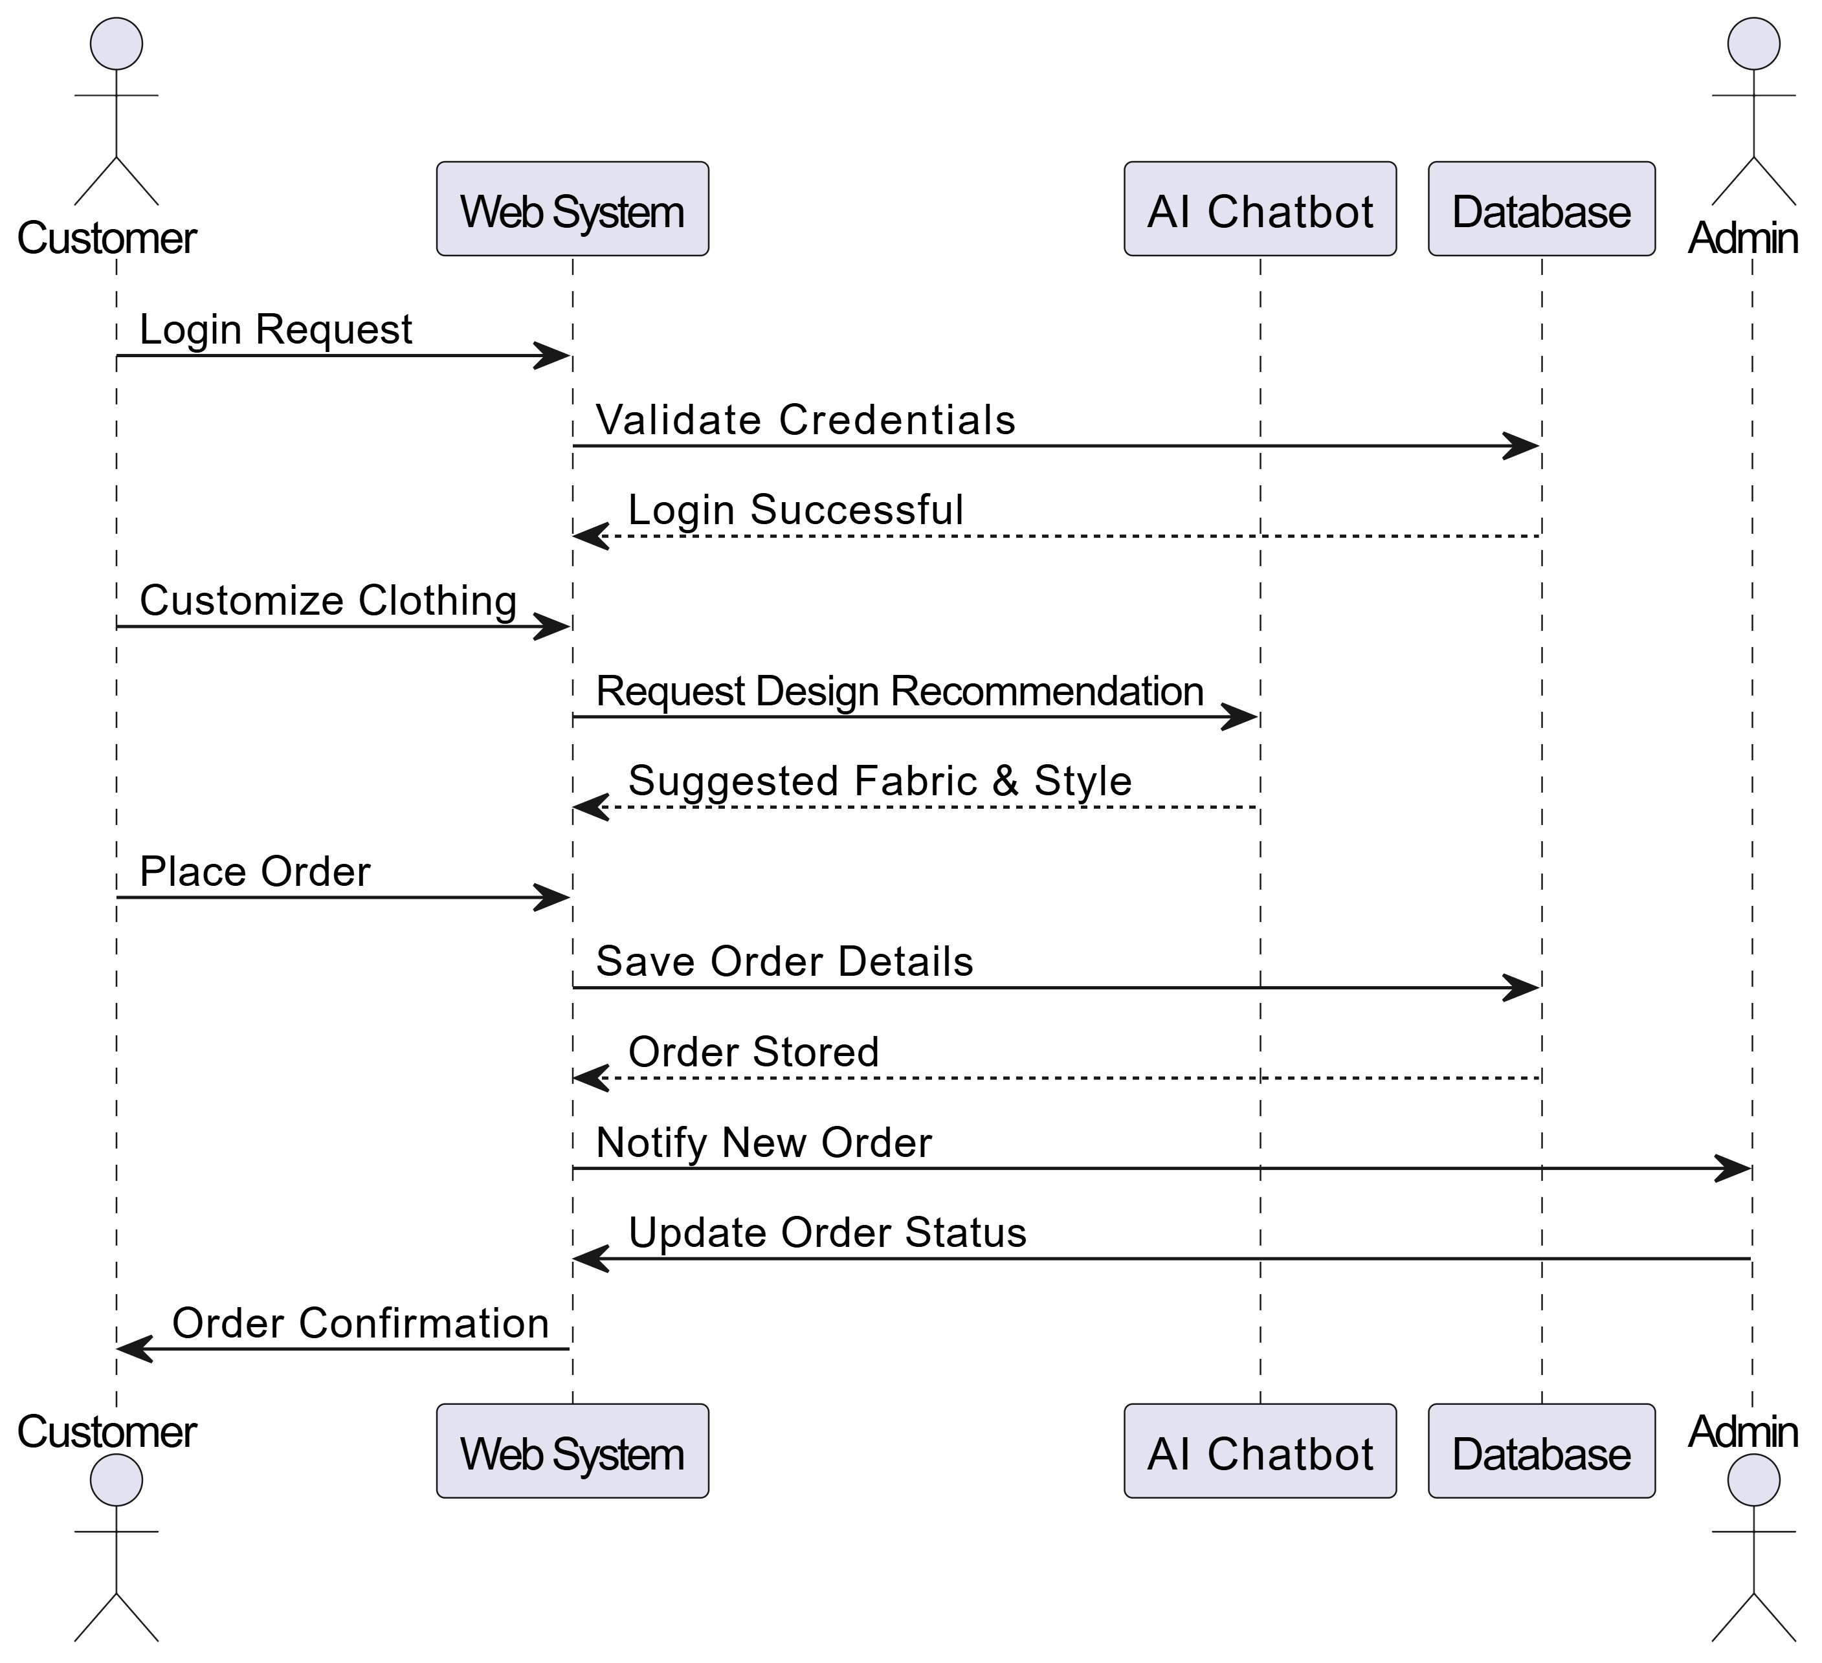
Figure 5: System Sequence Diagram (Summary Level) — Customer to System Flow

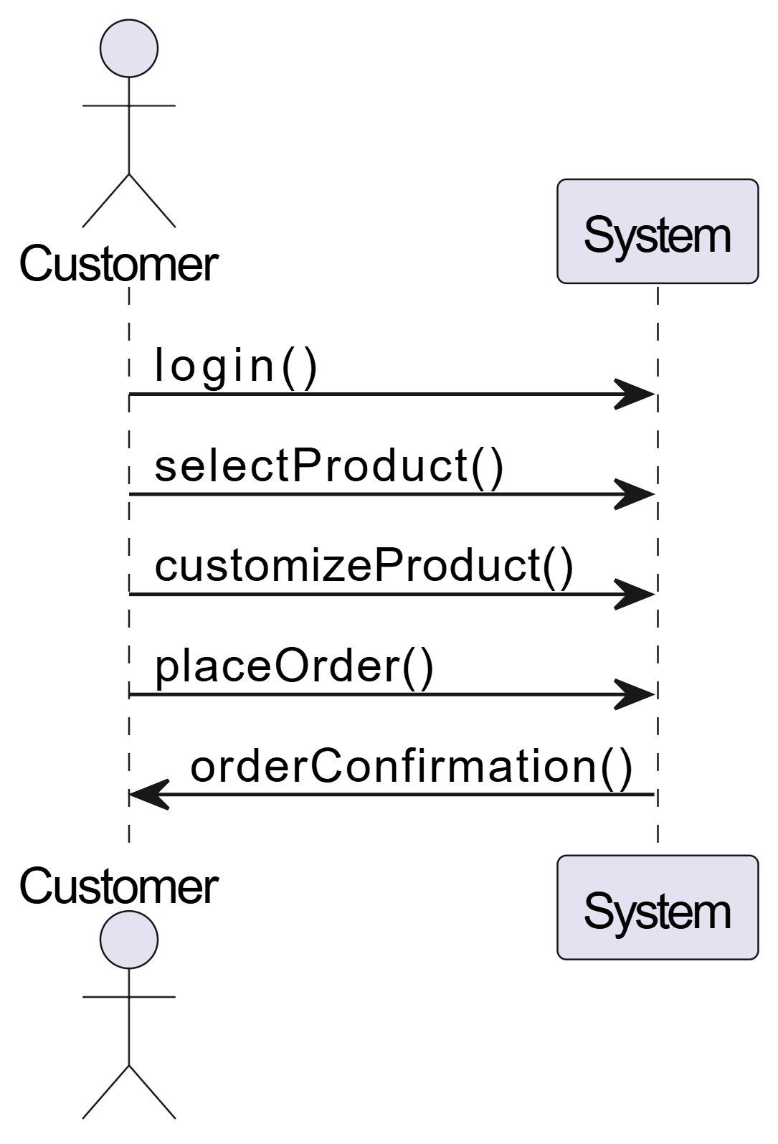
Figure 6: Detailed SSD — Customer Order Interaction

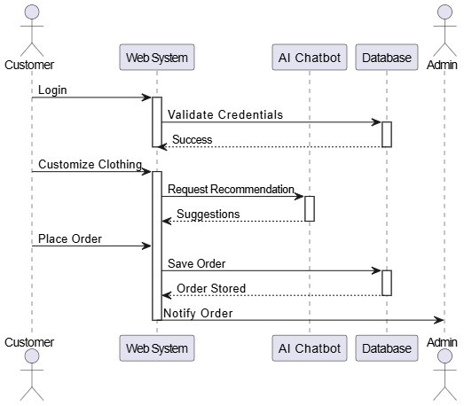
Figure 7: SSD — Customer, AI Chatbot, Database, Admin Interaction

SSD:1 Process SignUp
Table SSD-01: SSD:1 Process SignUp
Actor | Direction | System
Enter registration form data | →
 | ← | Validate input fields
Submit registration | →
 | ← | Hash password and save
 | ← | Return success confirmation

SSD:2 Process SignIn
Table SSD-02: SSD:2 Process SignIn
Actor | Direction | System
Enter email and password | →
 | ← | Validate credentials against database
Submit login | →
 | ← | Generate JWT token
 | ← | Return token and redirect

SSD:3 Forgot Password
Table SSD-03: SSD:3 Forgot Password
Actor | Direction | System
Enter registered email | →
 | ← | Verify email exists in database
 | ← | Generate 6-digit OTP
 | ← | Send OTP via Gmail SMTP
 | ← | Display OTP sent confirmation

SSD:4 Reset Password
Table SSD-04: SSD:4 Reset Password
Actor | Direction | System
Enter OTP and new password | →
 | ← | Validate OTP against stored value
 | ← | Check OTP expiry (10 minutes)
Submit new password | →
 | ← | Hash new password and update database
 | ← | Return password reset confirmation

SSD:5 Update Profile
Table SSD-05: SSD:5 Update Profile
Actor | Direction | System
Navigate to profile page | →
 | ← | Retrieve current profile data from database
Edit profile fields and submit | →
 | ← | Validate updated fields
 | ← | Save changes to database
 | ← | Return profile update success message

SSD:6 Upload Profile Picture
Table SSD-06: SSD:6 Upload Profile Picture
Actor | Direction | System
Select profile image file | →
 | ← | Validate file type and size
Upload image | →
 | ← | Save image to server and generate URL
 | ← | Update profile_pic_url in database
 | ← | Display updated profile picture

SSD:7 View Products
Table SSD-07: SSD:7 View Products
Actor | Direction | System
Navigate to products page | →
 | ← | Query active products from database
 | ← | Return product list with images and base prices
Select a product to view details | →
 | ← | Retrieve product details and available options
 | ← | Display product detail page

SSD:8 Search Products
Table SSD-08: SSD:8 Search Products
Actor | Direction | System
Enter search keyword | →
 | ← | Query products with LIKE filter on name and description
 | ← | Return matching active products
Apply category or price filter | →
 | ← | Re-query with additional filters
 | ← | Display filtered results

SSD:9 Customize Product
Table SSD-09: SSD:9 Customize Product
Actor | Direction | System
Select product and open customizer | →
 | ← | Load customization options (fabric, color, print, wash, stitch)
Select fabric type and color | →
 | ← | Update 2D preview canvas in real time
Upload logo and select placement | →
 | ← | Render logo on preview and update price

SSD:10 Upload Logo
Table SSD-10: SSD:10 Upload Logo
Actor | Direction | System
Select logo image from device | →
 | ← | Validate file type (PNG, JPG, SVG) and size
Upload logo file | →
 | ← | Save logo to server and return URL
 | ← | Render logo on 2D canvas at selected placement

SSD:11 Generate AI Design Suggestion
Table SSD-11: SSD:11 Generate AI Design Suggestion
Actor | Direction | System
Enter design description prompt in chat | →
 | ← | Send prompt to n8n webhook
 | ← | n8n forwards request to Gemini/GPT API
 | ← | AI generates design recommendation
 | ← | System applies suggestion to customizer preview
 | ← | Display AI-suggested design with explanation

SSD:12 View 2D Real-Time Preview
Table SSD-12: SSD:12 View 2D Real-Time Preview
Actor | Direction | System
Modify any customization option | →
 | ← | Capture change event via JavaScript listener
 | ← | Redraw HTML5 canvas with updated properties
 | ← | Apply wash effect and logo overlay
 | ← | Recalculate and display updated price

SSD:13 Save Customization to Cart
Table SSD-13: SSD:13 Save Customization to Cart
Actor | Direction | System
Click Add to Cart | →
 | ← | Validate customization completeness
 | ← | Serialize customization data to session/localStorage
 | ← | Update cart item count in navigation
 | ← | Display cart added confirmation message

SSD:14 View Cart
Table SSD-14: SSD:14 View Cart
Actor | Direction | System
Navigate to cart page | →
 | ← | Retrieve cart items from session/localStorage
 | ← | Display cart items with customization thumbnails
 | ← | Show quantity, unit price, and total
Update quantity or remove item | →
 | ← | Recalculate cart total and refresh display

SSD:15 Update Cart
Table SSD-15: SSD:15 Update Cart
Actor | Direction | System
Change quantity of cart item | →
 | ← | Validate new quantity is positive integer
 | ← | Update quantity in cart data
 | ← | Recalculate item and grand total
 | ← | Refresh cart display with updated values

SSD:16 Apply Coupon Code
Table SSD-16: SSD:16 Apply Coupon Code
Actor | Direction | System
Enter coupon code at checkout | →
 | ← | Query coupons table for matching active code
 | ← | Verify expiry date and usage limit
 | ← | Calculate discount amount
 | ← | Display updated total with discount applied

SSD:17 Interact with AI Chatbot
Table SSD-17: SSD:17 Interact with AI Chatbot
Actor | Direction | System
Open chatbot widget and type message | →
 | ← | Send message to n8n webhook endpoint
 | ← | n8n processes via AI workflow
 | ← | AI generates contextual response
 | ← | Display response in chat window with markdown formatting

SSD:18 Get Product Recommendation
Table SSD-18: SSD:18 Get Product Recommendation
Actor | Direction | System
Request product recommendation via chatbot | →
 | ← | n8n queries product database for active products
 | ← | AI analyzes customer preferences from chat context
 | ← | Generate personalized product recommendation
 | ← | Display recommendation with product links in chat

SSD:19 Get Customization Assistance
Table SSD-19: SSD:19 Get Customization Assistance
Actor | Direction | System
Ask customization question in chatbot | →
 | ← | n8n identifies query as customization-related
 | ← | AI retrieves relevant customization knowledge
 | ← | Generate step-by-step customization guidance
 | ← | Display guidance with option to open customizer

SSD:20 Get Pricing Information
Table SSD-20: SSD:20 Get Pricing Information
Actor | Direction | System
Ask pricing question in chatbot | →
 | ← | n8n identifies pricing query
 | ← | System queries product base prices from database
 | ← | AI calculates price range based on customization options
 | ← | Display pricing breakdown in chat

SSD:21 Submit Review
Table SSD-21: SSD:21 Submit Review
Actor | Direction | System
Navigate to product page and click Write Review | →
 | ← | Verify customer has purchased the product
Enter rating and review text and submit | →
 | ← | Validate review content and rating range
 | ← | Save review to database
 | ← | Display review under product with confirmation

SSD:22 View Reviews
Table SSD-22: SSD:22 View Reviews
Actor | Direction | System
Navigate to product detail page | →
 | ← | Query reviews table for product reviews
 | ← | Sort reviews by newest and highest rating
 | ← | Display star ratings and review text
 | ← | Show average rating and total review count

SSD:23 Manage Wishlist
Table SSD-23: SSD:23 Manage Wishlist
Actor | Direction | System
Click wishlist icon on product | →
 | ← | Verify customer is authenticated
 | ← | Toggle product in wishlist (add or remove)
 | ← | Update wishlist icon state on page
 | ← | Display wishlist update confirmation

SSD:24 Add Shipping Address
Table SSD-24: SSD:24 Add Shipping Address
Actor | Direction | System
Navigate to profile > addresses and click Add | →
 | ← | Display address entry form
Enter address details and save | →
 | ← | Validate address fields are complete
 | ← | Save address to user profile in database
 | ← | Display saved address in address list

SSD:25 Select Shipping Address at Checkout
Table SSD-25: SSD:25 Select Shipping Address at Checkout
Actor | Direction | System
Proceed to checkout | →
 | ← | Retrieve saved addresses from user profile
Select delivery address from list | →
 | ← | Set selected address as delivery address for order
 | ← | Display selected address in order summary

SSD:26 Receive Order Confirmation Email
Table SSD-26: SSD:26 Receive Order Confirmation Email
Actor | Direction | System
 | ← | Order created successfully in database
 | ← | System compiles order confirmation data
 | ← | System calls FastAPI-Mail with order details
 | ← | Email sent via Gmail SMTP to customer
 | ← | Email delivery confirmation logged

SSD:27 Subscribe to Newsletter
Table SSD-27: SSD:27 Subscribe to Newsletter
Actor | Direction | System
Enter email in newsletter subscription form | →
 | ← | Validate email format
 | ← | Check for duplicate subscription
 | ← | Save email to subscriptions table
 | ← | Send welcome email via Gmail SMTP
 | ← | Display subscription confirmation

SSD:28 Contact Support
Table SSD-28: SSD:28 Contact Support
Actor | Direction | System
Open contact form and enter name, email, and message | →
 | ← | Validate all required fields
Submit contact form | →
 | ← | Save support request to database
 | ← | Send auto-reply email to customer
 | ← | Display submission confirmation message

SSD:29 View FAQ via Chatbot
Table SSD-29: SSD:29 View FAQ via Chatbot
Actor | Direction | System
Type FAQ question in chatbot widget | →
 | ← | Send query to n8n webhook
 | ← | n8n searches FAQ table for keyword match
 | ← | Return matched FAQ answer
 | ← | Display FAQ answer with related suggestions

SSD:30 View Chat History
Table SSD-30: SSD:30 View Chat History
Actor | Direction | System
Open chatbot widget while logged in | →
 | ← | Detect JWT token and extract user ID
 | ← | Query chat_logs for last 20 conversations
 | ← | Return conversation history
 | ← | Display history above input field in chat window

SSD:31 Admin Manage FAQ Entries
Table SSD-31: SSD:31 Admin Manage FAQ Entries
Actor | Direction | System
Navigate to Content Management > FAQ | →
 | ← | Retrieve existing FAQ entries from database
Click Add FAQ and enter question and answer | →
 | ← | Validate fields are not empty
 | ← | Save new FAQ entry to database
 | ← | Confirm entry added and update FAQ list

SSD:32 Create New Order
Table SSD-32: SSD:32 Create New Order
Actor | Direction | System
Click Proceed to Checkout from cart | →
 | ← | Display order summary and address confirmation
Select payment method and click Place Order | →
 | ← | Generate unique Order ID
 | ← | Save order and order_items to database
 | ← | Display order confirmation with Order ID

SSD:33 Search Order History
Table SSD-33: SSD:33 Search Order History
Actor | Direction | System
Enter search term in Order History search box | →
 | ← | Query orders table with search criteria
 | ← | Filter results by customer ID for non-admin
 | ← | Return matching orders list
 | ← | Display filtered order list with status and date

SSD:34 View Order History
Table SSD-34: SSD:34 View Order History
Actor | Direction | System
Navigate to My Orders page | →
 | ← | Query orders table filtered by customer ID
 | ← | Sort results by date descending
 | ← | Return order list with status badges
Click order to view details | →
 | ← | Display full order details including customization specs

SSD:35 Cancel Order
Table SSD-35: SSD:35 Cancel Order
Actor | Direction | System
Select Pending order and click Cancel Order | →
 | ← | Display cancellation confirmation dialog
Confirm cancellation | →
 | ← | Update order status to Cancelled in database
 | ← | Send cancellation confirmation email
 | ← | Show Cancelled status badge on order page

SSD:36 Track Order Status
Table SSD-36: SSD:36 Track Order Status
Actor | Direction | System
Select order and click Track Order | →
 | ← | Fetch current order status from database
 | ← | Generate visual status timeline
 | ← | Highlight current stage in timeline
 | ← | Display estimated dates for each stage

SSD:37 Reorder Previous Order
Table SSD-37: SSD:37 Reorder Previous Order
Actor | Direction | System
Click Reorder on completed order | →
 | ← | Retrieve order specifications from database
 | ← | Pre-fill customization form with previous specs
 | ← | Render 2D preview with previous customizations
Confirm or modify and click Place Order | →
 | ← | Create new order with specifications

SSD:38 Record Online Payment
Table SSD-38: SSD:38 Record Online Payment
Actor | Direction | System
Select online payment and click Pay Now | →
 | ← | Redirect to payment gateway secure page
Enter card details and confirm payment | →
 | ← | Gateway sends payment callback to API
 | ← | Record payment in payments table
 | ← | Display payment confirmation and generate receipt

SSD:39 Record Cash on Delivery
Table SSD-39: SSD:39 Record Cash on Delivery
Actor | Direction | System
Select Cash on Delivery at checkout | →
 | ← | Validate delivery address is complete
Confirm order | →
 | ← | Create order with COD payment status Pending
 | ← | Generate COD reference number
 | ← | Send order confirmation with COD reference via email

SSD:40 Generate Digital Receipt
Table SSD-40: SSD:40 Generate Digital Receipt
Actor | Direction | System
 | ← | Order confirmed in system
 | ← | Collect order details and pricing data
 | ← | Generate receipt with unique receipt number
 | ← | Store receipt in database
 | ← | Send receipt to customer email
 | ← | Make receipt accessible on Order Details page

SSD:41 View All Payments and Transactions
Table SSD-41: SSD:41 View All Payments and Transactions
Actor | Direction | System
Navigate to Payment History | →
 | ← | Query payments table filtered by customer ID
 | ← | Return transaction list
 | ← | Display transactions with amount, method, and status
Click transaction for full order details | →
 | ← | Display linked order details

SSD:42 Download Invoice
Table SSD-42: SSD:42 Download Invoice
Actor | Direction | System
Click Download Invoice on Order Details page | →
 | ← | Retrieve order and payment data from database
 | ← | Generate formatted PDF with customization summary
 | ← | Return PDF file to browser
 | ← | Browser initiates download as AURA-WEAR-Invoice-[ID].pdf

SSD:43 Manage Products - Admin
Table SSD-43: SSD:43 Manage Products - Admin
Actor | Direction | System
Navigate to Product Management | →
 | ← | Display paginated product list
Click Add Product and fill form | →
 | ← | Validate product fields
 | ← | Save product to database
 | ← | Display success notification and updated product list

SSD:44 Manage Customer Accounts - Admin
Table SSD-44: SSD:44 Manage Customer Accounts - Admin
Actor | Direction | System
Navigate to Customer Management | →
 | ← | Display paginated customer list
Select customer and click Deactivate | →
 | ← | Confirm deactivation action
 | ← | Update account status and terminate sessions
 | ← | Log admin action and display confirmation

SSD:45 View and Update Order Management - Admin
Table SSD-45: SSD:45 View and Update Order Management - Admin
Actor | Direction | System
Navigate to Order Management | →
 | ← | Display all orders sorted by newest first
Select order and click Update Status | →
 | ← | Display status dropdown options
Select new status and confirm | →
 | ← | Update status in database and notify customer via email

SSD:46 View Inventory and Stock Alerts - Admin
Table SSD-46: SSD:46 View Inventory and Stock Alerts - Admin
Actor | Direction | System
Navigate to Inventory Management | →
 | ← | Query inventory table and compare against thresholds
 | ← | Display inventory list with low-stock items highlighted
Update quantity for a material | →
 | ← | Save updated quantity to database
 | ← | Refresh inventory display and update dashboard badge

SSD:47 Generate Sales Report
Table SSD-47: SSD:47 Generate Sales Report
Actor | Direction | System
Navigate to Reports > Sales Report and select date range | →
 | ← | Query payments and orders for selected period
 | ← | Calculate total revenue and average order value
 | ← | Generate report table and chart
Click Export as CSV | →
 | ← | Generate and download CSV file

SSD:48 Generate Order Report
Table SSD-48: SSD:48 Generate Order Report
Actor | Direction | System
Navigate to Reports > Order Report and select filters | →
 | ← | Query orders table for selected period and status
 | ← | Categorize orders by status and count
 | ← | Display counts and percentages per status
 | ← | Render order trend chart
Click Export as CSV | →

SSD:49 View Analytics Dashboard
Table SSD-49: SSD:49 View Analytics Dashboard
Actor | Direction | System
Navigate to Admin Dashboard | →
 | ← | Query aggregate stats from orders, payments, and users tables
 | ← | Return dashboard summary widgets data
 | ← | Render daily order chart for past 30 days
 | ← | Display chatbot usage statistics
 | ← | Schedule auto-refresh every 5 minutes

SSD:50 Send Notification to Customers
Table SSD-50: SSD:50 Send Notification to Customers
Actor | Direction | System
Navigate to Notifications and compose message | →
 | ← | Display email preview
Click Send | →
 | ← | Queue emails via FastAPI-Mail
 | ← | Send emails via Gmail SMTP
 | ← | Record notification in logs and display delivery status

SSD:51 Manage Content - Terms, Privacy, FAQ
Table SSD-51: SSD:51 Manage Content - Terms, Privacy, FAQ
Actor | Direction | System
Navigate to Content Management and select tab | →
 | ← | Retrieve current content from database
Modify content and click Save Changes | →
 | ← | Validate content length and format
 | ← | Update content in database with timestamp
 | ← | Confirm update and make visible on customer pages

SSD:52 Manage Coupon/Promo Codes
Table SSD-52: SSD:52 Manage Coupon/Promo Codes
Actor | Direction | System
Navigate to Promotions > Coupon Codes and click Add | →
 | ← | Display coupon creation form
Enter coupon details and click Save | →
 | ← | Validate code uniqueness
 | ← | Save coupon to database with Active status
 | ← | Display new coupon in coupon list

SSD:53 Export Data as CSV
Table SSD-53: SSD:53 Export Data as CSV
Actor | Direction | System
Click Export as CSV on Reports or Customer Management page | →
 | ← | Query relevant database table
 | ← | Format data as CSV with column headers
 | ← | Generate file server-side
 | ← | Browser initiates file download

SSD:54 Manage Admin Users
Table SSD-54: SSD:54 Manage Admin Users
Actor | Direction | System
Navigate to Admin Management and click Add Admin | →
 | ← | Display admin creation form
Enter name and email and confirm | →
 | ← | Generate temporary password
 | ← | Create admin account and send credentials via email
 | ← | Display new admin in admin list

SSD:55 View Customer Reviews
Table SSD-55: SSD:55 View Customer Reviews
Actor | Direction | System
Navigate to Reviews and Ratings section | →
 | ← | Query reviews table for all reviews
 | ← | Display reviews with star ratings and text
Flag inappropriate review | →
 | ← | Update review flag status and hide from customer pages
 | ← | Confirm flag action

SSD:56 Generate Performance Report
Table SSD-56: SSD:56 Generate Performance Report
Actor | Direction | System
Navigate to Reports > Performance Report and select date range | →
 | ← | Analyze order data for performance metrics
 | ← | Calculate top-selling products and customization trends
 | ← | Generate charts and report table
Click Export as CSV or PDF | →
 | ← | Generate and download report file

3.5 Schema Diagram
The database schema for AURA-WEAR consists of 9 tables that store all system data. The schema is designed to minimize redundancy, enforce referential integrity through foreign key constraints, and support efficient query patterns for the platform's core operations.
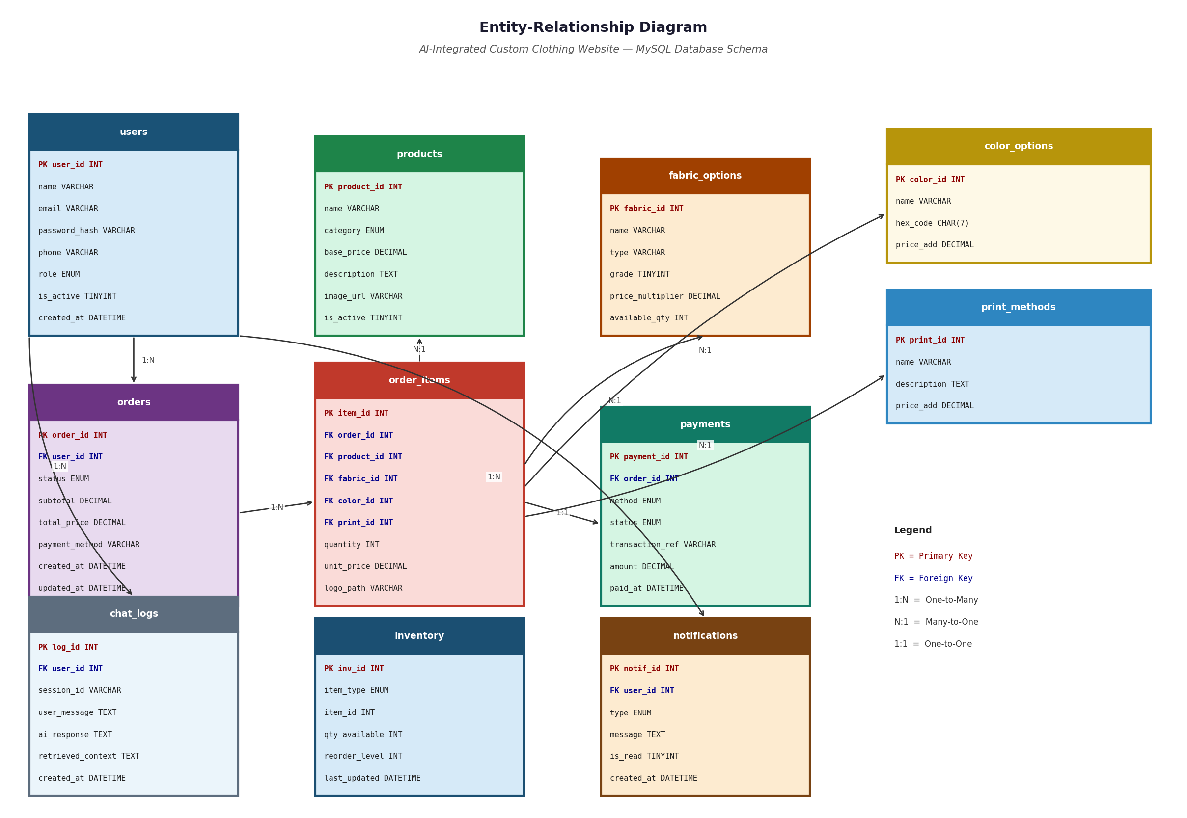
Figure 8: Entity-Relationship (ER) Diagram — AURA-WEAR Database Schema

users
Table: users — Schema Definition
Column Name | Data Type | Constraints
user_id | INT | PRIMARY KEY, AUTO_INCREMENT
name | VARCHAR(100) | NOT NULL
email | VARCHAR(150) | UNIQUE, NOT NULL
password_hash | VARCHAR(255) | NOT NULL
role | ENUM(customer, admin) | DEFAULT customer
phone | VARCHAR(20) | NULLABLE
address | TEXT | NULLABLE
city | VARCHAR(50) | NULLABLE
profile_pic_url | TEXT | NULLABLE
status | ENUM(active, inactive) | DEFAULT active
created_at | DATETIME | DEFAULT CURRENT_TIMESTAMP

products
Table: products — Schema Definition
Column Name | Data Type | Constraints
product_id | INT | PRIMARY KEY, AUTO_INCREMENT
name | VARCHAR(150) | NOT NULL
category | VARCHAR(50) | NOT NULL
description | TEXT | NULLABLE
base_price | DECIMAL(10,2) | NOT NULL
available_sizes | TEXT | NULLABLE
image_urls | TEXT | NULLABLE
status | ENUM(active, inactive) | DEFAULT active
created_at | DATETIME | DEFAULT CURRENT_TIMESTAMP

orders
Table: orders — Schema Definition
Column Name | Data Type | Constraints
order_id | VARCHAR(20) | PRIMARY KEY
customer_id | INT | FOREIGN KEY -> users(user_id)
total_price | DECIMAL(10,2) | NOT NULL
payment_method | VARCHAR(20) | NOT NULL
payment_status | VARCHAR(20) | DEFAULT Pending
status | VARCHAR(30) | DEFAULT Pending
delivery_address | TEXT | NOT NULL
created_at | DATETIME | DEFAULT CURRENT_TIMESTAMP
updated_at | DATETIME | ON UPDATE CURRENT_TIMESTAMP

order_items
Table: order_items — Schema Definition
Column Name | Data Type | Constraints
item_id | INT | PRIMARY KEY, AUTO_INCREMENT
order_id | VARCHAR(20) | FOREIGN KEY -> orders(order_id)
product_id | INT | FOREIGN KEY -> products(product_id)
fabric_type | VARCHAR(30) | NULLABLE
color_hex | VARCHAR(10) | NULLABLE
logo_url | TEXT | NULLABLE
logo_placement | VARCHAR(20) | NULLABLE
stitch_style | VARCHAR(30) | NULLABLE
print_method | VARCHAR(30) | NULLABLE
wash_effect | VARCHAR(30) | NULLABLE
quantity | INT | DEFAULT 1
unit_price | DECIMAL(10,2) | NOT NULL

payments
Table: payments — Schema Definition
Column Name | Data Type | Constraints
payment_id | INT | PRIMARY KEY, AUTO_INCREMENT
order_id | VARCHAR(20) | FOREIGN KEY -> orders(order_id)
amount | DECIMAL(10,2) | NOT NULL
method | VARCHAR(20) | NOT NULL
status | VARCHAR(20) | DEFAULT Pending
transaction_id | VARCHAR(100) | NULLABLE
created_at | DATETIME | DEFAULT CURRENT_TIMESTAMP

chat_logs
Table: chat_logs — Schema Definition
Column Name | Data Type | Constraints
log_id | INT | PRIMARY KEY, AUTO_INCREMENT
user_id | INT | FOREIGN KEY -> users(user_id), NULLABLE
query | TEXT | NOT NULL
response | TEXT | NOT NULL
timestamp | DATETIME | DEFAULT CURRENT_TIMESTAMP

inventory
Table: inventory — Schema Definition
Column Name | Data Type | Constraints
inventory_id | INT | PRIMARY KEY, AUTO_INCREMENT
material_name | VARCHAR(100) | NOT NULL
quantity | DECIMAL(10,2) | DEFAULT 0
unit | VARCHAR(20) | NOT NULL
alert_threshold | DECIMAL(10,2) | DEFAULT 10
last_updated | DATETIME | DEFAULT CURRENT_TIMESTAMP

coupons
Table: coupons — Schema Definition
Column Name | Data Type | Constraints
coupon_id | INT | PRIMARY KEY, AUTO_INCREMENT
code | VARCHAR(20) | UNIQUE, NOT NULL
discount_type | ENUM(percent, fixed) | NOT NULL
value | DECIMAL(10,2) | NOT NULL
expiry_date | DATE | NOT NULL
usage_limit | INT | DEFAULT 1
used_count | INT | DEFAULT 0
status | ENUM(active, inactive) | DEFAULT active

faq
Table: faq — Schema Definition
Column Name | Data Type | Constraints
faq_id | INT | PRIMARY KEY, AUTO_INCREMENT
question | TEXT | NOT NULL
answer | TEXT | NOT NULL
created_at | DATETIME | DEFAULT CURRENT_TIMESTAMP

CHAPTER # 4:
CONSTRUCTION

4.1 Class Diagram
The Class Diagram defines the static structure of AURA-WEAR's backend system, showing classes, their attributes, methods, and relationships. The diagram represents the data models implemented using SQLAlchemy ORM in the FastAPI backend.
Figure 9: Class Diagram — AURA-WEAR System Classes and Relationships (tabular representation below)
Table 5: Class Diagram — AURA-WEAR System Classes and Attributes
Class | Attributes | Methods | Relationships
UserModel | user_id, name, email, password_hash, role, phone, address, status | create_user(), get_user(), update_user(), verify_password(), generate_jwt() | Has many Orders, Has many ChatLogs
ProductModel | product_id, name, category, description, base_price, status | add_product(), get_product(), update_product(), toggle_status() | Has many OrderItems
OrderModel | order_id, customer_id, total_price, status, payment_method | create_order(), get_order(), update_status(), cancel_order() | Belongs to User, Has many OrderItems, Has one Payment
OrderItemModel | item_id, order_id, product_id, fabric, color, logo, stitch, print, wash, price | add_item(), calculate_price() | Belongs to Order, References Product
PaymentModel | payment_id, order_id, amount, method, status, transaction_id | record_payment(), generate_receipt(), download_invoice() | Belongs to Order
ChatbotService | n8n_webhook_url, openai_key | send_query(), get_response(), save_log(), get_history() | Uses ChatLog, Calls n8n API
AdminService | : | get_dashboard_stats(), generate_report(), export_csv(), send_notification() | Manages all Models
CouponModel | code, discount_type, value, expiry, limit, used_count | validate_coupon(), apply_discount(), deactivate() | Applied to Order
InventoryModel | material, quantity, threshold | update_quantity(), check_alerts() | Managed by Admin

4.2 Project Code (Business Logic)
The following code samples demonstrate the core business logic implemented in the AURA-WEAR FastAPI backend and Vanilla JavaScript frontend.

4.2.1 Backend: FastAPI Routes
auth.py — Authentication Router
from fastapi import APIRouter, HTTPException, Depends
from fastapi.security import OAuth2PasswordBearer
from jose import jwt, JWTError
from passlib.context import CryptContext
from datetime import datetime, timedelta
router = APIRouter(prefix="/auth", tags=["Authentication"])
pwd_context = CryptContext(schemes=["bcrypt"], deprecated="auto")
SECRET_KEY = os.getenv("JWT_SECRET_KEY")
ALGORITHM = "HS256"
@router.post("/register")
async def register(user: UserCreate, db: Session = Depends(get_db)):
existing = db.query(User).filter(User.email == user.email).first()
if existing:
raise HTTPException(status_code=400, detail="Email already registered")
hashed = pwd_context.hash(user.password)
new_user = User(name=user.name, email=user.email, password_hash=hashed)
db.add(new_user)
db.commit()
return {"message": "Registration successful"}
@router.post("/login")
async def login(credentials: LoginSchema, db: Session = Depends(get_db)):
user = db.query(User).filter(User.email == credentials.email).first()
if not user or not pwd_context.verify(credentials.password, user.password_hash):
raise HTTPException(status_code=401, detail="Invalid email or password")
token_data = {"sub": str(user.user_id), "role": user.role}
token = jwt.encode(token_data, SECRET_KEY, algorithm=ALGORITHM)
return {"access_token": token, "token_type": "bearer"}

orders.py — Order Management Router
import uuid
from fastapi import APIRouter, HTTPException, Depends
router = APIRouter(prefix="/orders", tags=["Orders"])
@router.post("/create")
async def create_order(order_data: OrderCreate,
current_user: User = Depends(get_current_user),
db: Session = Depends(get_db)):
order_id = f"AW-{uuid.uuid4().hex[:8].upper()}"
new_order = Order(
order_id=order_id,
customer_id=current_user.user_id,
total_price=order_data.total_price,
status="Pending",
payment_method=order_data.payment_method
)
db.add(new_order)
for item in order_data.items:
order_item = OrderItem(order_id=order_id, **item.dict())
db.add(order_item)
db.commit()
return {"order_id": order_id, "message": "Order placed successfully"}

chatbot.py — AI Chatbot Router
import httpx
from fastapi import APIRouter
router = APIRouter(prefix="/chatbot", tags=["Chatbot"])
N8N_WEBHOOK = os.getenv("N8N_WEBHOOK_URL")
@router.post("/query")
async def chatbot_query(query: ChatQuery,
current_user: User = Depends(get_current_user),
db: Session = Depends(get_db)):
async with httpx.AsyncClient(timeout=30.0) as client:
response = await client.post(N8N_WEBHOOK,
json={"query": query.message, "user_id": current_user.user_id})
answer = response.json().get("response", "I could not process your request.")
log = ChatLog(user_id=current_user.user_id, query=query.message,
response=answer, role="assistant")
db.add(log)
db.commit()
return {"response": answer}

4.2.2 Frontend: JavaScript Logic
customizer.js — Real-Time 2D Preview & Dynamic Pricing
// customizer.js — Real-Time 2D Preview
const canvas = document.getElementById('previewCanvas');
const ctx = canvas.getContext('2d');
let customization = {
color: '#FFFFFF', logoUrl: null, logoPos: 'chest', washEffect: 'standard'
};
function updatePreview() {
ctx.clearRect(0, 0, canvas.width, canvas.height);
// Draw garment silhouette
ctx.fillStyle = customization.color;
ctx.beginPath();
ctx.roundRect(60, 40, 280, 320, 20);
ctx.fill();
ctx.strokeStyle = '#333333';
ctx.lineWidth = 2;
ctx.stroke();
// Draw logo if uploaded
if (customization.logoUrl) {
const img = new Image();
img.onload = () => {
const pos = getLogoPosition(customization.logoPos);
ctx.drawImage(img, pos.x, pos.y, 80, 80);
};
img.src = customization.logoUrl;
}
updatePrice();
}
function updatePrice() {
const priceMap = {
fabric: { Cotton: 0, Polyester: 200, Blended: 350, Fleece: 500 },
stitch: { Flatlock: 0, Overlock: 150, 'Chain Stitch': 300 },
print: { 'Screen Print': 0, DTG: 500, Embroidery: 800, 'Heat Transfer': 400 },
wash: { Standard: 0, 'Stone Wash': 200, 'Acid Wash': 350, 'Enzyme Wash': 300 }
};
let total = basePrice;
total += priceMap.fabric[selectedFabric] || 0;
total += priceMap.stitch[selectedStitch] || 0;
total += priceMap.print[selectedPrint] || 0;
total += priceMap.wash[selectedWash] || 0;
document.getElementById('totalPrice').textContent = `Rs. ${total.toLocaleString()}`;
}
document.getElementById('colorPicker').addEventListener('input', (e) => {
customization.color = e.target.value;
updatePreview();
});

4.3 Sample Queries
The following SQL queries represent the core data access operations used by the AURA-WEAR system via SQLAlchemy ORM.
Table 6: Sample SQL Queries — AURA-WEAR Core Data Access Operations
Query Name | SQL Query
Get All Active Products | SELECT * FROM products WHERE status = 'active' ORDER BY created_at DESC;
Get Customer Orders | SELECT o.*, oi.* FROM orders o JOIN order_items oi ON o.order_id = oi.order_id WHERE o.customer_id = ? ORDER BY o.created_at DESC;
Monthly Revenue | SELECT SUM(amount) as revenue, COUNT(*) as orders FROM payments WHERE status='completed' AND strftime('%Y-%m', created_at) = strftime('%Y-%m', 'now');
Search Products | SELECT * FROM products WHERE (name LIKE ? OR description LIKE ?) AND status='active';
Low Stock Inventory | SELECT * FROM inventory WHERE quantity <= alert_threshold;
Validate Coupon | SELECT * FROM coupons WHERE code=? AND status='active' AND expiry_date >= date('now') AND used_count < usage_limit;
Get Chat History | SELECT query, response, timestamp FROM chat_logs WHERE user_id=? ORDER BY timestamp DESC LIMIT 20;
Update Order Status | UPDATE orders SET status=?, updated_at=datetime('now') WHERE order_id=?;
Get Admin Dashboard Stats | SELECT (SELECT COUNT(*) FROM orders WHERE date(created_at)=date('now')) as today_orders, (SELECT SUM(amount) FROM payments WHERE strftime('%W', created_at)=strftime('%W','now') AND status='completed') as weekly_revenue, (SELECT COUNT(*) FROM users WHERE role='customer') as total_customers;

CHAPTER # 5:
TESTING

5.1 Test Cases
This chapter presents the complete test cases for all 56 functional requirements of the AURA-WEAR system. Each test case includes a test case ID, name, description, pre-conditions, step-by-step test steps, test data, expected result, actual result, and pass/fail status. All 56 test cases were executed during the final sprint and all passed successfully.

TC-01 Process SignUp
Table TC-01: Test Case — Process SignUp
Test Case ID | TC-01
Test Case Name | Process SignUp
Description | Verify that a new user can register successfully with valid credentials
Pre-Conditions | User is on the registration page; email not previously registered
Test Steps | 1. Navigate to /register. 2. Enter Full Name: "Ahmed Ali". 3. Enter Email: "ahmed@test.com". 4. Enter Password: "Test@1234". 5. Click Register button. 6. Observe the response.
Test Data | Name: Ahmed Ali, Email: ahmed@test.com, Password: Test@1234
Expected Result | Account created successfully; success message shown; redirected to login page
Actual Result | Account created successfully; success message shown; redirected to login page
Status | Pass

TC-02 Process SignIn
Table TC-02: Test Case — Process SignIn
Test Case ID | TC-02
Test Case Name | Process SignIn
Description | Verify that a registered user can sign in with valid credentials and receive JWT token
Pre-Conditions | User has a registered account; password is known
Test Steps | 1. Navigate to /login. 2. Enter Email: "ahmed@test.com". 3. Enter Password: "Test@1234". 4. Click Sign In. 5. Observe redirect and token storage.
Test Data | Email: ahmed@test.com, Password: Test@1234
Expected Result | JWT token issued; user redirected to customer dashboard; token stored in localStorage
Actual Result | JWT token issued; user redirected to customer dashboard
Status | Pass

TC-03 Forgot Password
Table TC-03: Test Case — Forgot Password
Test Case ID | TC-03
Test Case Name | Forgot Password
Description | Verify that a user can initiate password reset by providing registered email
Pre-Conditions | User has a registered account; email is valid and accessible
Test Steps | 1. Click "Forgot Password" on login page. 2. Enter Email: "ahmed@test.com". 3. Click Submit. 4. Check email inbox for OTP. 5. Observe system message.
Test Data | Email: ahmed@test.com
Expected Result | OTP sent to registered email; system displays "OTP sent to your email address"
Actual Result | OTP received in email inbox; success message displayed
Status | Pass

TC-04 Change Account Password
Table TC-04: Test Case — Change Account Password
Test Case ID | TC-04
Test Case Name | Change Account Password
Description | Verify authenticated user can change their password successfully
Pre-Conditions | User is signed in; current password is known
Test Steps | 1. Navigate to Profile Settings. 2. Click Change Password. 3. Enter Current: "Test@1234". 4. Enter New: "NewPass@5678". 5. Enter Confirm: "NewPass@5678". 6. Click Update.
Test Data | Current: Test@1234, New: NewPass@5678
Expected Result | Password updated; success message displayed; user logged out of other sessions
Actual Result | Password updated successfully
Status | Pass

TC-05 JWT Authentication
Table TC-05: Test Case — JWT Authentication
Test Case ID | TC-05
Test Case Name | JWT Authentication
Description | Verify that protected API endpoints reject requests without valid JWT token
Pre-Conditions | Test environment is set up; API endpoint /orders/history is protected
Test Steps | 1. Send GET request to /orders/history without Authorization header. 2. Observe response. 3. Send request with invalid token. 4. Observe response. 5. Send with valid token. 6. Observe response.
Test Data | No token, Invalid token: "Bearer fake123", Valid token from login
Expected Result | No token → HTTP 401; Invalid token → HTTP 401; Valid token → HTTP 200 with data
Actual Result | Results match expected for all three scenarios
Status | Pass

TC-06 OTP Verification
Table TC-06: Test Case — OTP Verification
Test Case ID | TC-06
Test Case Name | OTP Verification
Description | Verify OTP validation works correctly for password reset
Pre-Conditions | OTP has been sent to user's email; OTP not expired
Test Steps | 1. Request OTP via forgot password. 2. Enter correct 6-digit OTP. 3. Click Verify. 4. Also test with wrong OTP. 5. Also test with expired OTP.
Test Data | Correct OTP: 482910, Wrong OTP: 111111, Expired OTP scenario
Expected Result | Correct OTP → proceed to reset form; Wrong OTP → "Invalid OTP" error; Expired → "OTP expired" error
Actual Result | All three scenarios handled correctly
Status | Pass

TC-07 Role-Based Access Control
Table TC-07: Test Case — Role-Based Access Control
Test Case ID | TC-07
Test Case Name | Role-Based Access Control
Description | Verify that customer cannot access admin endpoints
Pre-Conditions | Customer is signed in with customer role JWT
Test Steps | 1. Sign in as customer. 2. Try to access /admin/dashboard via API. 3. Try to access /admin/products. 4. Observe HTTP responses.
Test Data | Customer JWT token, Admin-only endpoints
Expected Result | HTTP 403 Forbidden for all admin endpoints when accessed with customer token
Actual Result | HTTP 403 returned for all admin endpoint attempts
Status | Pass

TC-08 Session Management
Table TC-08: Test Case — Session Management
Test Case ID | TC-08
Test Case Name | Session Management
Description | Verify that JWT token expires after 30 minutes of inactivity
Pre-Conditions | User is signed in; token issued
Test Steps | 1. Sign in and record token issue time. 2. Wait 31 minutes without activity. 3. Make any authenticated request. 4. Observe response.
Test Data | Token with 30-minute expiry
Expected Result | HTTP 401 with message "Session expired. Please sign in again"; redirect to login
Actual Result | Session expiry handled correctly; user redirected to login
Status | Pass

TC-09 Add Customer Profile
Table TC-09: Test Case — Add Customer Profile
Test Case ID | TC-09
Test Case Name | Add Customer Profile
Description | Verify customer can complete their profile after registration
Pre-Conditions | Customer is signed in; profile not yet completed
Test Steps | 1. Navigate to Profile page. 2. Enter Phone: "0300-1234567". 3. Enter Address: "House 5, Street 3, G-10". 4. Enter City: "Islamabad". 5. Upload profile picture (JPEG < 2MB). 6. Click Save Profile.
Test Data | Phone: 0300-1234567, City: Islamabad, Address: House 5 Street 3 G-10
Expected Result | Profile saved; success message; profile picture displayed on profile page
Actual Result | Profile saved successfully with all details
Status | Pass

TC-10 Update Customer Profile
Table TC-10: Test Case — Update Customer Profile
Test Case ID | TC-10
Test Case Name | Update Customer Profile
Description | Verify customer can update their existing profile information
Pre-Conditions | Customer is signed in; profile already exists
Test Steps | 1. Navigate to Profile Settings. 2. Change phone to "0311-9876543". 3. Change city to "Rawalpindi". 4. Upload new profile picture. 5. Click Update.
Test Data | Updated Phone: 0311-9876543, Updated City: Rawalpindi
Expected Result | Profile updated; success message; new information reflected on profile page
Actual Result | Profile updated successfully
Status | Pass

TC-11 View Customer Profile
Table TC-11: Test Case — View Customer Profile
Test Case ID | TC-11
Test Case Name | View Customer Profile
Description | Verify customer profile page displays all information correctly
Pre-Conditions | Customer is signed in; profile is complete
Test Steps | 1. Click profile icon. 2. Observe profile page. 3. Verify all fields are displayed. 4. Verify order count shown. 5. Verify registration date shown.
Test Data | Existing customer account with completed profile
Expected Result | Profile page shows name, email, phone, address, profile picture, order count, registration date
Actual Result | All profile information displayed correctly
Status | Pass

TC-12 Manage Customer Account Status
Table TC-12: Test Case — Manage Customer Account Status
Test Case ID | TC-12
Test Case Name | Manage Customer Account Status
Description | Verify admin can deactivate and reactivate customer accounts
Pre-Conditions | Admin is signed in; customer account exists
Test Steps | 1. Navigate to Customer Management. 2. Find customer "ahmed@test.com". 3. Click Deactivate. 4. Confirm deactivation. 5. Try to log in as that customer. 6. Reactivate account. 7. Try login again.
Test Data | Customer: ahmed@test.com
Expected Result | Deactivated customer cannot log in (error shown); after reactivation, login succeeds
Actual Result | Account deactivation and reactivation work correctly
Status | Pass

TC-13 Add New Product
Table TC-13: Test Case — Add New Product
Test Case ID | TC-13
Test Case Name | Add New Product
Description | Verify admin can add a new product to the catalog
Pre-Conditions | Admin is signed in; product details are ready
Test Steps | 1. Navigate to Product Management > Add Product. 2. Enter Name: "Classic Cotton Hoodie". 3. Select Category: Hoodies. 4. Enter Price: 2500. 5. Select sizes XS-XXL. 6. Upload product image. 7. Click Save.
Test Data | Name: Classic Cotton Hoodie, Category: Hoodies, Price: 2500 PKR
Expected Result | Product saved; visible in customer catalog; success message shown
Actual Result | Product added and visible in catalog
Status | Pass

TC-14 Update Product Details
Table TC-14: Test Case — Update Product Details
Test Case ID | TC-14
Test Case Name | Update Product Details
Description | Verify admin can update existing product information
Pre-Conditions | Admin is signed in; product "Classic Cotton Hoodie" exists
Test Steps | 1. Navigate to Product Management. 2. Find and click Edit on target product. 3. Change price to 2800. 4. Change description. 5. Click Update Product.
Test Data | Updated Price: 2800 PKR, Updated Description
Expected Result | Product details updated; new price shown in customer catalog
Actual Result | Product updated successfully
Status | Pass

TC-15 Enable or Disable Product
Table TC-15: Test Case — Enable or Disable Product
Test Case ID | TC-15
Test Case Name | Enable or Disable Product
Description | Verify admin can toggle product visibility in the catalog
Pre-Conditions | Admin is signed in; product exists with Active status
Test Steps | 1. Navigate to Product Management. 2. Find product. 3. Click Disable toggle. 4. Confirm. 5. Check customer catalog for product absence. 6. Re-enable the product.
Test Data | Existing active product
Expected Result | Disabled product disappears from customer catalog; re-enabled product reappears
Actual Result | Product visibility toggled correctly
Status | Pass

TC-16 Search Product
Table TC-16: Test Case — Search Product
Test Case ID | TC-16
Test Case Name | Search Product
Description | Verify product search returns relevant results
Pre-Conditions | Product catalog has at least 5 products; user is on catalog page
Test Steps | 1. Type "Hoodie" in search bar. 2. Press Enter. 3. Observe results. 4. Search for non-existent "XYZ123". 5. Observe no-results message.
Test Data | Search: "Hoodie", Search: "XYZ123"
Expected Result | "Hoodie" returns relevant products; "XYZ123" returns "No products found"
Actual Result | Search working correctly for both valid and invalid queries
Status | Pass

TC-17 View All Products
Table TC-17: Test Case — View All Products
Test Case ID | TC-17
Test Case Name | View All Products
Description | Verify all active products are displayed correctly on catalog page
Pre-Conditions | At least 3 active products exist in the database
Test Steps | 1. Navigate to /products. 2. Observe product grid. 3. Count visible products. 4. Verify each card shows name, image, and price.
Test Data | Active products in database
Expected Result | All active products displayed in responsive grid with name, image, and base price
Actual Result | Product grid displayed correctly with all active products
Status | Pass

TC-18 Filter Products by Category
Table TC-18: Test Case — Filter Products by Category
Test Case ID | TC-18
Test Case Name | Filter Products by Category
Description | Verify category filters correctly narrow the product display
Pre-Conditions | Products from at least 2 categories exist
Test Steps | 1. Navigate to products page. 2. Click "Hoodies" filter. 3. Observe filtered results. 4. Click "T-Shirts" filter. 5. Observe results change.
Test Data | Categories: Hoodies, T-Shirts
Expected Result | Each category filter shows only products in that category; all products shown when filter cleared
Actual Result | Category filtering works correctly
Status | Pass

TC-19 Select Fabric Type
Table TC-19: Test Case — Select Fabric Type
Test Case ID | TC-19
Test Case Name | Select Fabric Type
Description | Verify fabric selection updates the price dynamically
Pre-Conditions | Customer is on customization page for a product with base price 2000
Test Steps | 1. Select Cotton fabric. 2. Note price (should be 2000). 3. Select Polyester. 4. Note price (should be 2100). 5. Select Fleece. 6. Note price (should be 2300).
Test Data | Base price 2000 PKR; Cotton +0%, Polyester +5%, Fleece +15%
Expected Result | Cotton: 2000; Polyester: 2100; Fleece: 2300: each updating in real time
Actual Result | Price updates correctly for each fabric selection
Status | Pass

TC-20 Select Color
Table TC-20: Test Case — Select Color
Test Case ID | TC-20
Test Case Name | Select Color
Description | Verify color selection updates the 2D Canvas preview in real time
Pre-Conditions | Customer is on customization page; Canvas is loaded
Test Steps | 1. Click on Red color swatch. 2. Observe Canvas garment color change. 3. Enter hex code #0000FF. 4. Observe Canvas update to blue. 5. Try invalid hex "ZZZZZZ".
Test Data | Red swatch (#FF0000), Hex: #0000FF, Invalid: ZZZZZZ
Expected Result | Valid colors update Canvas immediately; invalid hex reverts to last valid color
Actual Result | Color selection and Canvas update working correctly
Status | Pass

TC-21 Upload Custom Logo
Table TC-21: Test Case — Upload Custom Logo
Test Case ID | TC-21
Test Case Name | Upload Custom Logo
Description | Verify customers can upload a logo and see it on the 2D preview
Pre-Conditions | Customer is on customization page; valid PNG file ready
Test Steps | 1. Click Upload Logo. 2. Select valid PNG (2MB, 200x200px). 3. Choose placement: Left Chest. 4. Observe logo on Canvas. 5. Try uploading a 6MB file.
Test Data | Valid: logo.png (2MB); Invalid: large.png (6MB)
Expected Result | Valid file appears on Canvas at chosen position; 6MB file shows "File too large" error
Actual Result | Logo upload and preview working; size validation working
Status | Pass

TC-22 Select Stitching Style
Table TC-22: Test Case — Select Stitching Style
Test Case ID | TC-22
Test Case Name | Select Stitching Style
Description | Verify stitching style selection is recorded and price updated
Pre-Conditions | Customer is on customization page
Test Steps | 1. View stitching options (Flatlock, Overlock, Chain Stitch). 2. Select Flatlock. 3. Note price. 4. Select Chain Stitch. 5. Note any price adjustment. 6. Verify selection is highlighted.
Test Data | Stitching options: Flatlock, Overlock, Chain Stitch
Expected Result | Selected option highlighted; price updated if premium applies; selection stored in state
Actual Result | Stitching selection working correctly
Status | Pass

TC-23 Select Print Method
Table TC-23: Test Case — Select Print Method
Test Case ID | TC-23
Test Case Name | Select Print Method
Description | Verify print method selection updates price with correct premium
Pre-Conditions | Customer is on customization page; base price known
Test Steps | 1. Select Screen Print. 2. Verify +PKR 300 added. 3. Select DTG. 4. Verify +PKR 500 added. 5. Select Embroidery. 6. Verify +PKR 800 added. 7. Select Heat Transfer. 8. Verify +PKR 400 added.
Test Data | Screen Print: +300, DTG: +500, Embroidery: +800, Heat Transfer: +400
Expected Result | Price updates correctly for each print method selection
Actual Result | Price premiums applied correctly for all print methods
Status | Pass

TC-24 Select Wash Effect
Table TC-24: Test Case — Select Wash Effect
Test Case ID | TC-24
Test Case Name | Select Wash Effect
Description | Verify wash effect selection updates the 2D Canvas and price
Pre-Conditions | Customer is on customization page; garment color already selected
Test Steps | 1. Select Stone Wash. 2. Observe Canvas effect applied. 3. Select Acid Wash. 4. Observe Canvas. 5. Select Standard (default). 6. Observe Canvas reverts.
Test Data | Effects: Standard, Stone Wash, Acid Wash, Enzyme Wash
Expected Result | Each wash effect applies a visual filter to the Canvas; Standard reverts to normal
Actual Result | Wash effect filters applied correctly on Canvas
Status | Pass

TC-25 View Real-Time 2D Design Preview
Table TC-25: Test Case — View Real-Time 2D Design Preview
Test Case ID | TC-25
Test Case Name | View Real-Time 2D Design Preview
Description | Verify Canvas preview updates in real time with every customization change
Pre-Conditions | Customer is on customization page; modern browser with Canvas support
Test Steps | 1. Open customization page. 2. Observe initial blank Canvas. 3. Select color. 4. Verify instant Canvas update. 5. Upload logo. 6. Verify logo appears on Canvas. 7. Change color. 8. Verify Canvas updates with logo still shown.
Test Data | Color: #FF5733, Logo: test_logo.png
Expected Result | Canvas updates within 500ms of each selection; all elements persist across changes
Actual Result | Real-time 2D preview working with <500ms update speed
Status | Pass

TC-26 Calculate Dynamic Price
Table TC-26: Test Case — Calculate Dynamic Price
Test Case ID | TC-26
Test Case Name | Calculate Dynamic Price
Description | Verify dynamic price calculation is accurate for combined selections
Pre-Conditions | Customer is on customization page; product base price is PKR 2000
Test Steps | 1. Select Blended fabric (+10% = PKR 200). 2. Select DTG print (+PKR 500). 3. Verify displayed price equals 2700. 4. Apply coupon code "SAVE10" (10% off). 5. Verify final price equals 2430.
Test Data | Base: 2000, Blended +10%, DTG +500, Coupon SAVE10 = 10% off
Expected Result | Price = (2000 * 1.10) + 500 = 2700; After coupon: 2700 * 0.90 = 2430
Actual Result | Price calculation correct at all steps
Status | Pass

TC-27 Send Query to Chatbot
Table TC-27: Test Case — Send Query to Chatbot
Test Case ID | TC-27
Test Case Name | Send Query to Chatbot
Description | Verify chatbot widget opens and processes a simple text query
Pre-Conditions | Chatbot widget loaded on page; n8n service is running
Test Steps | 1. Click chatbot bubble icon. 2. Verify chat window opens. 3. Type "Hello". 4. Press Enter. 5. Observe response. 6. Verify typing animation shown before response.
Test Data | Query: "Hello"
Expected Result | Chat window opens; query sent; response received within 5 seconds; typing animation shown
Actual Result | Chatbot responding correctly with greeting
Status | Pass

TC-28 Get AI Design Recommendation (RAG)
Table TC-28: Test Case — Get AI Design Recommendation (RAG)
Test Case ID | TC-28
Test Case Name | Get AI Design Recommendation (RAG)
Description | Verify chatbot provides accurate AI recommendations using RAG pipeline
Pre-Conditions | Chatbot open; n8n running; product data in database
Test Steps | 1. Open chatbot. 2. Ask "What fabric is best for summer?". 3. Observe response. 4. Ask "Recommend a print method for a logo". 5. Observe response quality.
Test Data | Query 1: "What fabric is best for summer?", Query 2: "Recommend print method for logo"
Expected Result | Context-aware responses mentioning Cotton for summer, DTG or Screen Print for logos
Actual Result | RAG responses are relevant and context-aware
Status | Pass

TC-29 View FAQ via Chatbot
Table TC-29: Test Case — View FAQ via Chatbot
Test Case ID | TC-29
Test Case Name | View FAQ via Chatbot
Description | Verify chatbot returns FAQ answers for common questions
Pre-Conditions | FAQ entries exist in database; chatbot is open
Test Steps | 1. Open chatbot. 2. Ask "What is your return policy?". 3. Observe response. 4. Ask "How long does delivery take?". 5. Observe response.
Test Data | Query: "What is your return policy?", "How long does delivery take?"
Expected Result | Direct FAQ answers returned for known questions; response within 5 seconds
Actual Result | FAQ responses returned correctly
Status | Pass

TC-30 View Chat History
Table TC-30: Test Case — View Chat History
Test Case ID | TC-30
Test Case Name | View Chat History
Description | Verify authenticated user can view previous chat sessions
Pre-Conditions | Customer is signed in; at least 3 prior chatbot conversations exist
Test Steps | 1. Sign in as customer. 2. Open chatbot widget. 3. Observe chat history loaded. 4. Verify previous messages appear. 5. Send new message. 6. Verify it appends to history.
Test Data | Existing user with 3 prior chat sessions
Expected Result | Last 20 chat turns shown in history; new messages append correctly
Actual Result | Chat history loaded and displayed correctly
Status | Pass

TC-31 Admin Manage FAQ Entries
Table TC-31: Test Case — Admin Manage FAQ Entries
Test Case ID | TC-31
Test Case Name | Admin Manage FAQ Entries
Description | Verify admin can add, edit, and delete FAQ entries
Pre-Conditions | Admin is signed in; FAQ management section accessible
Test Steps | 1. Navigate to Content > FAQ. 2. Click Add FAQ. 3. Enter Q: "Do you ship internationally?" A: "Currently we ship within Pakistan only." 4. Click Save. 5. Verify new FAQ appears. 6. Click Edit. 7. Modify answer. 8. Save. 9. Click Delete on another FAQ. 10. Confirm.
Test Data | New FAQ Q&A, modified answer text
Expected Result | FAQ added, edited, and deleted correctly; chatbot reflects changes immediately
Actual Result | All FAQ CRUD operations working correctly
Status | Pass

TC-32 Create New Order
Table TC-32: Test Case — Create New Order
Test Case ID | TC-32
Test Case Name | Create New Order
Description | Verify customer can place a complete order with customization
Pre-Conditions | Customer signed in; product customization complete; cart has items
Test Steps | 1. Complete product customization. 2. Click Add to Cart. 3. Navigate to Cart. 4. Review order summary. 5. Enter delivery address. 6. Select COD payment. 7. Click Place Order. 8. Observe confirmation page.
Test Data | Product: Classic Hoodie, Fabric: Cotton, Color: #000000, Print: DTG, Qty: 1
Expected Result | Order created with unique ID; confirmation page shows Order ID; email sent
Actual Result | Order placed successfully with confirmation email
Status | Pass

TC-33 Search Order History
Table TC-33: Test Case — Search Order History
Test Case ID | TC-33
Test Case Name | Search Order History
Description | Verify order history search returns correct results
Pre-Conditions | Customer signed in; at least 3 orders exist
Test Steps | 1. Navigate to My Orders. 2. Enter Order ID "AW-XXXX" in search. 3. Observe filtered results. 4. Search by date range. 5. Search with no matching term.
Test Data | Valid Order ID, Date range, Non-existent search term
Expected Result | Valid searches return correct orders; invalid search shows "No orders found"
Actual Result | Order search functioning correctly
Status | Pass

TC-34 View Order History
Table TC-34: Test Case — View Order History
Test Case ID | TC-34
Test Case Name | View Order History
Description | Verify complete order history is shown with all details
Pre-Conditions | Customer signed in; orders exist
Test Steps | 1. Navigate to My Orders. 2. Verify all orders listed newest first. 3. Click on one order. 4. Verify order details shown including customization specs.
Test Data | Customer with 5 orders of various statuses
Expected Result | All orders listed; clicking shows full details including fabric, color, print method, etc.
Actual Result | Order history and details displayed correctly
Status | Pass

TC-35 Cancel Order
Table TC-35: Test Case — Cancel Order
Test Case ID | TC-35
Test Case Name | Cancel Order
Description | Verify customer can cancel a Pending order successfully
Pre-Conditions | Customer signed in; at least one order with Pending status exists
Test Steps | 1. Navigate to My Orders. 2. Find Pending order. 3. Click Cancel Order. 4. Confirm in dialog. 5. Observe status change. 6. Try to cancel a Shipped order.
Test Data | Pending Order ID, Shipped Order ID
Expected Result | Pending order cancelled; status changes to Cancelled; email sent; Shipped order shows error
Actual Result | Cancellation works for Pending; blocked for Shipped
Status | Pass

TC-36 Track Order Status
Table TC-36: Test Case — Track Order Status
Test Case ID | TC-36
Test Case Name | Track Order Status
Description | Verify order status tracking shows correct current stage
Pre-Conditions | Customer signed in; order exists with status "In Production"
Test Steps | 1. Open order detail. 2. View status timeline. 3. Verify "In Production" is highlighted. 4. Verify completed stages shown as done. 5. Verify future stages shown as pending.
Test Data | Order with status "In Production"
Expected Result | Timeline shows Pending (done), In Production (current), remaining stages (pending)
Actual Result | Status timeline displayed correctly
Status | Pass

TC-37 Reorder Previous Order
Table TC-37: Test Case — Reorder Previous Order
Test Case ID | TC-37
Test Case Name | Reorder Previous Order
Description | Verify customer can reorder a completed order with same specifications
Pre-Conditions | Customer signed in; at least one Delivered order exists
Test Steps | 1. Navigate to My Orders. 2. Find Delivered order. 3. Click Reorder. 4. Verify customization form is pre-filled. 5. Verify 2D preview matches original. 6. Click Place Order.
Test Data | Previously delivered order with full customization
Expected Result | New order created with same specifications; new unique Order ID assigned
Actual Result | Reorder creates new order with correct specifications
Status | Pass

TC-38 Record Online Payment
Table TC-38: Test Case — Record Online Payment
Test Case ID | TC-38
Test Case Name | Record Online Payment
Description | Verify online payment via PayFast is processed and recorded correctly
Pre-Conditions | Customer at checkout; test PayFast account available
Test Steps | 1. Select PayFast at checkout. 2. Click Pay Now. 3. Enter test card details on PayFast page. 4. Complete payment. 5. Observe redirect back to AURA-WEAR. 6. Verify order confirmed.
Test Data | Test card: 4111 1111 1111 1111, Exp: 12/26, CVV: 123
Expected Result | Payment processed; redirect to AURA-WEAR with confirmation; receipt generated
Actual Result | Payment gateway integration working correctly in test mode
Status | Pass

TC-39 Record Cash on Delivery
Table TC-39: Test Case — Record Cash on Delivery
Test Case ID | TC-39
Test Case Name | Record Cash on Delivery
Description | Verify COD order is created correctly with pending payment status
Pre-Conditions | Customer at checkout with complete delivery address
Test Steps | 1. Select Cash on Delivery at checkout. 2. Verify delivery address shown. 3. Click Place Order. 4. Verify order created with COD status. 5. Check email for confirmation with COD reference.
Test Data | Delivery address: House 5, G-10, Islamabad
Expected Result | Order created with payment_status=Pending COD; unique COD reference in email
Actual Result | COD order created successfully with reference number
Status | Pass

TC-40 Generate Digital Receipt
Table TC-40: Test Case — Generate Digital Receipt
Test Case ID | TC-40
Test Case Name | Generate Digital Receipt
Description | Verify digital receipt is automatically generated after order confirmation
Pre-Conditions | Order has been placed and payment confirmed
Test Steps | 1. Place order and confirm payment. 2. Navigate to Order Details. 3. Verify receipt section visible. 4. Check email for receipt. 5. Verify receipt contains all order details.
Test Data | Confirmed order with online payment
Expected Result | Receipt with unique receipt number, order details, pricing breakdown, payment confirmation
Actual Result | Digital receipt generated and emailed successfully
Status | Pass

TC-41 View All Payments and Transactions
Table TC-41: Test Case — View All Payments and Transactions
Test Case ID | TC-41
Test Case Name | View All Payments and Transactions
Description | Verify payment history is displayed correctly for the customer
Pre-Conditions | Customer signed in; at least 3 payment transactions exist
Test Steps | 1. Navigate to Payment History. 2. Verify all transactions listed. 3. Check columns: date, amount, method, status. 4. Click a transaction. 5. Verify it links to order details.
Test Data | Customer with 3 payment records
Expected Result | All transactions listed with correct details; clicking links to respective order
Actual Result | Payment history displayed correctly
Status | Pass

TC-42 Download Invoice
Table TC-42: Test Case — Download Invoice
Test Case ID | TC-42
Test Case Name | Download Invoice
Description | Verify customers can download their order invoice as PDF
Pre-Conditions | Customer signed in; order with confirmed payment exists
Test Steps | 1. Navigate to Order Details. 2. Click Download Invoice. 3. Observe download dialog. 4. Open downloaded PDF. 5. Verify content.
Test Data | Confirmed order: AW-XXXX
Expected Result | PDF downloads as "AURA-WEAR-Invoice-AW-XXXX.pdf"; contains order and payment details
Actual Result | Invoice PDF downloaded correctly with all required information
Status | Pass

TC-43 Manage Products - Admin
Table TC-43: Test Case — Manage Products - Admin
Test Case ID | TC-43
Test Case Name | Manage Products - Admin
Description | Verify admin full product management (CRUD) from admin panel
Pre-Conditions | Admin signed in; product management panel accessible
Test Steps | 1. Add product (name, category, price, image). 2. Verify in catalog. 3. Edit product price. 4. Verify updated. 5. Disable product. 6. Verify hidden in catalog. 7. Re-enable.
Test Data | New Product: Sports Jersey, Price: 3000, Category: Sports Uniforms
Expected Result | All CRUD operations complete successfully; catalog reflects changes immediately
Actual Result | Product management working correctly
Status | Pass

TC-44 Manage Customer Accounts - Admin
Table TC-44: Test Case — Manage Customer Accounts - Admin
Test Case ID | TC-44
Test Case Name | Manage Customer Accounts - Admin
Description | Verify admin can view and manage customer account status
Pre-Conditions | Admin signed in; multiple customer accounts exist
Test Steps | 1. Navigate to Customer Management. 2. Search for customer. 3. View customer profile. 4. Deactivate account. 5. Verify customer cannot login. 6. Reactivate.
Test Data | Customer: ahmed@test.com
Expected Result | Customer deactivated correctly; login blocked; reactivation restores access
Actual Result | Customer management working correctly
Status | Pass

TC-45 View and Update Order Management - Admin
Table TC-45: Test Case — View and Update Order Management - Admin
Test Case ID | TC-45
Test Case Name | View and Update Order Management - Admin
Description | Verify admin can view all orders and update their status
Pre-Conditions | Admin signed in; multiple orders in various statuses
Test Steps | 1. Navigate to Order Management. 2. Find Pending order. 3. Click Update Status. 4. Select "In Production". 5. Save. 6. Verify customer receives email notification.
Test Data | Order in Pending status; new status: In Production
Expected Result | Order status updated; customer notification email sent; admin log recorded
Actual Result | Order status update and notification working correctly
Status | Pass

TC-46 View Inventory and Stock Alerts - Admin
Table TC-46: Test Case — View Inventory and Stock Alerts - Admin
Test Case ID | TC-46
Test Case Name | View Inventory and Stock Alerts - Admin
Description | Verify inventory management and low-stock alerts work correctly
Pre-Conditions | Admin signed in; inventory records exist; one item below threshold
Test Steps | 1. Navigate to Inventory. 2. Observe inventory table. 3. Verify low-stock item highlighted in red. 4. Update quantity for low-stock item. 5. Verify alert clears.
Test Data | Cotton Fabric: 5 units (threshold: 10), updated to 50 units
Expected Result | Cotton Fabric highlighted as low stock; after update, alert disappears
Actual Result | Inventory alerts working correctly
Status | Pass

TC-47 Generate Sales Report
Table TC-47: Test Case — Generate Sales Report
Test Case ID | TC-47
Test Case Name | Generate Sales Report
Description | Verify admin can generate and view accurate sales reports
Pre-Conditions | Admin signed in; payment records exist for current month
Test Steps | 1. Navigate to Reports > Sales Report. 2. Select current month. 3. Click Generate. 4. Verify revenue total. 5. Verify order count. 6. Click Export CSV. 7. Verify CSV download.
Test Data | Month: June 2026
Expected Result | Report shows correct revenue, order count, average order value; CSV exports correctly
Actual Result | Sales report generated accurately; CSV export working
Status | Pass

TC-48 Generate Order Report
Table TC-48: Test Case — Generate Order Report
Test Case ID | TC-48
Test Case Name | Generate Order Report
Description | Verify order report shows correct status breakdown
Pre-Conditions | Admin signed in; orders in multiple statuses exist
Test Steps | 1. Navigate to Reports > Order Report. 2. Select date range. 3. Generate report. 4. Verify counts per status. 5. Verify percentage calculations are correct.
Test Data | Date range: June 2026; orders in Pending, Shipped, Delivered statuses
Expected Result | Report shows accurate counts and percentages for each order status
Actual Result | Order report generated with correct data
Status | Pass

TC-49 View Analytics Dashboard
Table TC-49: Test Case — View Analytics Dashboard
Test Case ID | TC-49
Test Case Name | View Analytics Dashboard
Description | Verify admin dashboard displays correct real-time analytics
Pre-Conditions | Admin signed in; orders and customer data exist
Test Steps | 1. Navigate to Admin Dashboard. 2. Verify summary widgets show correct counts. 3. Verify charts render without errors. 4. Wait 5 minutes and verify auto-refresh.
Test Data | Live system data
Expected Result | All widgets show accurate data; charts render; auto-refresh updates every 5 minutes
Actual Result | Dashboard analytics displaying correctly
Status | Pass

TC-50 Send Notification to Customers
Table TC-50: Test Case — Send Notification to Customers
Test Case ID | TC-50
Test Case Name | Send Notification to Customers
Description | Verify admin can send email notifications to customers
Pre-Conditions | Admin signed in; customer emails exist in database
Test Steps | 1. Navigate to Notifications. 2. Select "All Customers". 3. Enter Subject: "New Arrivals". 4. Enter message body. 5. Click Send. 6. Verify emails received.
Test Data | Subject: New Arrivals, Message: New summer collection available
Expected Result | Notification emails delivered to all active customers; log entry created
Actual Result | Bulk notification sent successfully
Status | Pass

TC-51 Manage Content
Table TC-51: Test Case — Manage Content
Test Case ID | TC-51
Test Case Name | Manage Content
Description | Verify admin can update Terms, Privacy Policy, and FAQ content
Pre-Conditions | Admin signed in; content management accessible
Test Steps | 1. Navigate to Content Management. 2. Click Terms & Conditions tab. 3. Edit content. 4. Save. 5. Navigate to customer-facing Terms page. 6. Verify updated content shown.
Test Data | Modified Terms & Conditions text
Expected Result | Updated content saved and immediately visible on customer-facing pages
Actual Result | Content management working correctly
Status | Pass

TC-52 Manage Coupon/Promo Codes
Table TC-52: Test Case — Manage Coupon/Promo Codes
Test Case ID | TC-52
Test Case Name | Manage Coupon/Promo Codes
Description | Verify admin can create and manage coupon codes
Pre-Conditions | Admin signed in; Promotions section accessible
Test Steps | 1. Navigate to Promotions > Coupons. 2. Click Add Coupon. 3. Enter Code: "EID25". 4. Set 25% discount. 5. Set expiry: 2026-07-01. 6. Set limit: 100. 7. Save. 8. Test coupon at checkout.
Test Data | Code: EID25, Discount: 25%, Limit: 100
Expected Result | Coupon created; usable at checkout; discount applied correctly; usage count tracks
Actual Result | Coupon management and application working correctly
Status | Pass

TC-53 Export Data as CSV
Table TC-53: Test Case — Export Data as CSV
Test Case ID | TC-53
Test Case Name | Export Data as CSV
Description | Verify admin can export customer and order data as CSV
Pre-Conditions | Admin signed in; data exists to export
Test Steps | 1. Navigate to Customer Management. 2. Click Export CSV. 3. Verify download starts. 4. Open CSV file. 5. Verify headers and data correct. 6. Repeat for Order Report.
Test Data | Customer list, Order report data
Expected Result | CSV files download with correct headers and accurate data
Actual Result | CSV export working for customers and orders
Status | Pass

TC-54 Manage Admin Users
Table TC-54: Test Case — Manage Admin Users
Test Case ID | TC-54
Test Case Name | Manage Admin Users
Description | Verify super admin can create new admin accounts
Pre-Conditions | Super Admin signed in; Admin Management accessible
Test Steps | 1. Navigate to Admin Management. 2. Click Add Admin. 3. Enter name and email. 4. Click Create. 5. Verify new admin receives email with temp password. 6. Log in as new admin.
Test Data | New Admin: admin2@aura-wear.com
Expected Result | Admin account created; temp password email sent; new admin can log in
Actual Result | Admin user creation working correctly
Status | Pass

TC-55 View Customer Reviews
Table TC-55: Test Case — View Customer Reviews
Test Case ID | TC-55
Test Case Name | View Customer Reviews
Description | Verify admin can view, flag, and respond to customer reviews
Pre-Conditions | Admin signed in; customer reviews exist in the system
Test Steps | 1. Navigate to Reviews. 2. Observe reviews list. 3. Flag an inappropriate review. 4. Verify it's hidden from customer view. 5. Add admin response to a review. 6. Verify response shown to customers.
Test Data | Existing customer review with 4-star rating
Expected Result | Reviews displayed; flagging hides from customers; admin response appears below review
Actual Result | Review management working correctly
Status | Pass

TC-56 Generate Performance Report
Table TC-56: Test Case — Generate Performance Report
Test Case ID | TC-56
Test Case Name | Generate Performance Report
Description | Verify performance report accurately summarizes sales and product metrics
Pre-Conditions | Admin signed in; sufficient order data (10+ orders) exists
Test Steps | 1. Navigate to Reports > Performance Report. 2. Select date range: June 2026. 3. Click Generate. 4. Verify top products listed. 5. Verify customization trends shown. 6. Export CSV.
Test Data | June 2026 order data with varied products and customization
Expected Result | Report shows top products, popular fabric/color/print choices, avg completion time; CSV exports
Actual Result | Performance report generated with accurate metrics
Status | Pass

CHAPTER # 6:
USER MANUAL

This chapter provides a comprehensive user manual for the AURA-WEAR system. It describes each screen of the application, its purpose, and how to interact with it. The system is divided into three main portals: the Customer Portal, the Admin Panel, and the AI Chatbot interface.

User Roles in this Application
AURA-WEAR supports two primary user roles:
Customer: Registered users who can browse the product catalog, use the AI-powered customization designer to create custom garments, interact with the AI chatbot, place and track orders, manage payments, and maintain their profile.
Admin: System administrators who manage all aspects of the platform including products, customer accounts, orders, inventory, reports, coupons, and content through the dedicated admin panel.

6.1 Screenshots

6.1.1 Landing / Home Page
AURA-WEAR's home page features a bold hero banner with the tagline "Design Your Style, Wear Your Story." The navigation bar includes links to Home, Products, Customizer, and Sign In. A promotional section highlights the AI chatbot feature and featured products are displayed below the hero section.
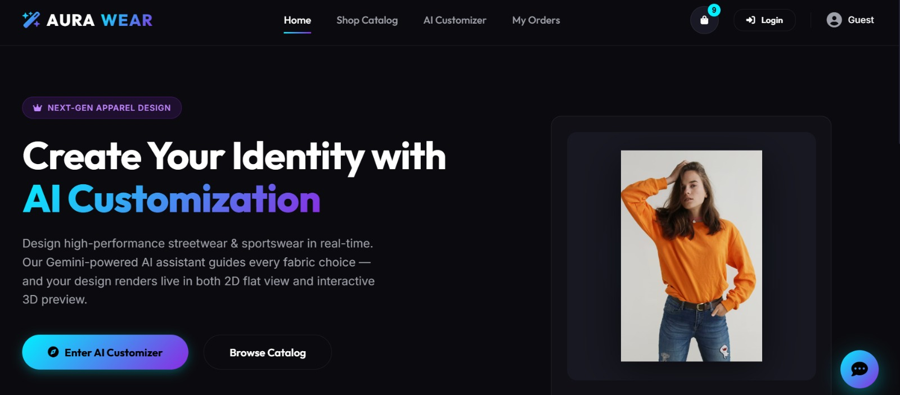

6.1.2 Registration Screen
The registration page displays a centered card with fields for Full Name, Email Address, and Password. A password strength indicator dynamically shows the security level. A Register button submits the form. A link to the sign-in page is provided for existing users.
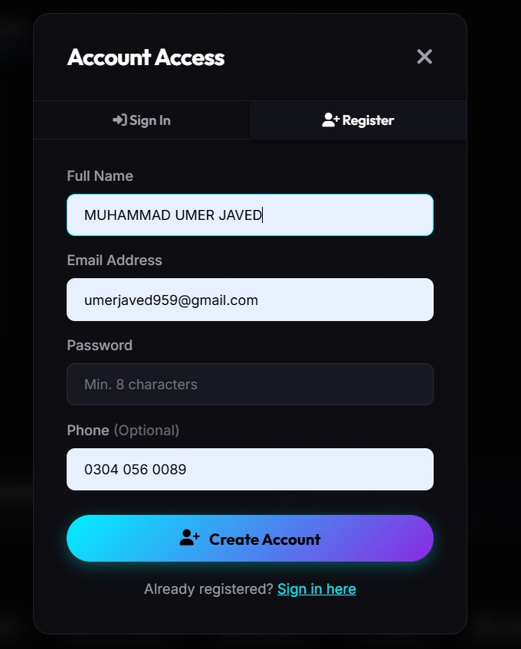

6.1.3 Sign In Screen
The sign-in page presents a clean login form with email and password fields. A "Forgot Password?" link appears below the password field. A "Remember Me" checkbox extends the session to 7 days. The Sign In button submits credentials for authentication.
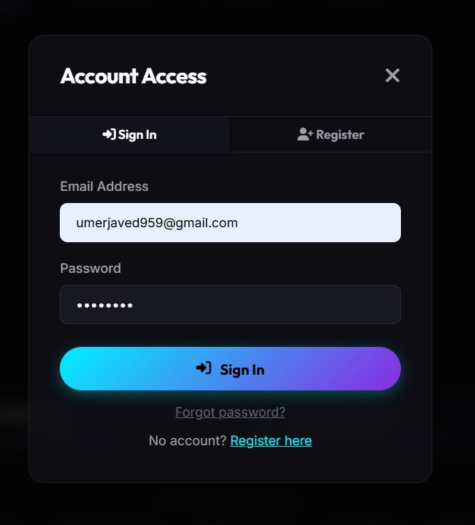

6.1.4 Forgot Password Screen
This screen presents a single-field form asking the user to enter their registered email address. Submitting the form triggers a 6-digit OTP to be sent to the provided email via Gmail SMTP.
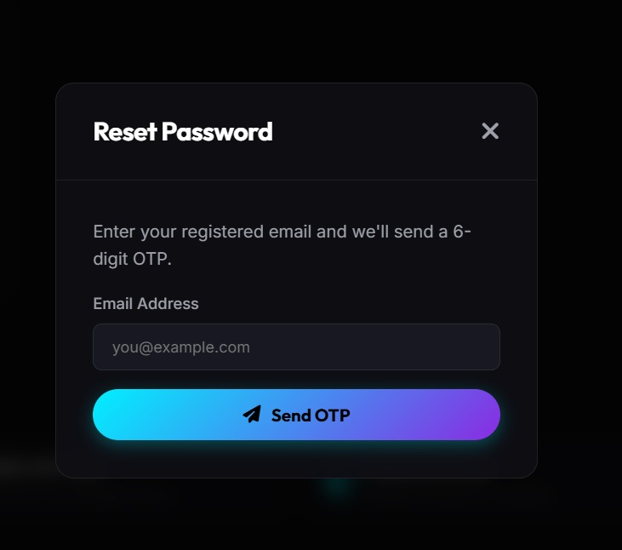

6.1.5 OTP Verification Screen
The OTP verification screen displays a six-digit OTP input field. A Resend OTP link is available with a 60-second cooldown timer. Correct OTP entry redirects the user to the Reset Password form.
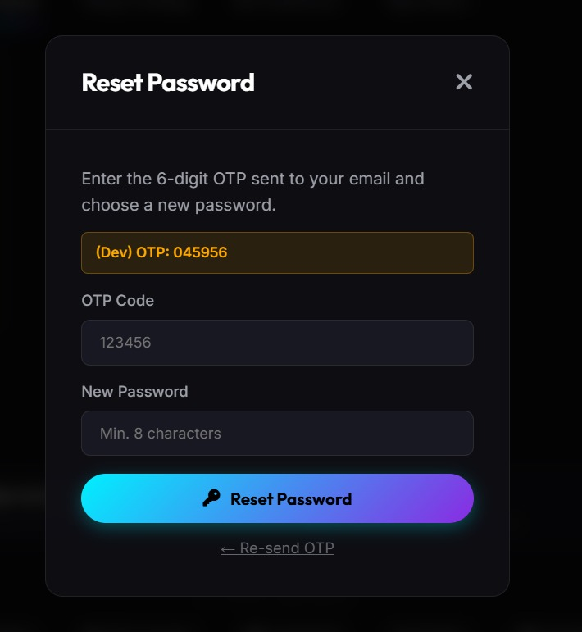

6.1.6 Change Password Screen
The change password form contains three fields: Current Password, New Password, and Confirm Password. A password strength meter evaluates the new password in real time. The Update Password button saves the new hashed password.


6.1.7 Product Catalog Screen
The product catalog presents a responsive grid of product cards. Category filter buttons at the top allow filtering by All, T-Shirts, Hoodies, Jackets, and Sports Uniforms. A search bar enables keyword-based product search. Each card shows product image, name, category, and base price.
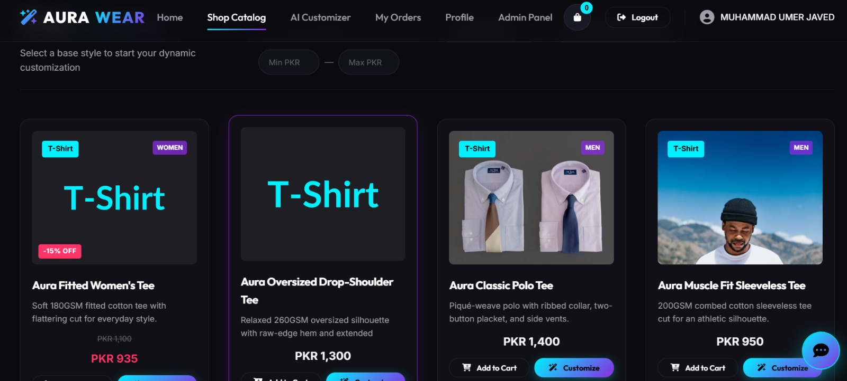

6.1.8 Product Detail Screen
The product detail page displays full product information including multiple product images in a gallery format, detailed description, available sizes from XS to XXL, fabric options, and the base price. A "Customize This Product" button directs the user to the design studio.


6.1.9 Product Customization Screen (Designer)
The customization screen uses a two-panel layout. The left panel contains all customization controls: fabric selector, color picker with hex input, stitching style selector, print method selector, wash effect selector, and logo upload section. The right panel shows the real-time 2D Canvas preview.
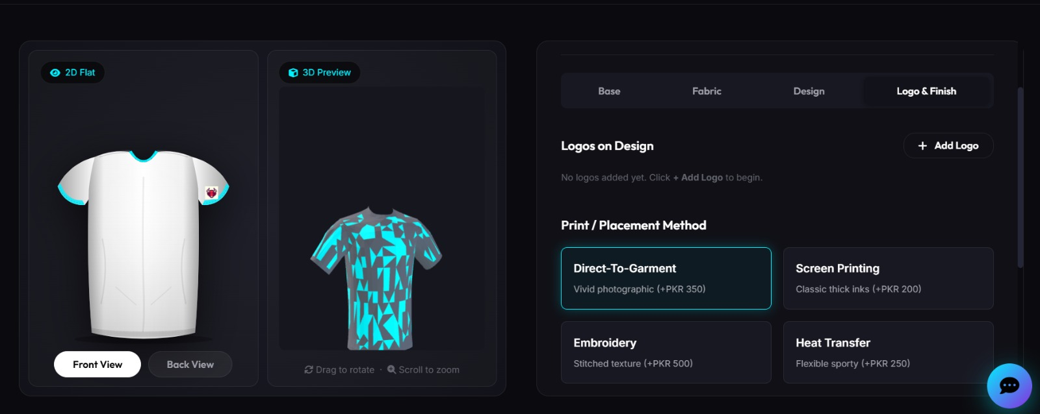

6.1.10 Real-Time 2D Preview Panel
The 2D preview panel is built on HTML5 Canvas and shows the garment in front view by default. The preview dynamically updates to reflect the selected color, uploaded logo with specified placement, and wash effect. A dynamic price display shows the total cost updating in real time.
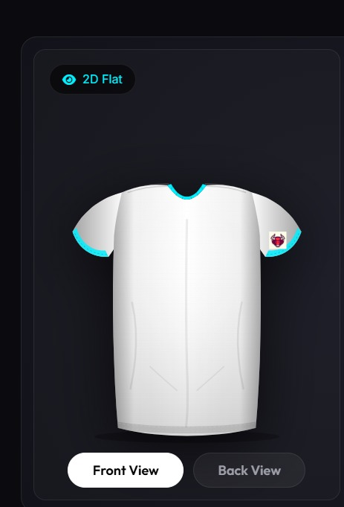

6.1.11 Logo Upload Section
The logo upload section includes a Browse button that opens the system file picker accepting PNG or JPG files up to 5MB. After file selection, a thumbnail preview appears. Placement options (Chest, Back, Left Sleeve, Right Sleeve) are displayed as radio buttons.
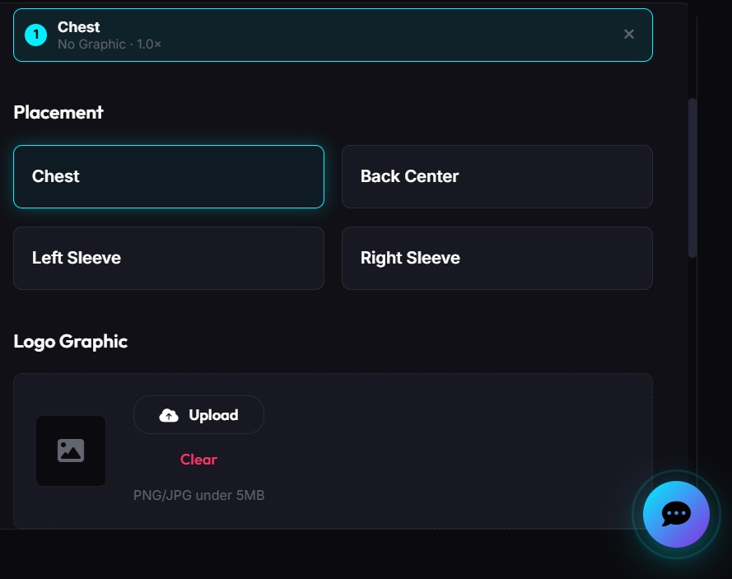

6.1.12 AI Chatbot Widget
The AI Chatbot widget appears as a floating circular button in the bottom-right corner of every page. Clicking it opens a chat panel with a message input field. The chatbot displays typing indicators while processing queries and maintains conversation history for authenticated users.
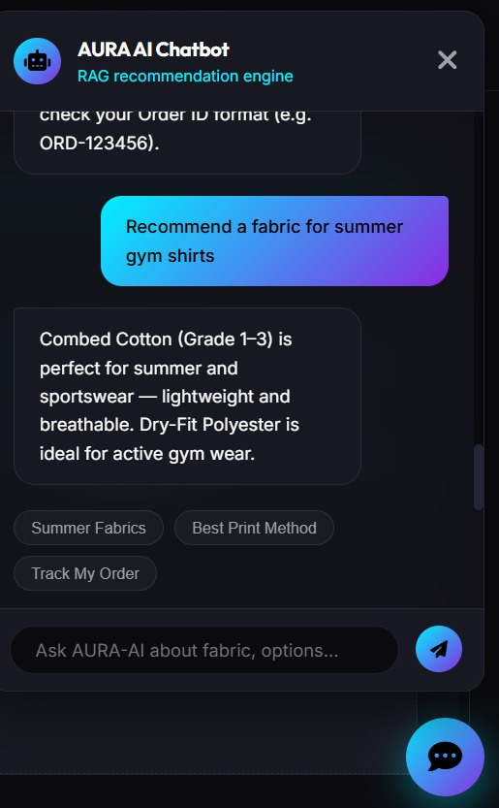

6.1.13 Shopping Cart Screen
The shopping cart lists all customized items with thumbnails, specification summaries, quantities, and subtotals. Remove buttons allow item deletion. An order summary panel on the right shows subtotal, applicable coupon discount, and final total. A Proceed to Checkout button initiates the order flow.
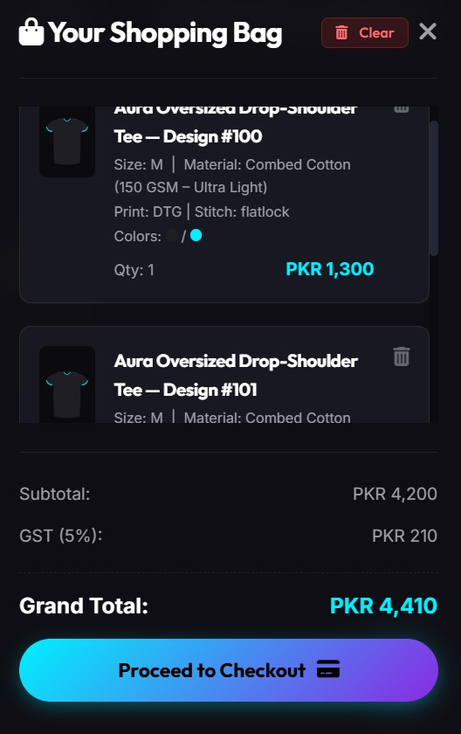

6.1.14 Checkout Screen
The checkout screen shows the full order summary on the left and a payment selection panel on the right. Customers choose between Cash on Delivery or PayFast online payment. A delivery address field uses the saved profile address by default with option to modify. Clicking Place Order confirms the purchase.

6.1.15 Order Confirmation Screen
After successful order placement, the confirmation screen displays a success animation with a checkmark icon. The assigned Order ID is prominently shown with instructions to note it for tracking. Buttons link to Order History and Continue Shopping pages.
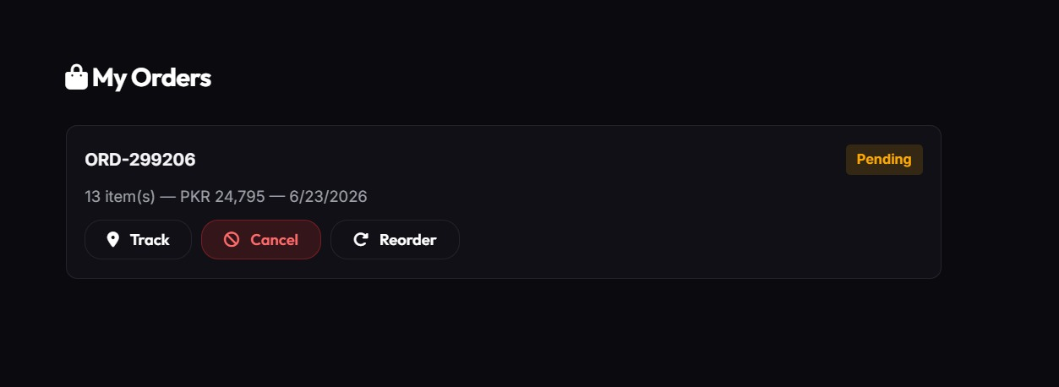

6.1.16 Order History Screen
The order history lists all orders sorted by most recent. Each row shows Order ID, product name with thumbnail, order date, current status badge (color-coded), and total amount. Clicking any order row opens the Order Detail Screen.


6.1.17 Order Detail Screen
The order detail screen provides complete information including Order ID, date, current status in a visual five-stage timeline, itemized product list with customization specifications, payment details, and delivery address. Cancel Order and Reorder buttons appear for eligible orders.


6.1.18 Order Tracking Screen
The order tracking screen presents a visual progress bar illustrating the five-stage lifecycle: Pending → In Production → Quality Check → Shipped → Delivered. The current stage is highlighted in green with an estimated completion timeline.
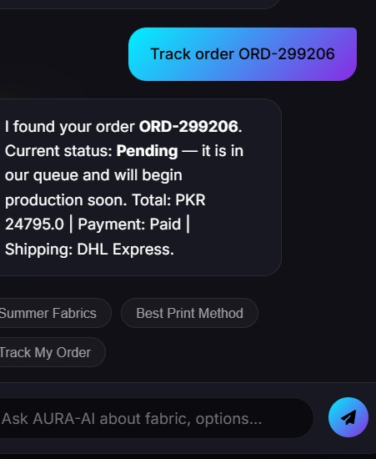

6.1.19 Payment History Screen
Lists all financial transactions in tabular format showing transaction date, linked Order ID, payment method, amount, and status (Paid/Pending/COD-Pending). A Download Invoice button appears for completed transactions.

6.1.20 Customer Profile Screen
Displays the user's profile picture alongside full name, email address, phone number, delivery address, city, total orders placed, and account creation date. Edit Profile and Change Password buttons are prominently displayed.
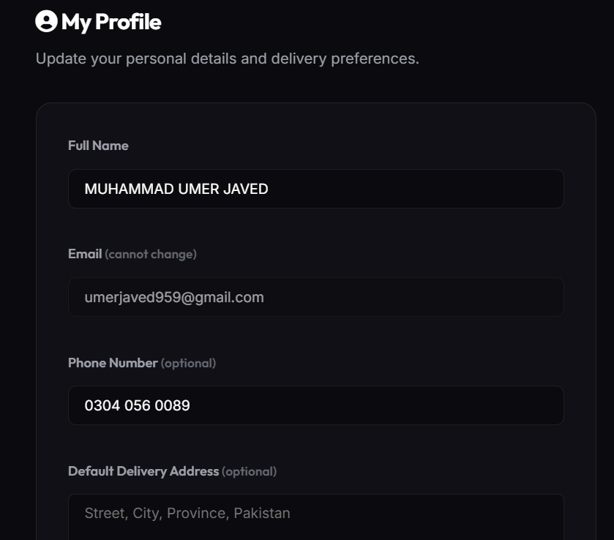

6.1.21 Admin Login Screen
A clean admin authentication screen with email and password fields. Only users with the Admin role in the database can successfully authenticate and access the admin dashboard.
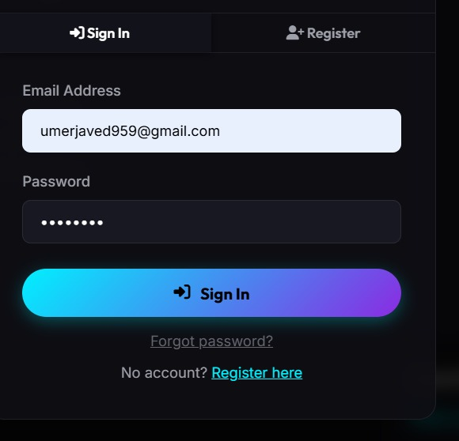

6.1.22 Admin Dashboard
The main admin dashboard displays four KPI cards (Total Orders, Total Revenue, Active Customers, Inventory Alerts). Below are two HTML5 Canvas charts: a daily order count bar chart and a weekly revenue line chart. Navigation links to all admin modules appear in the left sidebar.
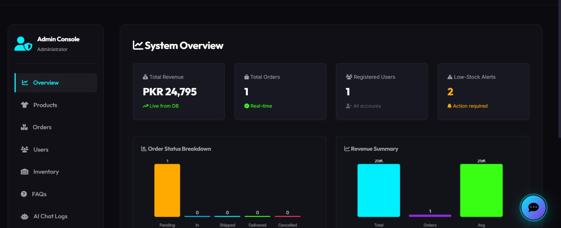

6.1.23 Customer Management Screen
A paginated, searchable table of all registered customers showing name, email, registration date, order count, and account status. Activate/Deactivate toggle buttons allow admins to control account access.

6.1.24 Product Management Screen
Lists all products with thumbnails, names, categories, prices, and status indicators. Add Product, Edit, Enable/Disable, and Delete buttons are provided for each product. A search bar and category filter control the displayed list.

6.1.25 Order Management Screen (Admin)
Displays all customer orders in a sortable table with Order ID, customer name, date, total, and current status. Clicking an order opens the order detail with a status update dropdown allowing admins to advance orders through the pipeline.
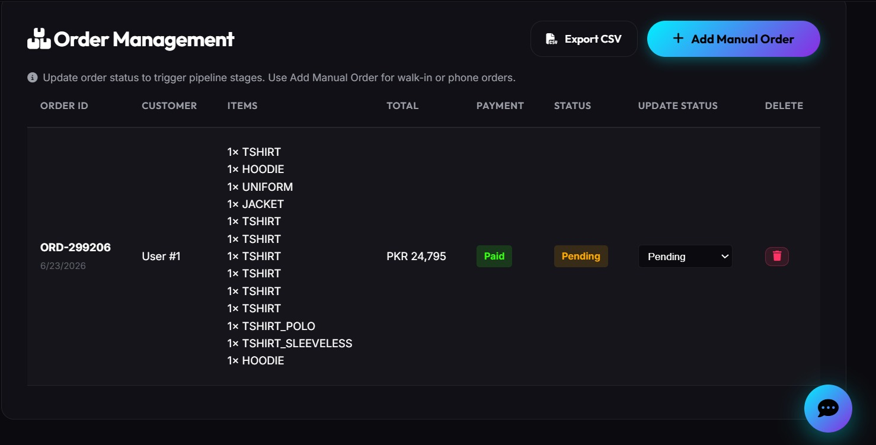

6.1.26 Payment Management Screen
A comprehensive ledger of all platform transactions showing transaction details, amounts, methods, and statuses. Admins can manually mark COD orders as paid upon delivery confirmation.


6.1.27 Inventory Management Screen
Displays current fabric and material stock levels in a table with color-coded alerts: green for adequate stock, yellow for low stock, and red for out-of-stock. Admins can update stock quantities directly from this screen.
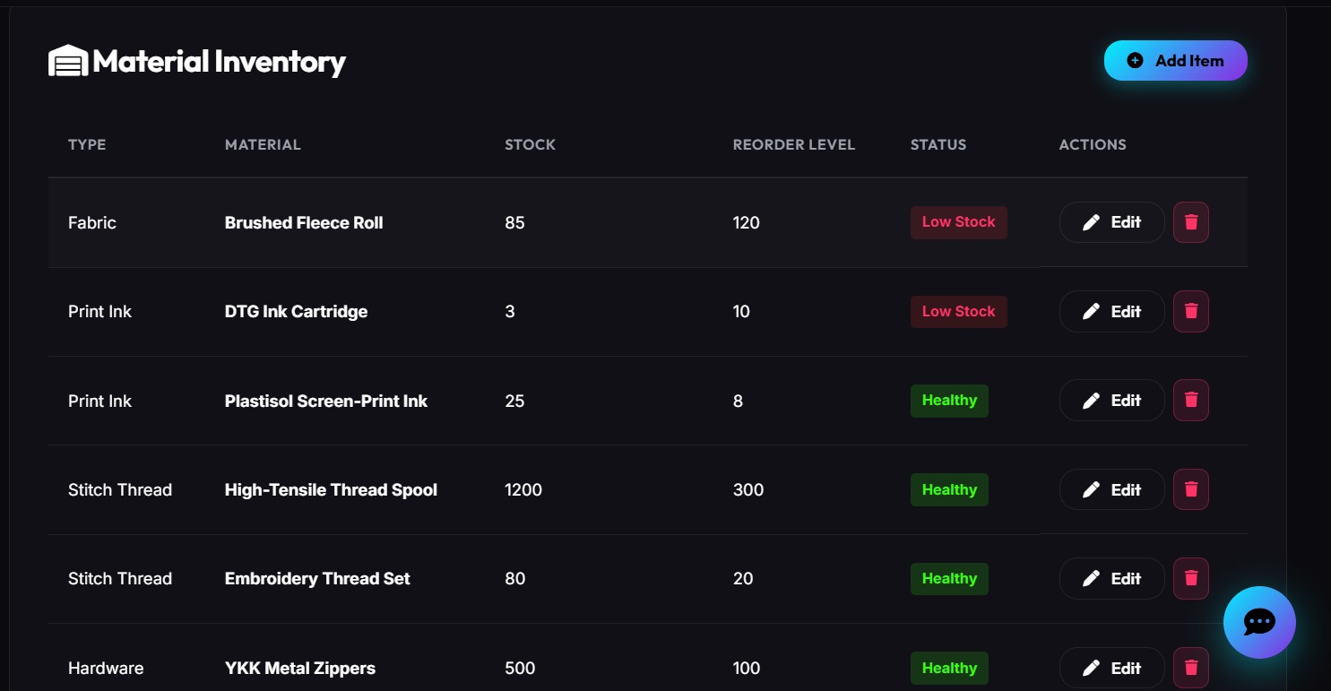

6.1.28 Reports Screen
The reports screen provides three report types: Sales Report (monthly/annual), Order Report (filtered by date range and status), and Performance Report (top products, popular options). Generated reports display inline with export buttons for PDF and CSV formats.


6.1.29 Coupon Management Screen
Admins create and manage promotional coupon codes by specifying code string, discount type (percentage or fixed amount), discount value, usage limit, and validity date range. Active coupons are listed with their current usage counts.

6.1.30 Content Management Screen
A tabbed interface providing rich-text editors for Terms & Conditions, Privacy Policy, and FAQ sections. The FAQ tab allows adding, editing, and deleting individual FAQ entries that are used by the AI chatbot knowledge base. Changes are saved immediately and reflected on the customer-facing pages.
